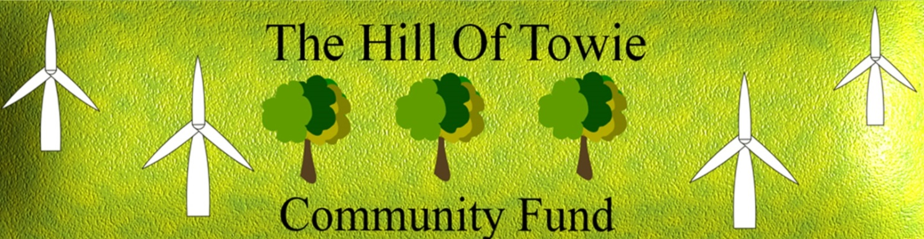

Hill of Towie Wind Farm
Community Benefit Fund

Annual Report
Round 24
2024

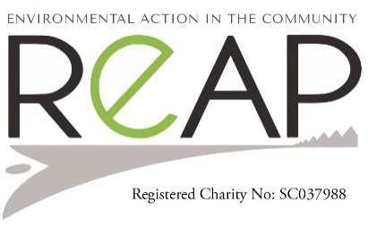
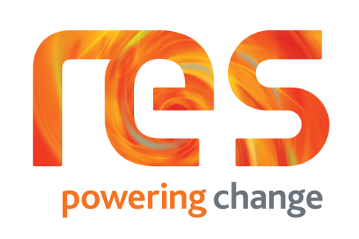
COMMUNITY BENEFIT FUND
The Round 24 Decision-Making Panel meeting was held on 28th May, 2024 at Boharm Hall. 11 applications were considered: 3 applications were awarded in full; 1 partially funded; 1 declined; with 6 deferred to round 25.

SUCCESSFUL APPLICANTS

Round 24 - May 2024

Drummuir & Botriphnie Community Trust - Solar PV and battery storage £31,958.07
Loft Youth Project - Holiday activities programme £9,086.40
Keith Country Show – Marquee £20,000.00
Frog Squad - Developing opportunities for outdoor learning (Partially-funded) £13,616.67
Total for Round 24: £74,661.14

Round 24

Drummuir & Botriphnie Community Trust - PV Panels & Battery Storage

A continuous rise in the electricity costs, to heat & light Drummuir Hall, prompted their Management Committee to investigate a way to reduce these costs.
It was decided, with the approval of the Drummuir & Botriphnie Community Trust (DBCT) members, that the installation of PV panels and a battery storage system would be the best option.
Following a successful application to the Hill of Towie Windfarm Community Benefit Fund, DBCT received a grant of £48,693.60, in May 2024 and the contract for the works was awarded to iProtech, Kintore.
40 PV Panels were installed and 3 Tesla batteries to store the energy for use at a later time.
The project did not get underway until January 2025 and was completed by the end of February 2025.
It is hoped that at least 35% of their annual energy usage will be covered by the system, with the performance data monitored regularly.
The system is predicted to be the equivalent of planting over 650 trees over its lifespan and will avoid using in the region of 3.4 tonnes of CO2 per year to power the building via fossil fuel grid energy.
The renewable energy project is a good fit for DBCT’s aim to be as energy efficient as possible, having installed a ground source heat pump and solar panels in the Hall in 2011, and replaced their lighting with low energy models in 2021.

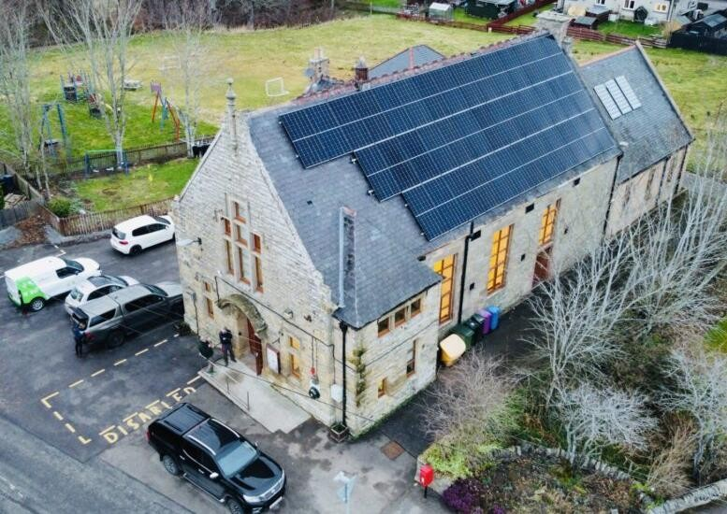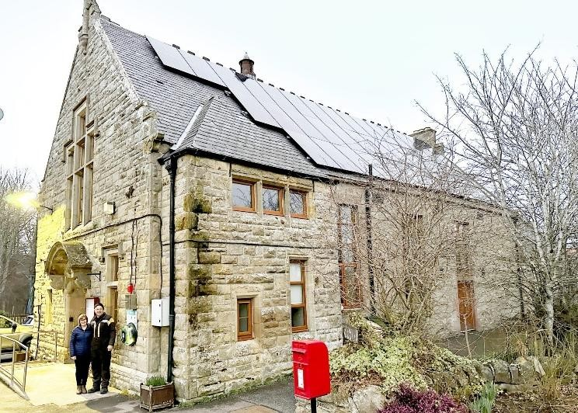

Loft Youth Project - Holiday activities programme

The ongoing cost of living crisis continues to cause a need for our young people and families even more so during the school holiday periods.
The Loft Youth Project has been an established youth project charity since 2000. It offers a wide range of activities for young people in Keith and the surrounding rural areas, and by offering this aims to combat anti-social behaviour in our community.
The activities that take place in The Loft are both vocational and diversionary which empower young people to participate within their community and gain skills through informal learning. We are fortunate that they have years of experience behind them, and we know how popular their holiday activity programmes are and how well they are attended.
Thanks to the Hill of Towie Windfarm Community Benefit Fund, there are fantastic opportunities for our young people to access holiday programmes for free, including all refreshments, etc.
This year’s funding of £9,086.40 was spent on staffing costs which had to be increased for October cooking sessions; plus community bus hire; Active Schools provision; and music tuition.
The Summer Holidays programme was a great success with 776 young people over the 6 weeks taking part in activities, BBQs and drop ins.
Trips included strawberry picking at Nairn; the Keith & Dufftown Railway; and Lossiemouth and Cullen beaches, in which a packed lunch for every young person was provided.
The music project was a great success, as were the BBQs in the park on Friday evenings. Experience with typical Scottish weather meant adapting and changing some activities, but they also used some of the funding to purchase a gazebo for the park BBQs, and this can be used for years to come.
The October Holiday programme had 248 young people attending a range of Hallowe’en activities and a drop in.
Due to miserable weather, pumpkin picking had to be rearranged to indoors, however! Staffing for the cooking/baking in October was increased to accommodate young people with additional support needs attending these sessions. In these cooking sessions, young people were given more of a variety, including pumpkin cookies, pumpkin soup and pumpkin spice - that was used in lattes and hot chocolate. Sounds yum and the photos show what fun was had!

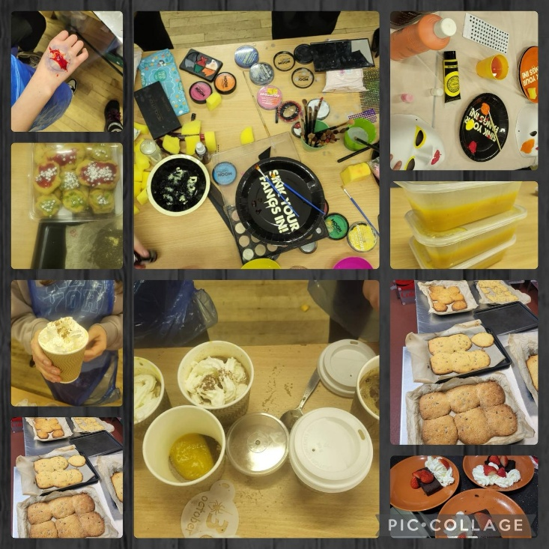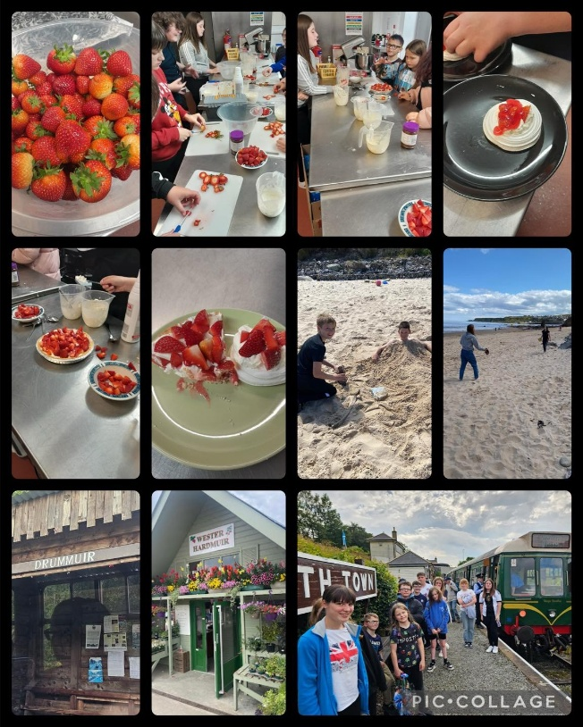
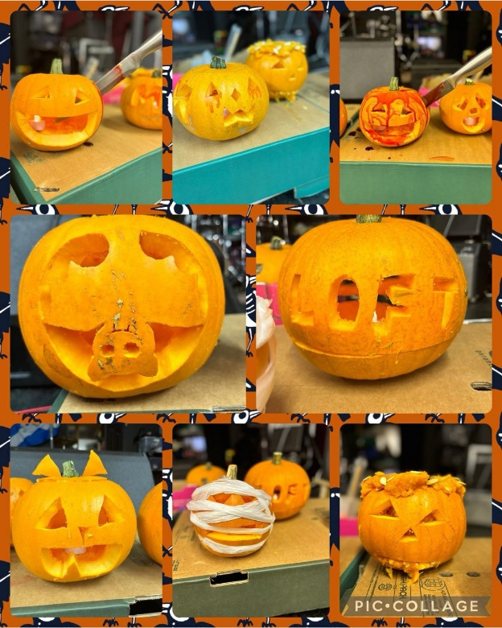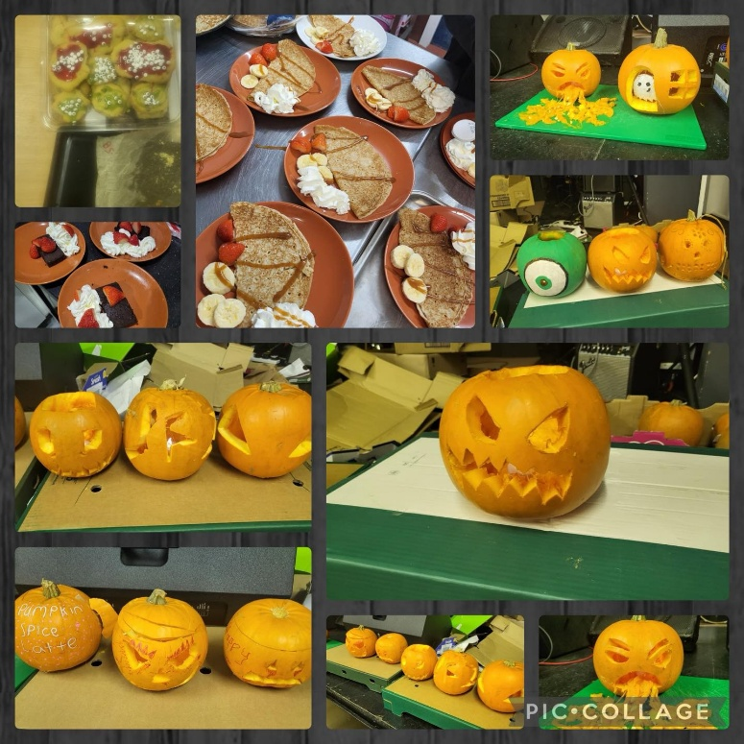

Keith Country Show – Marquee

The Keith Country Show, 2023, was another successful show after the phenomenal support shown when it returned after COVID in 2022. The Show had added a Ladies’ Day to the calendar in 2022 and again in 2023 this was a huge success, with tickets selling out in record time. The Show hugely benefitted from the funding received from the Beatrice windfarm with which new canvasses and the new marquee were purchased.
Keith Country Show is a major event as the largest two-day show in Moray, and it cannot operate without marquees. The Show has historically hired all the marquees, but since COVID the cost of hiring has increased considerably and the availability of marquees for hire has become very challenging, with North of Scotland Marquees closing too. The rest of the marquees were borrowed from New Deer Show but unfortunately, they have decided to no longer allow their marquees to be borrowed due to wear and tear.
So, to save ongoing costs in the longer term and to reduce their carbon footprint (avoiding marquees being transported long distances), the Show applied for Hill of Towie Community Benefit funding to purchase additional marquees and canvasses. This was recognised to be a large initial outlay that will save money in the longer term.
Keith Country Show also recognise that owning their own marquees allows them to organise other activities and events during the year and to allow other organisations and weddings to run events in the show park and to hire the marquees.

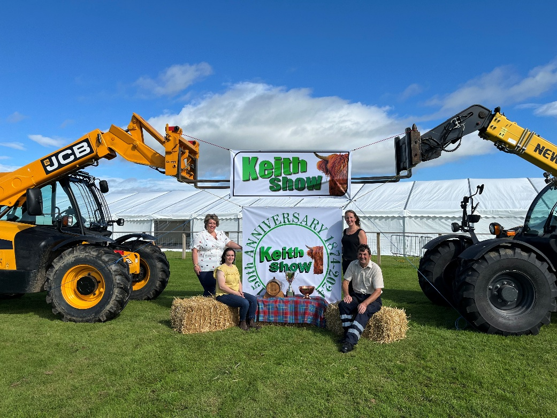

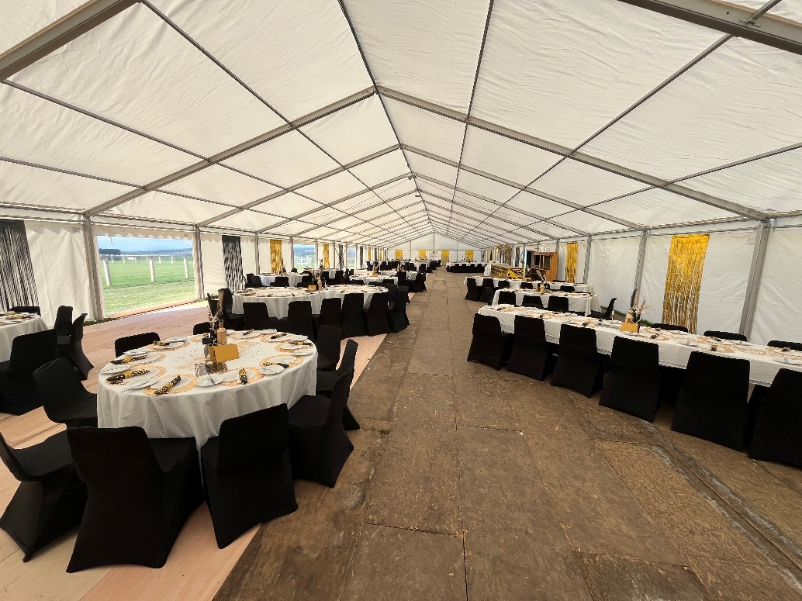

We were pleased to receive the Show’s feedback on their dealings with REAP, as administrators of the fund, when they ‘strongly agreed’ with the following statements:

The application process was easy to follow;
They found enough information to complete their application on the REAP website;
REAP helped them with their application;
The information provided was valuable to their situation;
REAP kept them informed during the application process;
REAP staff were courteous and helpful;
REAP is a valuable local support network;
They would recommend REAP to others; and
They would use REAP’s services again.

Frog Squad - Developing opportunities for outdoor learning

We would like to thank the committee linked with Hill of Towie Fund for reading and then accepting our application.

We were absolutely delighted to receive the money this time around to help us purchase and install an outdoor classroom building.

Although there have been some delays in choosing a suitable design for the space etc. we are delighted that we are almost there with the final construction.

The outdoor classroom building will make such a positive difference to our pupils here – giving them a quality place to learn and work outdoors.

We would love to share some photos when the building is fully finished but I have included a couple of photos below for just now. We are waiting for the roof and final fixtures to be fitted e.g. doors and windows etc. Then we will look to furnishing it and putting in some storage etc.

we are delighted that we have managed to get so much for the money you granted us.

