

Hill of Towie Wind Farm
Community Benefit Fund

Annual Report
Rounds 22 & 23
2023

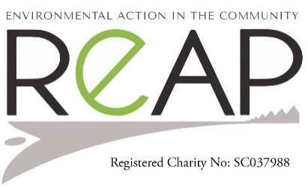
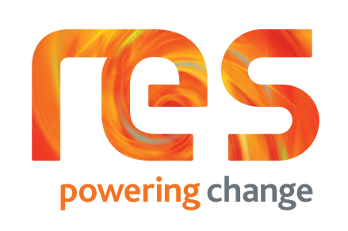
COMMUNITY BENEFIT FUND
Twenty-five applications were received for rounds 22 and 23 of the Hill of Towie Windfarm community benefit fund in 2023.
Round twenty-two decision-making panel meeting was held in June. Fourteen applications were considered. Ten main and four short. Twelve were successful and awarded on the night, two projects were declined, and one withdrew its main project. The total funds applied for was £108,437.96. Allocated funds amounted to £72,378.55.
In round twenty-three the Decision-making panel meeting was held in November of that year. Eleven applications were considered, ten main and one short. The total funds applied for was high at £133,490.50. Eight applicants were successfully awarded on the night. The Drummuir pot was ring fenced for the next round totalling £16,735.35. Two applications had merit but were deferred due to lack of funds. The funds that were awarded on the night amounted to £24,354.85.

SUCCESSFUL APPLICANTS

Round 22 - June 2023

Drummuir and Bortriphnie Community Trust – Drummuir in bloom £592.00
Drummuir and Bortriphnie Community Trust – Running costs £200.00
Keith Football Club – Architect feasibility Study £1,800.00
Keith Community Council – Workshop & Store repair phase 1 £17,700.00
Keith Christmas Lights – Overhead lights Mid street replacement £26,433.00
Keith & District Silver band – Upgrade of instruments £5,000.00
Keith Royal British Legion – Replacement of internal doors £7,500.00
Mulben Picnic Committee – Running costs £200.00
Loch Park Rural Skills – Tree planting project £953.55
Newmill Renewables CIC – Running costs £1,210.14
Longmore Community Hall – Tanking exterior wall £5,000.00
Keith Country Show – Marquee Canvasses £7,000.00
TOTAL £73.588.69

Round 23 – November 2023

Keith Football Club Youth – U14 goals £3,987.60
Keith & District Sports Development -Youth Football £1,000.00
Keith & District Men’s Shed – Phase 2 – Hobbies room completion £2,794.85
Longmore Community Hall – Toilets upgrade £10,000.00
Boharm Hall – Alternations to utility room £2,847.40
Keith Grammar School – Barista Skills £3,725.00
TOTAL £24,354.85
Round 22

Drummuir & Botriphnie Community Trust - Drummuir in bloom

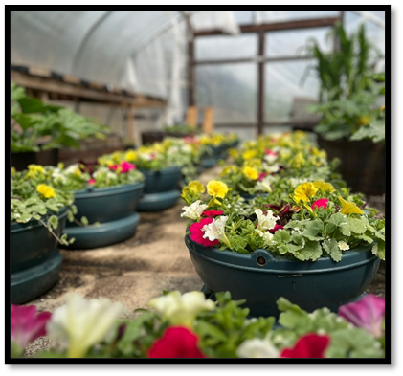
In June 2023 Drummuir & Botriphnie Community Trust received a grant of £592.00, to employ the services of Lochpark Rural Skills, which is a local Day Centre for Adults with learning difficulties. They supplied compost and plants for planting out the hanging baskets and floral displays, in and around the Village of Drummuir. They also maintained and watered the plants throughout the summer months. The beautiful display of flowers was very much appreciated by the local and wider communities and visitors to the area and being able to support Lochpark Rural Skills was an added benefit.

Keith Football Club – Architect Feasibility Study
Keith Football club applied to the Hill of Towie Community Fund to fund a local architect to carry out a feasibility study and pre-application discussions with the local council about upgrading their current facilities. Their current hospitality building was originally built as a wooden shed. Over the years it has been converted into its current state. Sadly, due to the nature of its construction, the building was no longer fit for purpose. There is little to no insulation, expensive electric heating and due to the nature of the business dampness was taking hold. The current office block was no longer occupied. It was therefore proposed that KFC would begin planning for the office block to be converted into the main hospitality building at Keith Football Club.
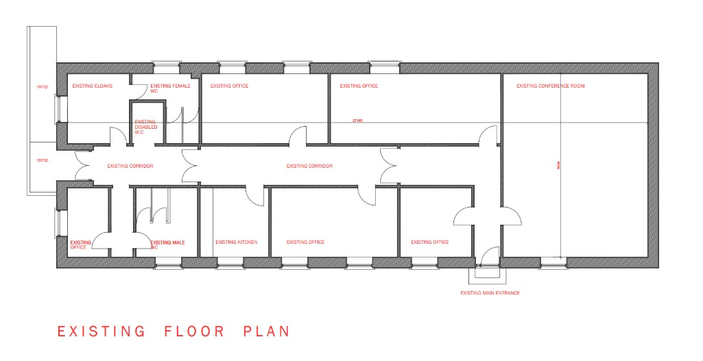
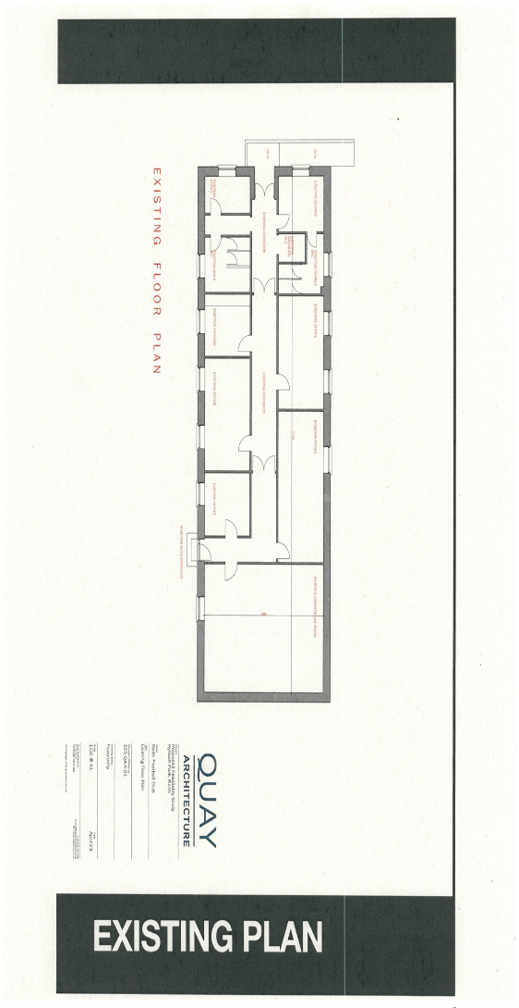

Keith Community Council – Workshop and store repair phase 1
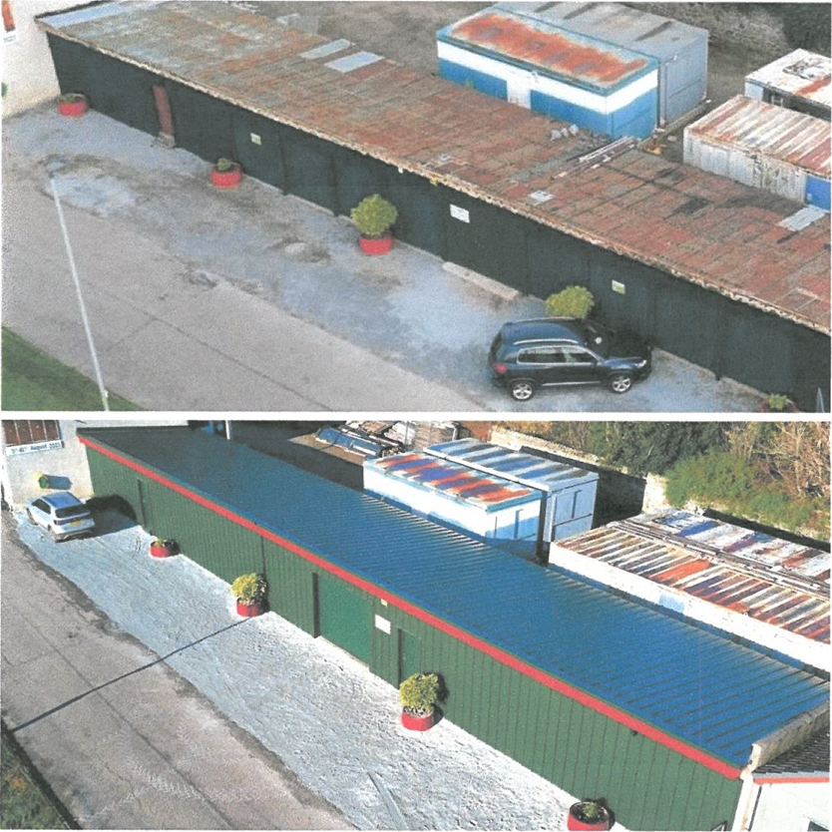

For a number of years, Keith Community Council has been sharing the old 'green sheds' at Seafield Park with Keith Show. The 'sheds' are regularly used as our community workshop as well as storage. In December of 2023, we identified the need to carry out significant repairs to the building to ensure its future. With all groups using the building being voluntary run, we decided to apply for assistance from the Hill of Towie Community Benefit Fund in April 2023 for 'Phase 1.’ Phase 1 of the project was to replace the roofing timbers, clad with insulated profile sheeting and refurbish the original stone wall to the rear.

Our groups were delighted to hear Keith Community Council were successful in the application and were granted £l7,700 to complete 'Phase 1 ' of the project from the Hill of Towie fund in June. With our committee members involvement in Keith festival, Keith Show as well as other commitments in the summer, it was decided we would commence the project in the Autumn.
We'd like to send a huge thank you to the panel members of the community fund as well as RES for supporting our project. Without this support, the building would have been left to ruin.

Keith Christmas Lights – Replacement of overhead lights Mid street
Keith Christmas Lights is a small group of volunteers who take care of the festive lighting around Keith and Fife Keith, both on town streets and on the A96.
Responsible for over 100 fittings, which means hundreds of hours of work each year.
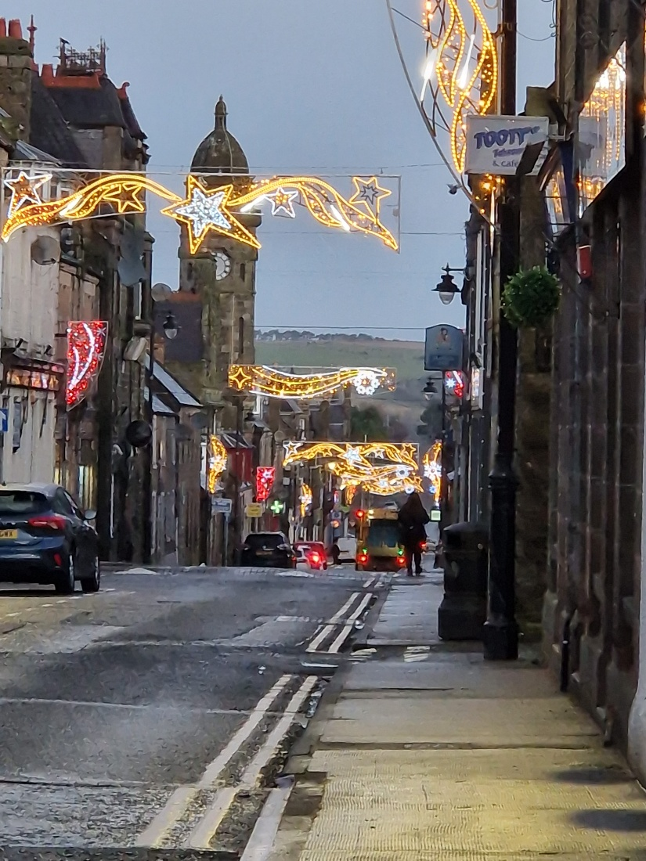
Our team meet most Monday nights from February - October to complete maintenance on the fittings and work tirelessly on planning the displays carefully. The winter of 2022/23 was particularly harsh on the lights and while our funds allowed us to repair small light fittings, we were unable to entirely repair the overhead fittings in Mid St. The power supplies in Mid St have become increasingly unreliable over the last 10 years, with our lights 'dulling' from being left on 24/7 or not coming on at all at times. This brought us to the conclusion that we needed a total refresh of the lighting in Mid St.

We applied to the Hill of Towie Community Benefit fund in April of 2023, after receiving quotes for new overhead and side mounted fixtures.
We were delighted to hear that in June, we were granted the full sum. We called a meeting to discuss final styles and colours for the lights, and although the lower quotation was originally preferred, we found the service and quality from the other company, Blachere to be far better. The quotes weren't far apart in value, so we were able to put the difference in from our reserves. The lights were ordered late June, in the hope they'd arrive in enough time for us to manufacture bespoke brackets to mount them to the buildings in Mid St.
The response we had to the new lights was immense. People posted pictures on social media with hundreds commenting on posts, with comments like 'Best display in Scotland' and the like. Townspeople have approached us in the streets, congratulating us on our display and all the work we put in. This praise, along with the visual difference we've made makes our volunteers time all worthwhile.
We took all the lights, new and old down in the second week of January, and we're now testing them all, making sure they're safe and working for this year. We're also working on refurbishing some old lights we were given, to add to the town's display.
The Christmas Lights Committee and 'parent group' Keith Community Council would like to extend our thanks to RES and to the panel of volunteers who give up their time to make sure funding is distributed where best.

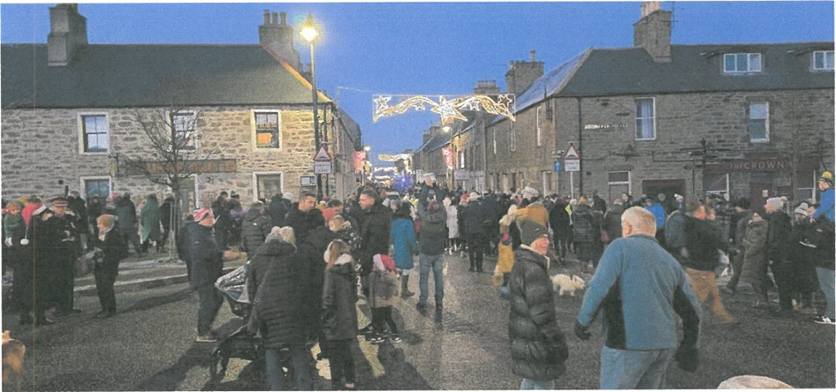

Keith & District Silver Band – Upgrade of instruments
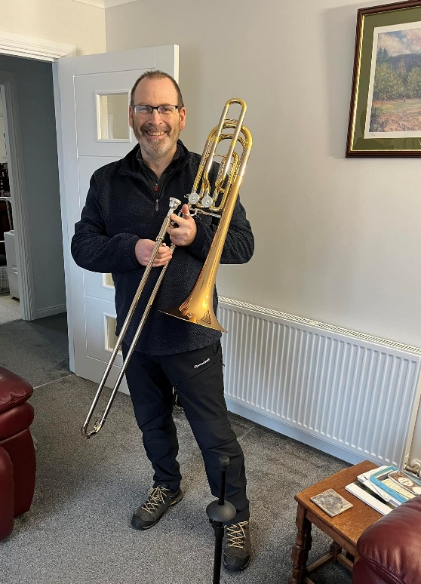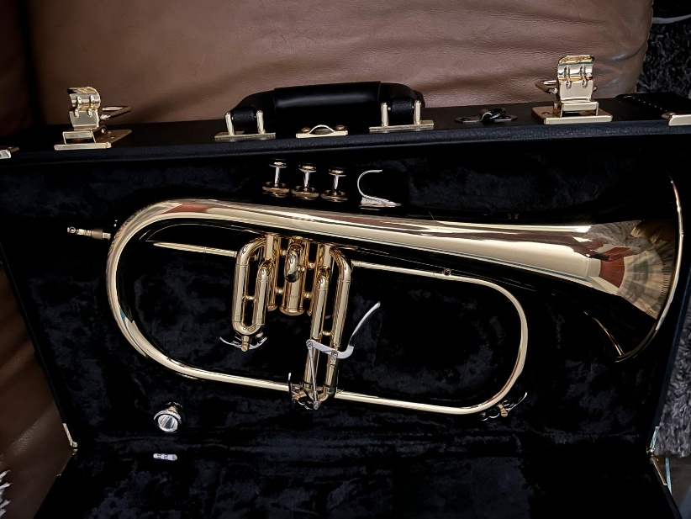
Someone is a very happy Bass Trombone player!
One of the two new instruments bought with the monies from the Hill of Towie Wind Farm funding. The other being a Flugel.
“Like many things some of the Keith & District Silver Bands instruments were beginning to show their age. The grant from Hill of Towie Windfarm has enabled them to buy professional standard instruments to be use by the band from many years to come. Thank you to Hill of Towie for your grant towards our instruments.”

Royal British Legion Keith – Replacement of internal doors

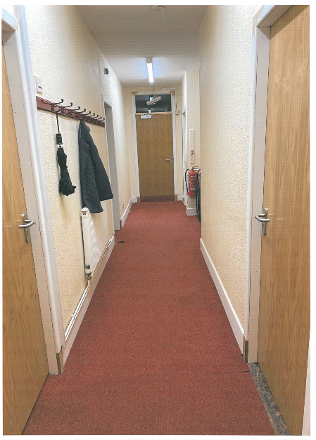
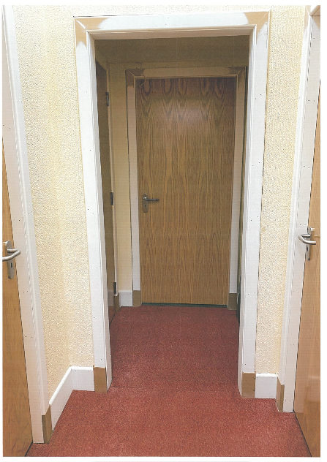
The Royal British Legion Keith Committee would like to express our sincere gratitude for the grant we received to help refurbish our interior doors. The money was used to purchase interior doors throughout the building. They are not just pleasing to the eye but easier to use. As well as keeping the costs down we are now draft free. We have had a great response from members and groups who utilise the premises. We can only thank you once again for the grant as without it we would not be able to take it to this standard.

Loch Park Rural Skills – Tree planting project
We were very grateful to receive a Reap grant last year, and we thought you might like to see how this has helped us. Your generous donation allowed us to purchase a number of trees, bushes and shrubs, which our service users have planted in our new sensory garden area.
This project is part of the regeneration of the scrubland on the Loch Park area of the Isla Way Walk in Drummuir. We wanted to turn this land into a tree nursery and wildlife haven, with bug hotels, bee-attracting flowers, and areas in which the local wildlife can thrive. We also wanted to provide a calming space for our service users, by planting colourful and sweet-smelling flowers that are known to be ‘autism friendly’.
It will also benefit the ramblers that use the Isla Way Walk, and local community members that visit the centre. We wanted to turn this land into a tree nursery and wildlife haven, with bug hotels, bee-attracting flowers, and areas in which the local wildlife can thrive. We also wanted to provide a calming space for our service users, by planting colourful and sweet-smelling flowers that are known to be ‘autism friendly’. It will also benefit the ramblers that use the Isla Way Walk, and local community members that visit the centre.
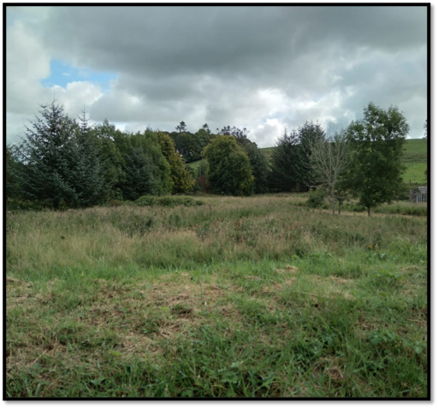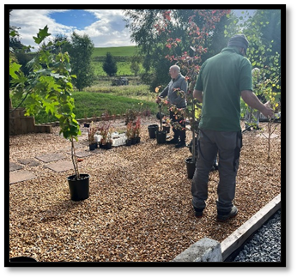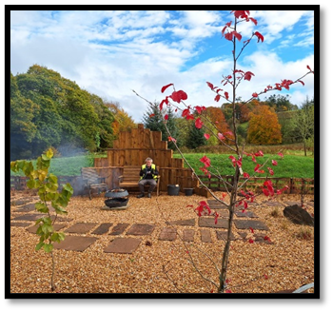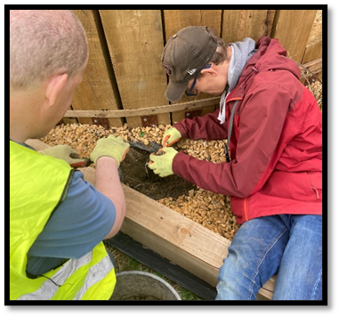
This has been a great team project that everyone of all abilities could get involved in.
Your donation has helped us to continue to teach our service users gardening skills, and cooking with the fruits that we grow. It has helped us to encourage good mental and physical health in everyone involved. We also hope that our project will encourage an increase in the insect, bees, and bird population.
“Thank you so much for your help with our project.”

Longmore Community Hall – Tanking Exterior wall

Keith Country Show – Marquee canvasses
Keith Show we are truly delighted to have received the funding for our “Marquee Canvasses” project back in 2023. It enabled us as a show to purchase our own marquee canvasses which is a huge saving to our show as in previous years we have had to hire at a cost.

Keith Show 2023 was a great success and hugely benefitted from the funding received to purchase new canvasses for the second-hand marquee and the new marquee purchased from Beatrice funding. The purchase of marquee canvasses enabled us to save ongoing costs and to reduce our carbon footprint.

We thank you once again for your continued support towards our show and we look forward to welcoming you along to our 150th Anniversary Show in August this year.
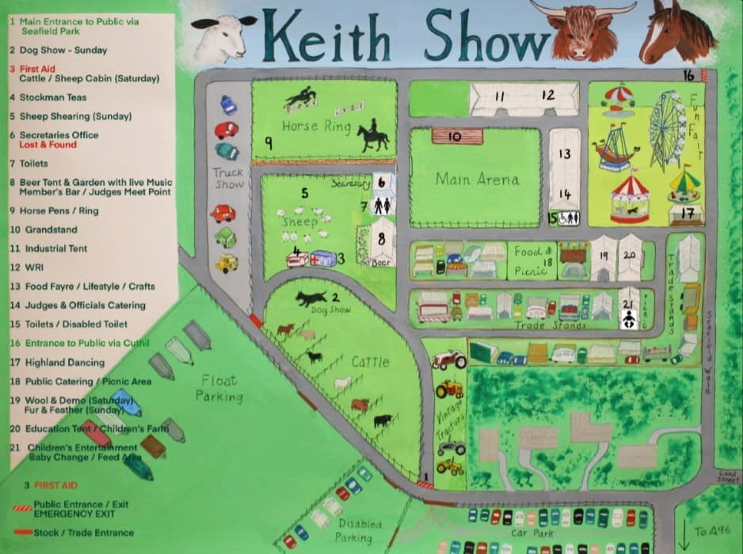

Round 23

Keith Football Club Youth – Under 14’s goals

Keith & District Sports Development – Youth football

‘Many thanks to the Hill of Towie windfarm for funding KDSD - it was very much appreciated! We were able to buy equipment to make our training sessions more fun and "professional" and the banners and paint both contribute to augmenting a sense of pride in our home pitch.’
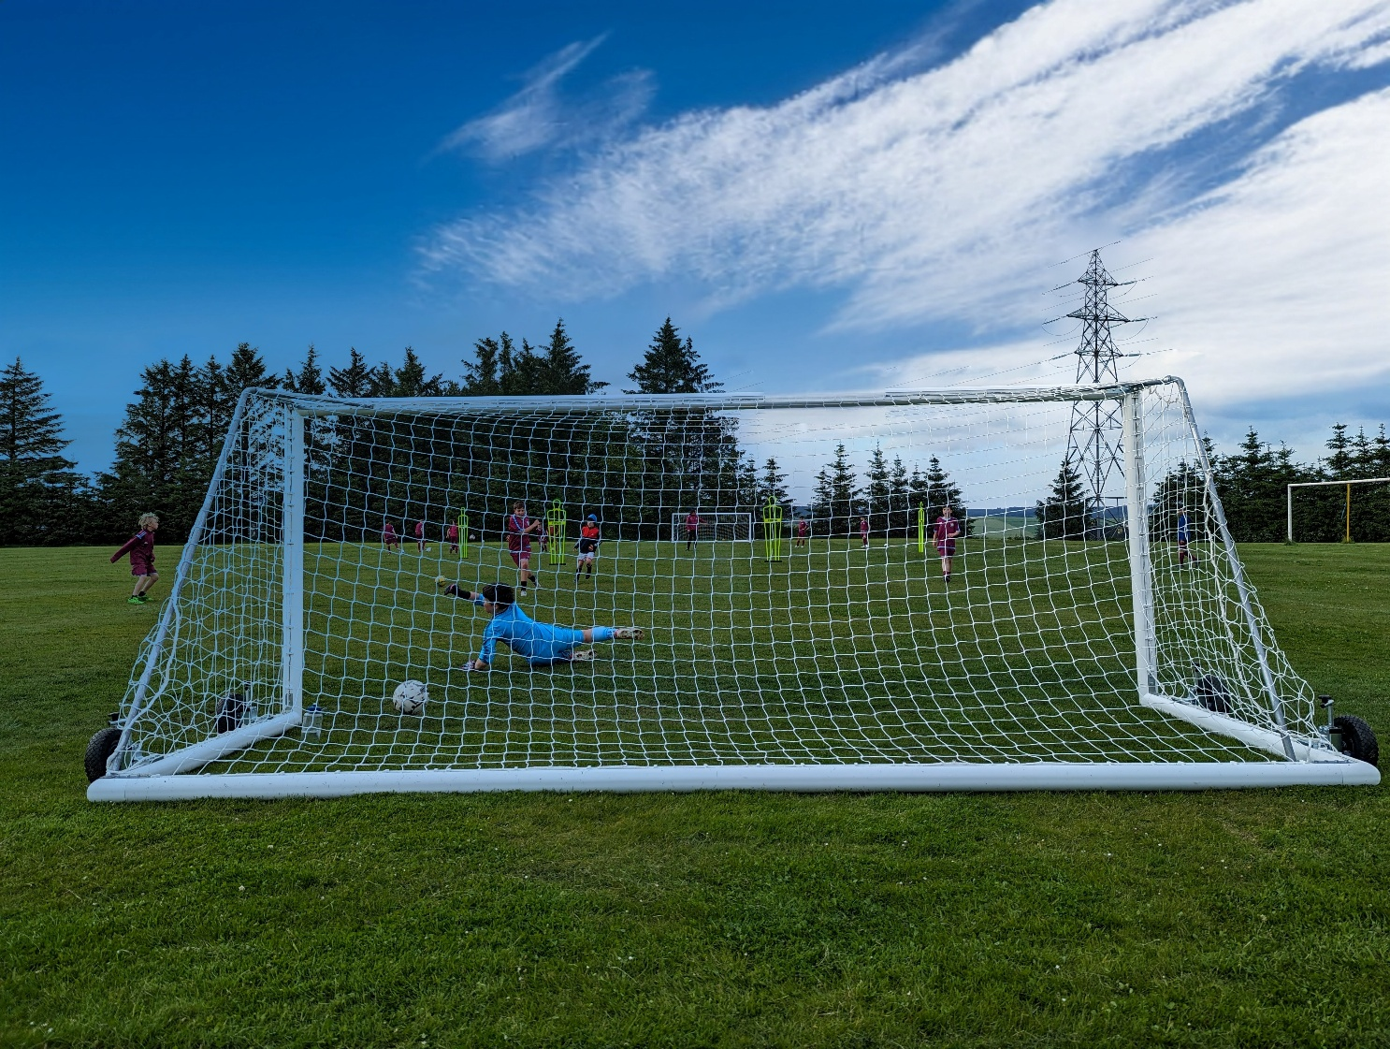

Keiths Men Shed – Hobbies room completion phase 2

Longmore Community Hall – Toilet upgrade

Boharm Hall – Alternations to utility room

Keith Grammar School – Barista skills
Keith Grammar School applied for a grant for their “barista skills” project. This funding helped to run a SQA course in the Home Economics department. This would help the pupils develop their knowledge, understanding and technical skills required for the role of a barista.

The money has been very well spent on a new machine for the young people to develop essential skills for life and work and to achieve their Level 5 award in Barista training.
The young people have been so grateful for the grant and have thoroughly enjoyed learning on the machine.
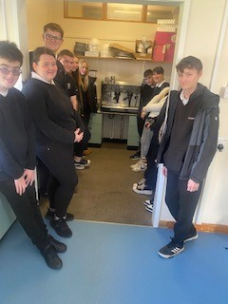

Fund Governance and Administration
Governance of the fund is overseen by a local volunteer Decision Making according to the fund aims and objective. All complete and eligible applications are assessed by Panel members and discussed at Decision Making meetings.

The fund is administered by REAP, a local environmental charity. REAP staff can assist with the application process and clarify any questions on the application form. All applications are screened for completeness, and advice is given to applicants where necessary. Application forms and guidance notes are always available on the website and hard copies are available on request.
Grants awarded are published on the REAP website, along with reports from successful applicants.

The fund is advertised in local venues, local radio station Keith Community Radio, TSI Moray and online and on social media.

Accounts
The annual grant fund of £110,847.79 for 2023 was received from RES in May. REAP’s fee for administration was £8,477.84 leaving £102,369.95 funds available for community grants.

A total of grants totalling £132,792.81 were awarded in round 22 and 23.

