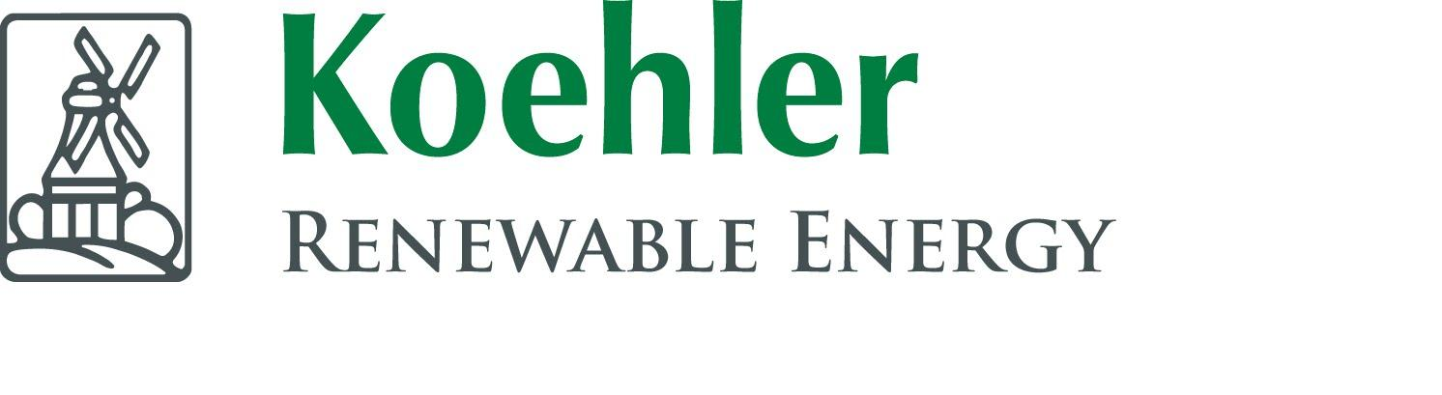

Grant funding made available by Edintore Wind Farm Ltd.

Edintore Wind Farm

Community Benefit Fund 2022

Grant Awards

ROUND 5

Edintore Wind Farm Community Benefit Fund

The Community Fund is made available by the wind farm developers Koehler and the Edintore Wind Farm Ltd. The fifth round of funding was awarded in September 2022. Interest in the fund was high and once again, all grant funds for the year were awarded in a single round.

Ten applications totalling £93,422.16 were received, eight from the primary area of benefit and two from the secondary area of benefit. The available grant was £70,500 and the fund balance as per 1st September was £92,679.67.

Nine applicants were awarded full grant funding and one was declined and given advice to apply for a windfarm fund closer to their area. Grants totalling £78,422.16 were awarded in this round leaving £14,257.51 in the fund’s balance. Keith Football Club withdrew their application ‘Upgrade of floodlights in effort to achieve Net Zero’ amount £33,994.17,leaving the fund amount £48,251.68.

Successful applicants

Botriphnine Parent Council £4,819.99

Keith Football Club £905.75

Event 1st Aid Service £12,000

Bin rangers club £943.13

REAP £7,634.13

The Loft Youth Project £990

Tyred n Cranky £985.25

Glass Community Association £16,419.74

TOTAL £44,427.99

Botriphnie Parent Council – New shed
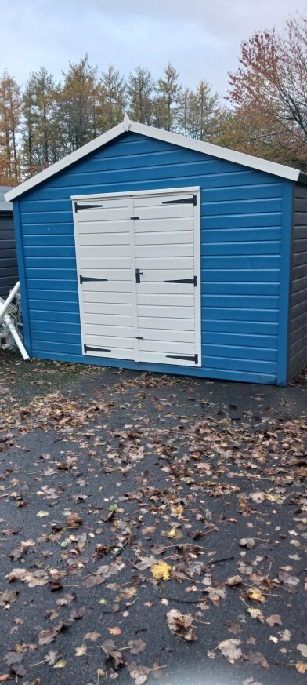
A new shed was purchased for the Botriphnie Primary school to keep all their equipment safe and dry from the elements. This helped the school free up resources and space in the school building. This helped not only the school but also Drummuir toddler group keep all their equipment safe and tidy. They would like to thank the Edintore fund for its support.
Keith’s Football Club – Pitch repair
The club received funding from Edintore to upgrade equipment which they use to maintain the pitch each season. The equipment they used was getting very old and unsafe, so they were extremely happy to receive new tools to complete the standard in which they are used to. Keith Football club also got a visit from Koehler Senior Project Developer Nick Forrest who was gifted a signed KFC football shirt as a way of appreciation for all the funds help in the past and present.
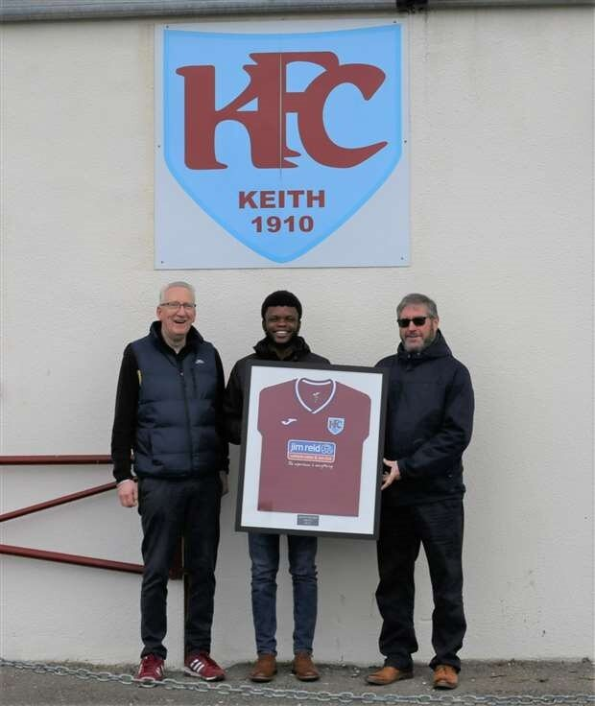

Event 1st aid service Scotland – EFAS treatment Vehicle
EFAS made an application to the Edintore Wind Farm Community Benefit Fund in August 2022 for a grant of £12,000 towards the purchase of a “suitable second-hand vehicle in order to give them independence and flexibility using the vehicle when they needed it rather than relying on the availability of a hired vehicle.”
Having their own vehicle has enabled them to keep it always stocked with their first aid equipment and ensures they are permanently event ready. The purchase of this vehicle has allowed them to treat members of the public in a more controlled clinical environment for the lifetime of the vehicle as opposed to some of the more unsanitary places they have previously been offered.
Event 1st aid will help communities develop and become more resilient and therefore better able to cope in an emergency. It has been proven that volunteering improves the mental health of individuals. Their charity encourages and supports personal development through learning enhanced first aid skills that can only be of benefit to all communities.
“We have spoken with several event organisers, especially those who are unable to provide appropriate first aid facilities for whom it will be extremely beneficial for us to have our own treatment vehicle. Being mobile would allow us to support smaller charitable events and community fundraisers.’
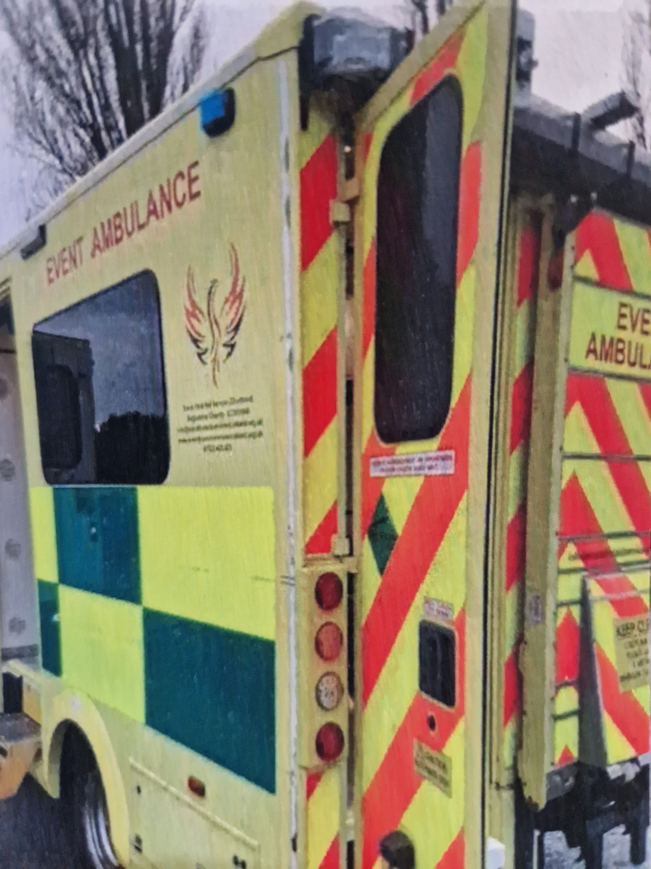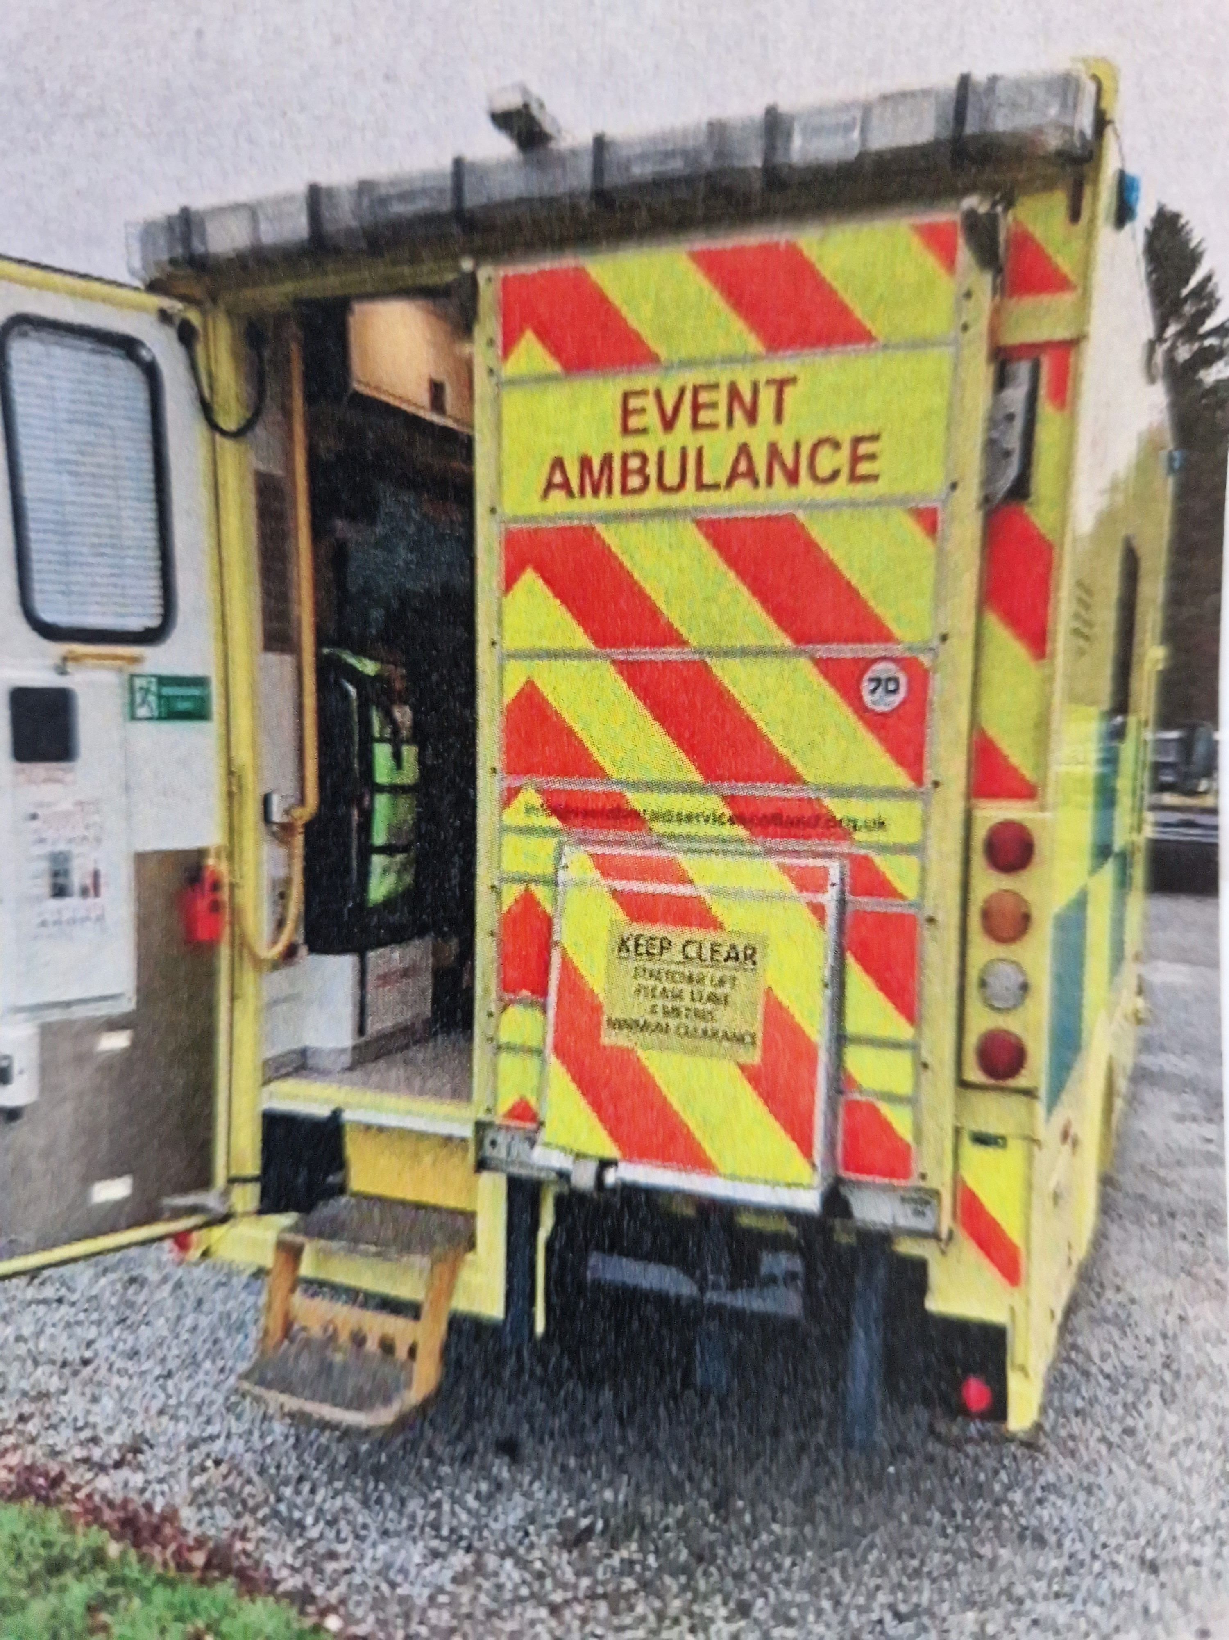

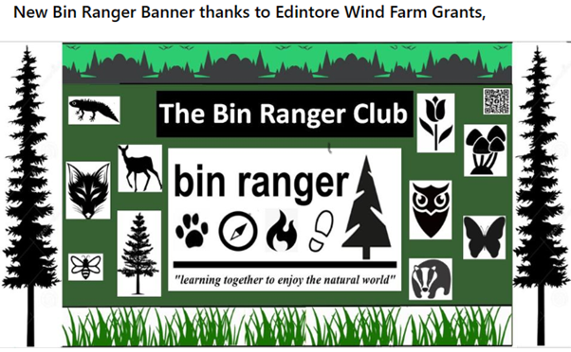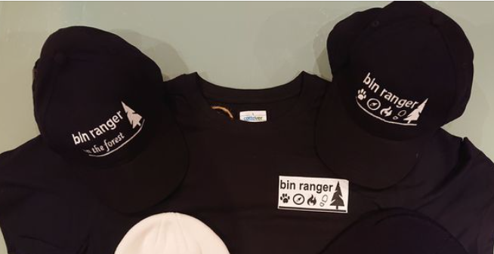
Bin Rangers Club – Learning together in the forest
The Bin rangers are a family orientated constituted community group which focuses on forest skills and activities for 6–16-year-olds to learn together and enjoy the natural world around them. They applied for funding to purchase good quality and long-lasting equipment for future and present Bin rangers.
They would like to take this opportunity to once again thank you for Edintore’s generous grant support given to the Bin Ranger Club. It has provided the club with resources which will help it to develop and grow itself over the coming years; by continuing our work to support young people in growing into confident individuals through active engagement with the natural world in which they live.

REAP – Power hub technology
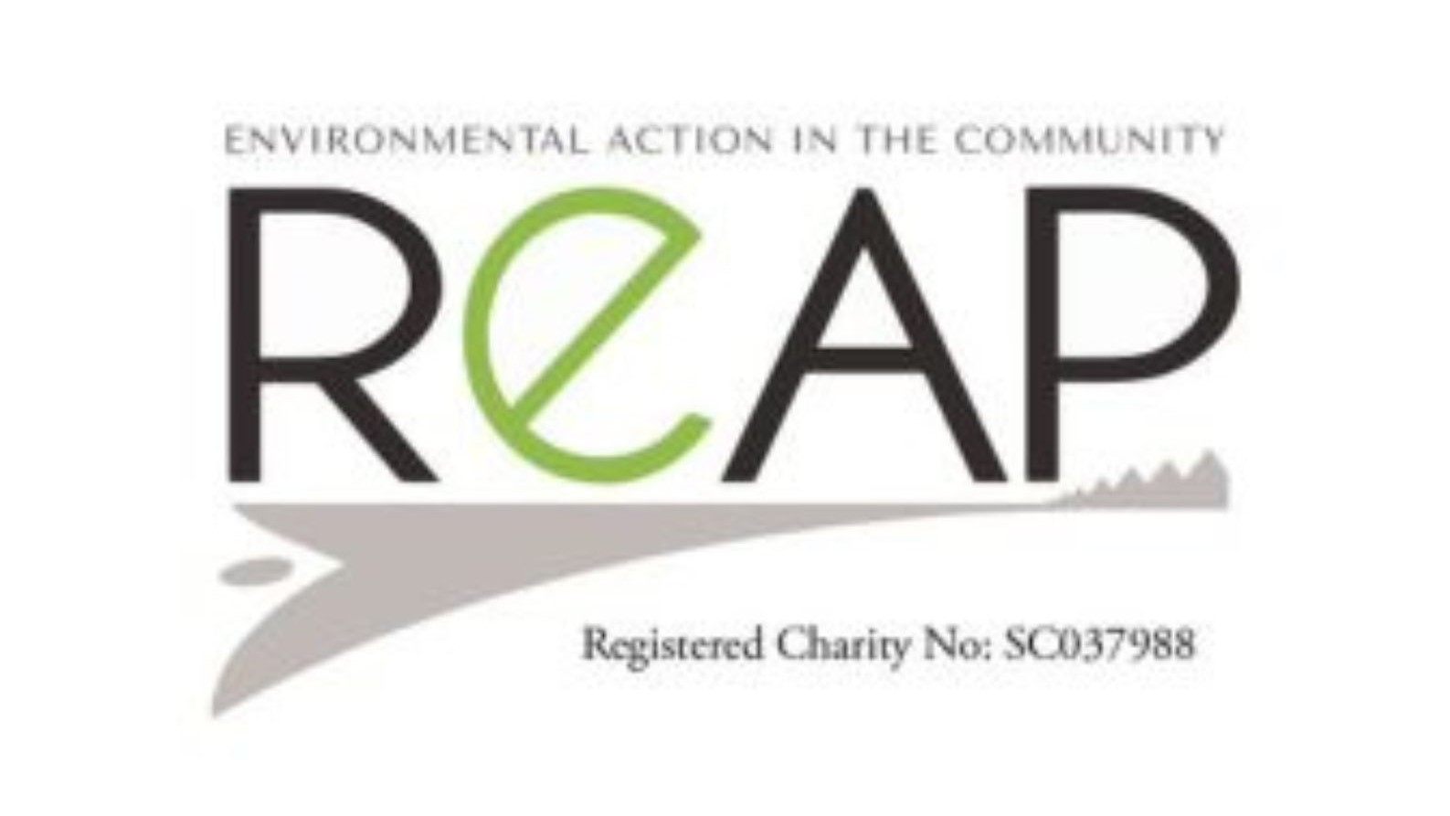
Reaps ‘Keith Community Hub’ is situated on Mid Street at their office. The power hub project provides extra help to vulnerable households and Reap’s aim with the Power hub to is to try to help and inform as many households as they can through community engagement, workshops, office appointments and events. The hub provides other organisations such as Citizen's advice and In Keiths development officer too have a presence in the community.
‘REAP would like to thank the Edintore Windfarm Community Benefit Fund for the grant that has supported their ‘Power hub’ project. As a community Hub in Keith, REAP has helped many clients with the use of these devices through office appointments, drop ins, workshops and out on the community. REAP is grateful for the support that Edintore funding has provided.’
The Loft – Winter warmers cooking
Winter Warmers project we had 27 young people in total that learned new skills in cooking soups, stovies, curries, apple pie, pasta dishes etc from scratch. The young learned a variety of skills including budgeting, most importantly they were able to take home what they cooked on a weekly basis to their families. This was a successful project and thanks to Edintore for the money to make this project successful.
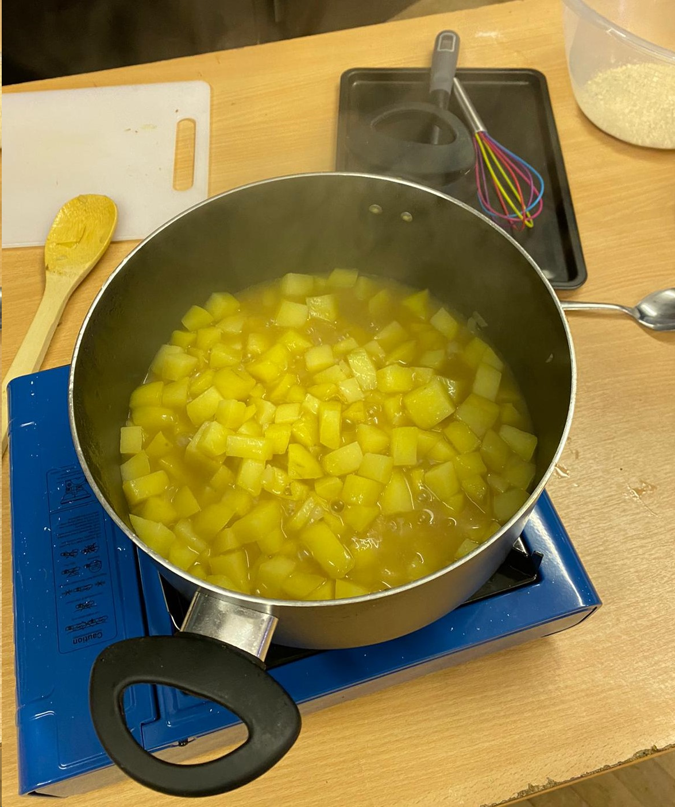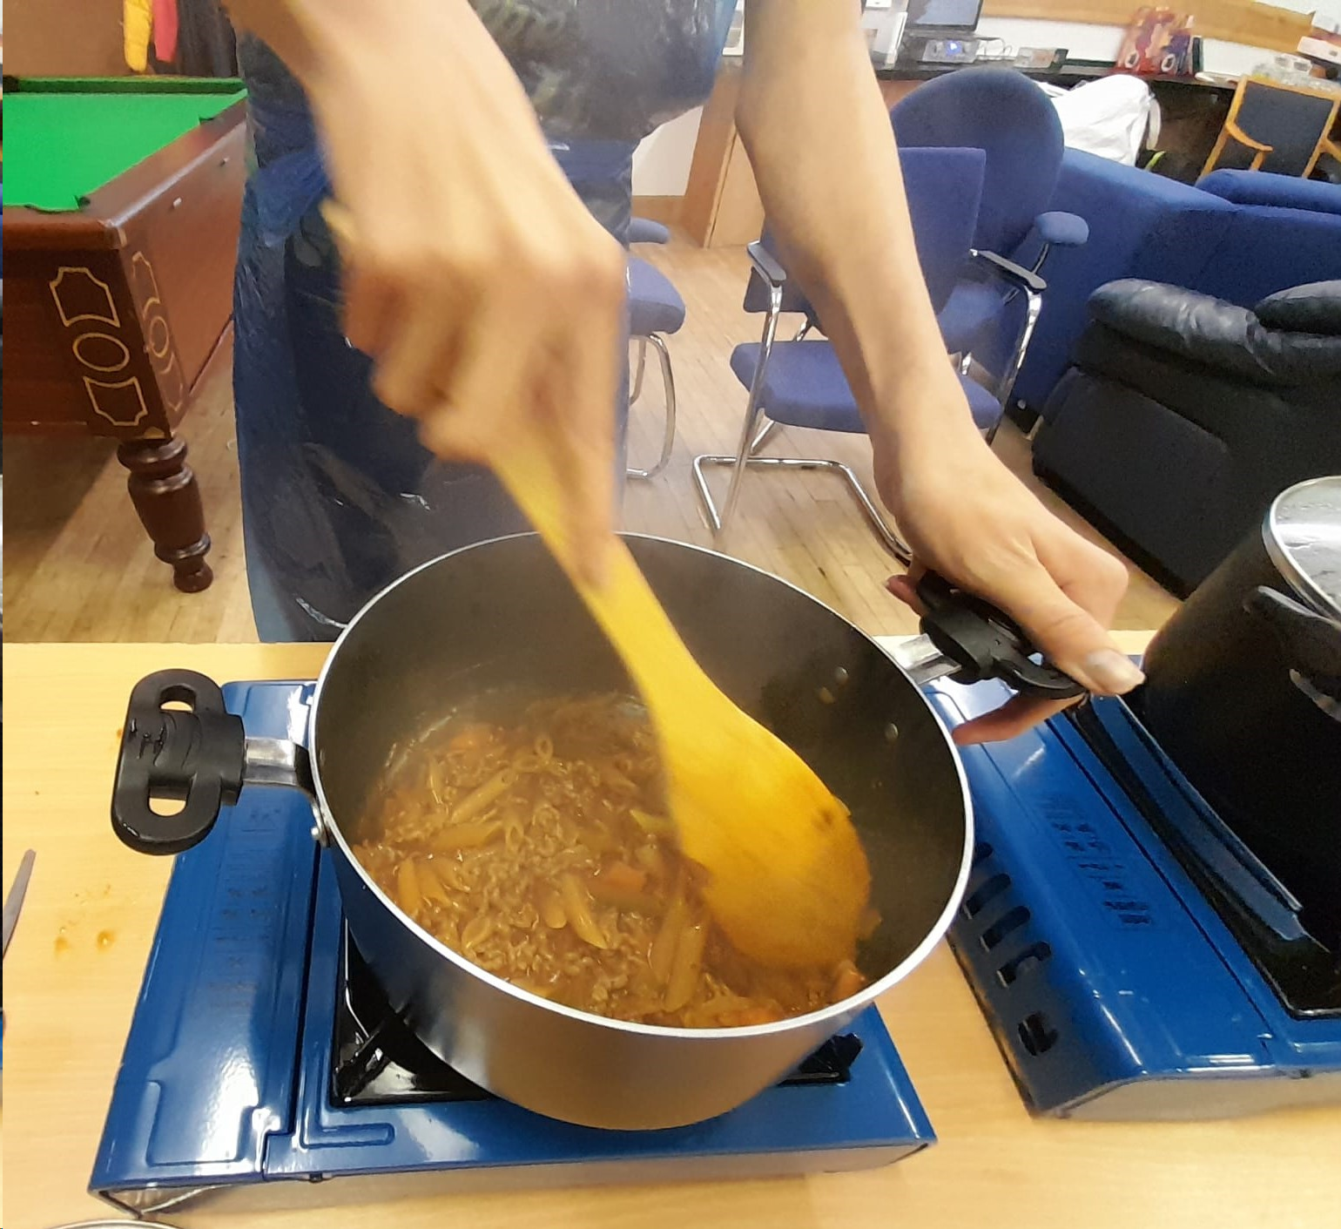

Tyred N Cranky – Pop up cycle repair
Not only did 45 people from the Keith area benefit from having their bikes repaired or serviced as a result of this project, but as a result of those 45 people not having to travel to Elgin and back twice each (once to drop off their bike and once to collect it) we have saved each of those 45 people at least two hours of their time travelling (90 hours in total), we have also saved each of them the wear and tear on their vehicles of travelling 72 miles (3240 miles in total), approximately £9 in fuel (£405 in total), and saved 0.77 tonnes of CO2 emissions. This project was in every way a success for us. We thank Edintore for funding our project.

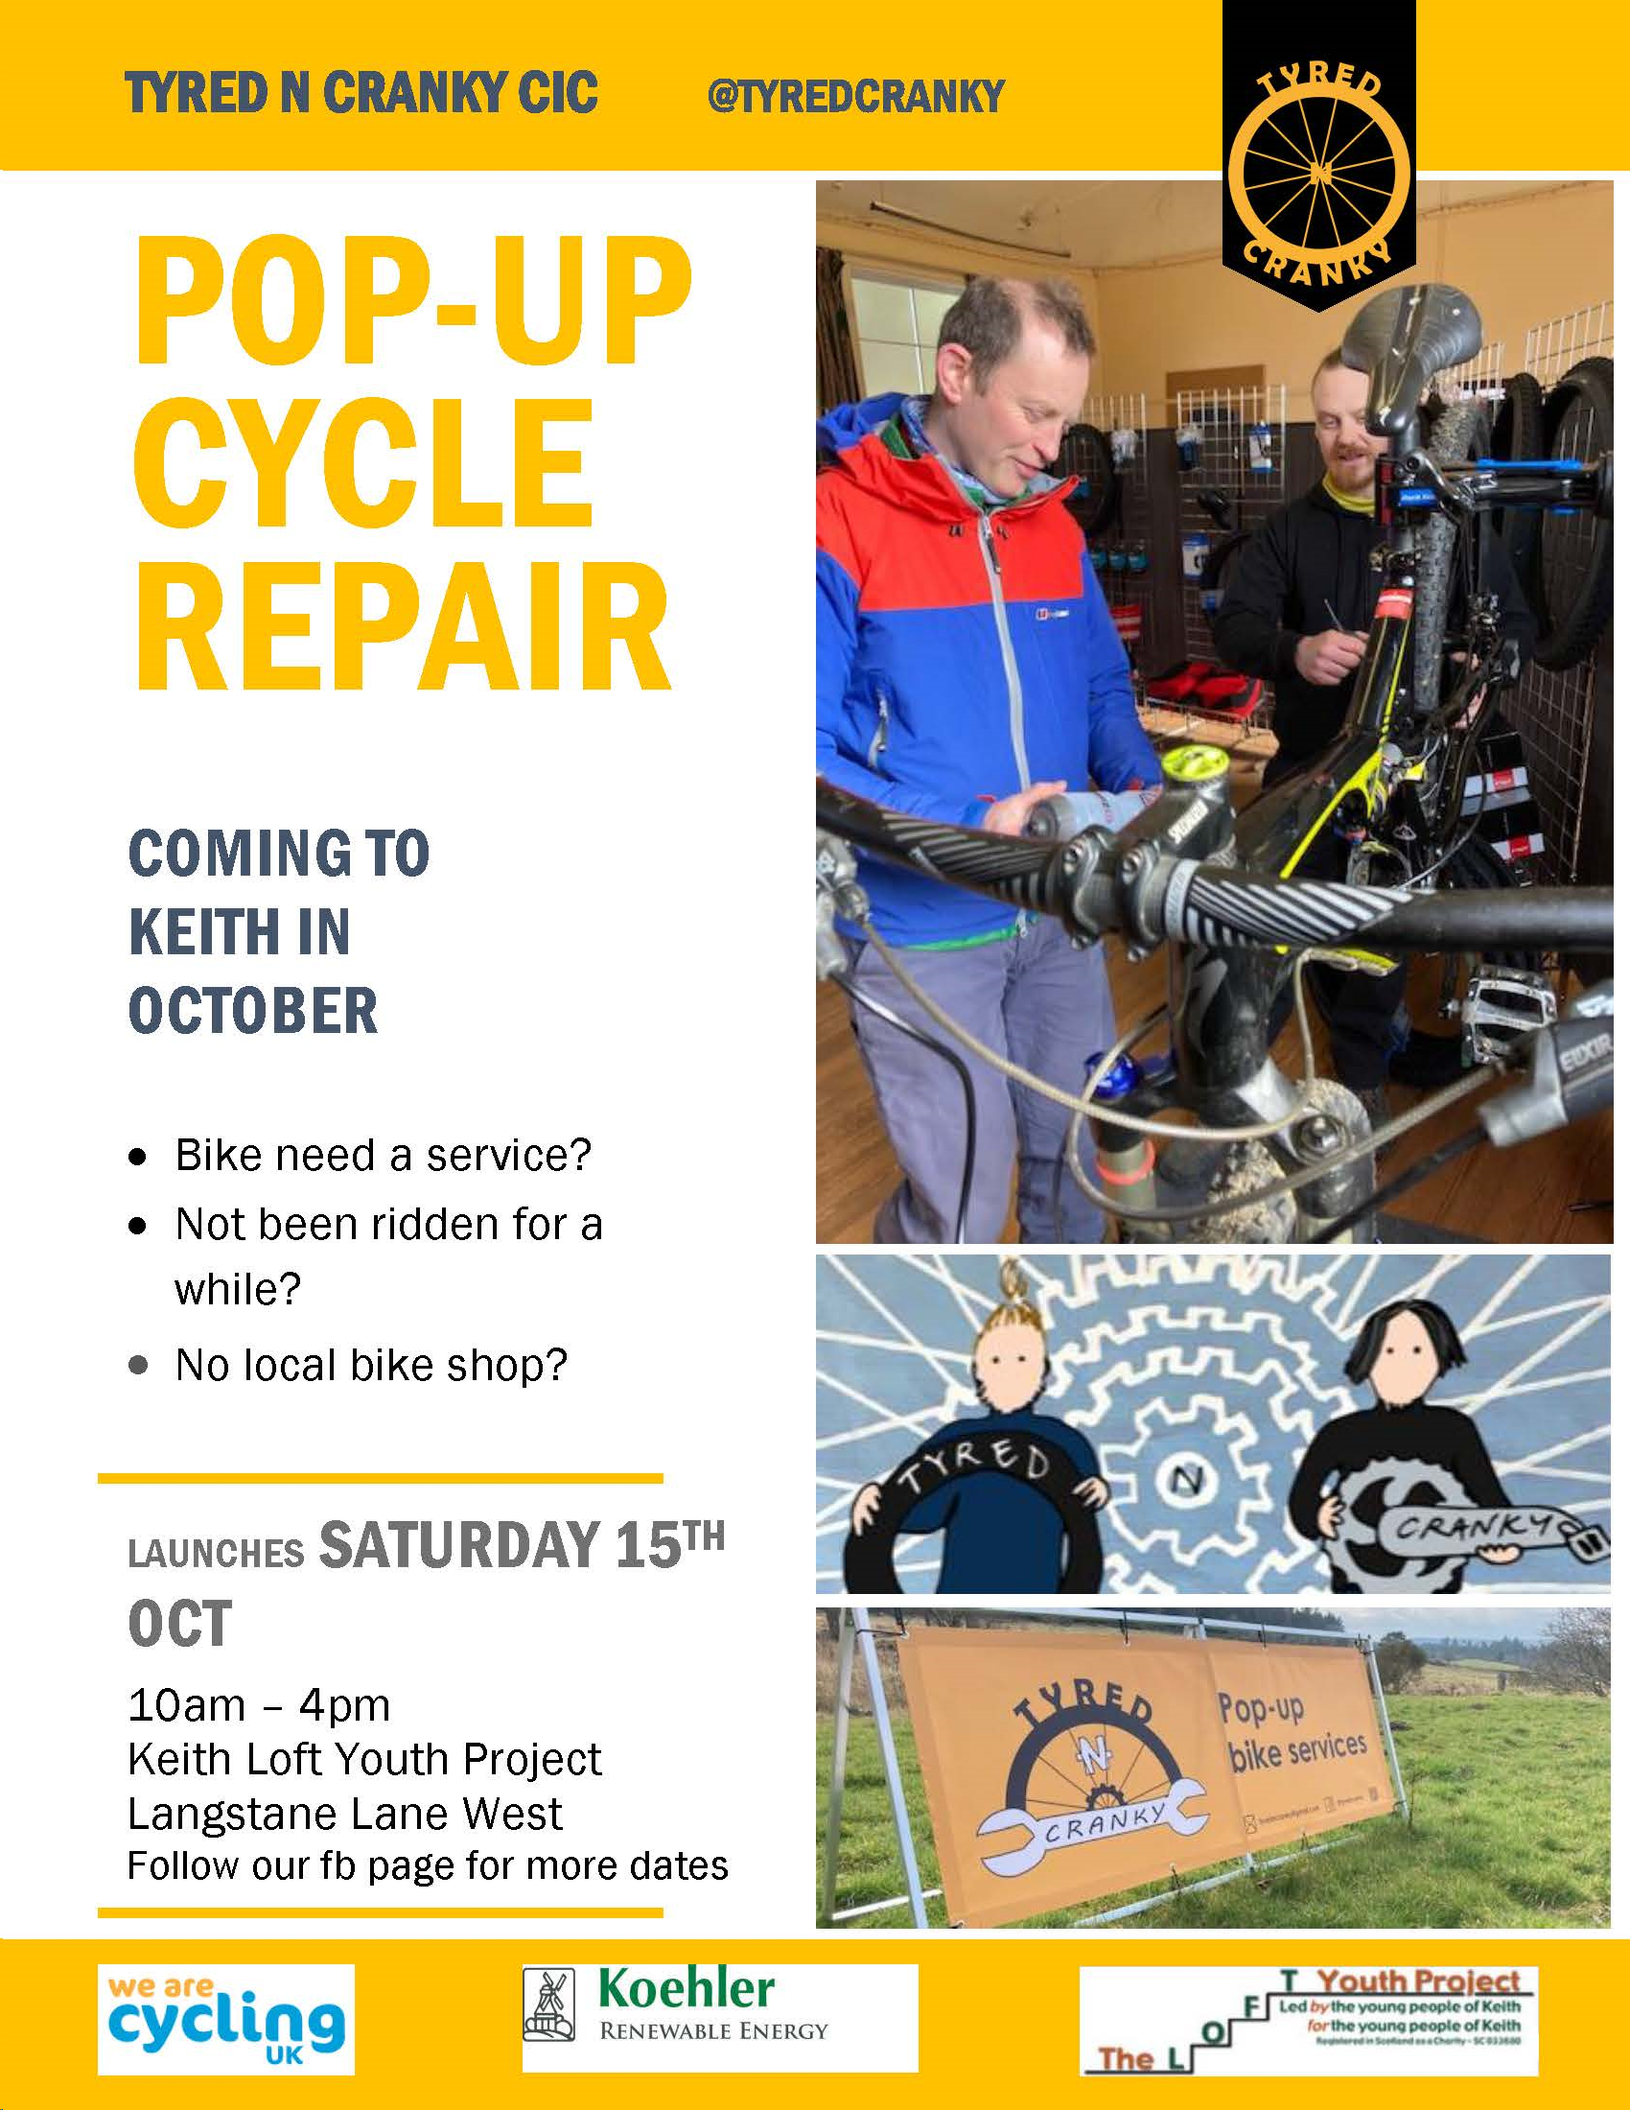

Glass Community Association – Renovations of Glass Hall and community green spaces
Glass Community Association applied for funding for their Hall in Glass. After community consultation it was found that the hall was not currently ‘fit for purpose’ and the community felt they needed to address issues and future proof the hall for generations to come. The funds from this round of the Edintore windfarm funded many parts of the stage one of their project. This included tree surgery, bat boxes, under road ducting, bill of quantities for the plans for extension and underfloor insulation. Glass Community Association thanks the Edintore Community Benefit fund for the grant that made this all possible.

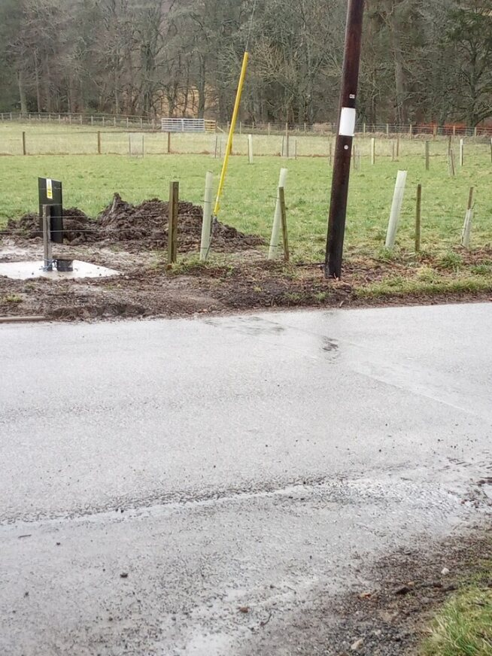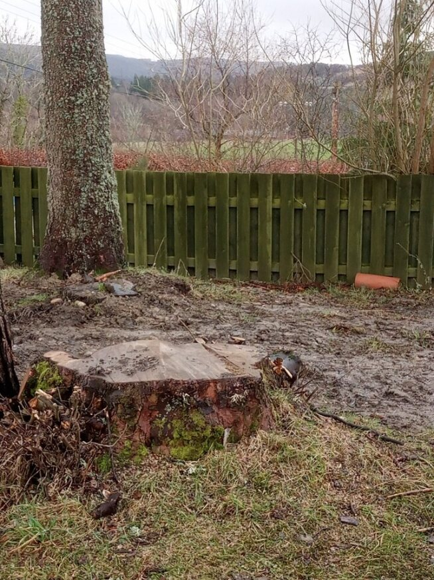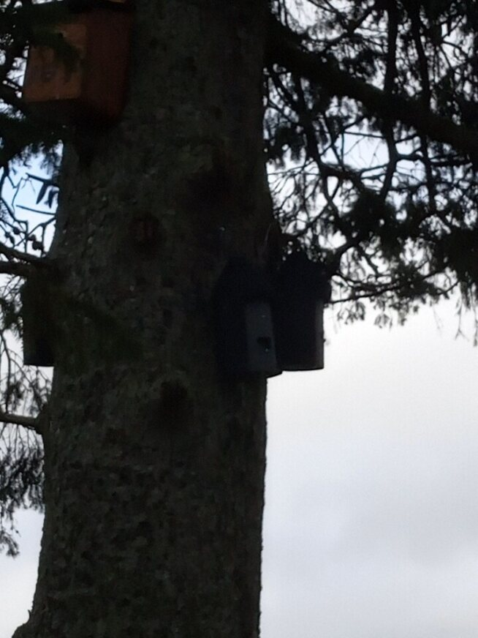
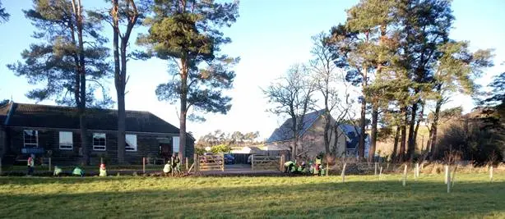

Application process and support

Application forms and guidance notes are available for download on the REAP website (www.reapscotland.org.uk) and hard copies are available on request. REAP staff are available to provide support or answer questions about the application process or forms.

Successful applicants are required to complete an end of grant report itemising grant fund spend, provide supporting evidence, and confirm the grant has been spent per their application. We also like to see photographs of the projects to add to the annual report.

Details of grants awarded award reports and minutes of decision-making meetings are available online on the REAP website.

