


Grant funding made available by Edintore Wind Farm Ltd.

Edintore Wind Farm

Community Benefit Fund 2021

Grant Awards

ROUND 4

Edintore Wind Farm Community Benefit Fund

The Community Fund is made available by the wind farm developers, Koehler Renewable Energy and Vento Ludens, Edintore Wind Farm Ltd. The fourth round of funding was awarded in August 2021. Interest in the fund was high and once again, all grant funds for the year were awarded in a single round.

Round 4

Fourteen applications totalling £121,968.54 were received. Ten from the primary area of benefit and four from the secondary area of benefit. The funds available was £123,060.92.

Eleven applicants were awarded full grant funding and three were declined and given advice. Grants totalling £95,50854 were awarded in this round.

Successful applicants

Keith Football Club | £21,951.31
Keith Men’s Shed | £27,357.60
Grange Community Association | £2,200.00
Moray Food Plus | £2,074.00
Strathisla Pipe Band | £3,855.56
Keith Royal British Legion | £10,500.00
Moray Wellbeing Hub | £998.50
Keith Golf Club | £10,000.00
St Andrews Kirk | £5,574.00
Crossroads School Council | £7,026.00
Keith Christmas Lights | £3,971.57
Total | £95,508.54

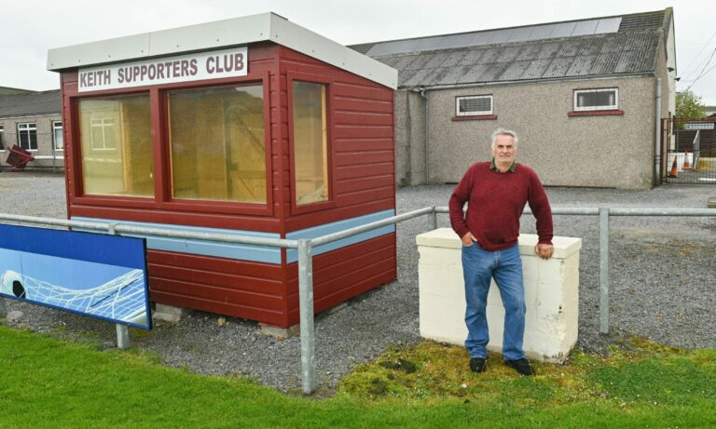
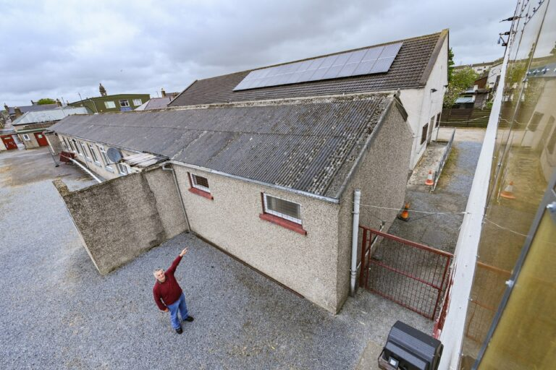
Keith Football Club – Solar Panel Installation £21,95.31

Keith Football Club applied for funding for installation of solar panels to reduce their carbon footprint at the club. They identified the importance of the use of renewable energy to reduce the negative impact of climate change and to reduce the energy costs at the club.
Club chief Andy Troup said: “One of our biggest costs as a club is electricity for heating, floodlights and that sort of thing. As a board we’ve been speaking about it for about three seasons, but when Covid hit everything was put on hold. We were very lucky to get a grant from Edintore Wind Farm Community Benefit Fund in Keith, which we’re incredibly grateful for and was a huge help. They’ve helped to pay for the solar panels and along with funding from the club we’ve managed to make this happen.”
Keith Men’s Shed – Groundworks £27,357.60
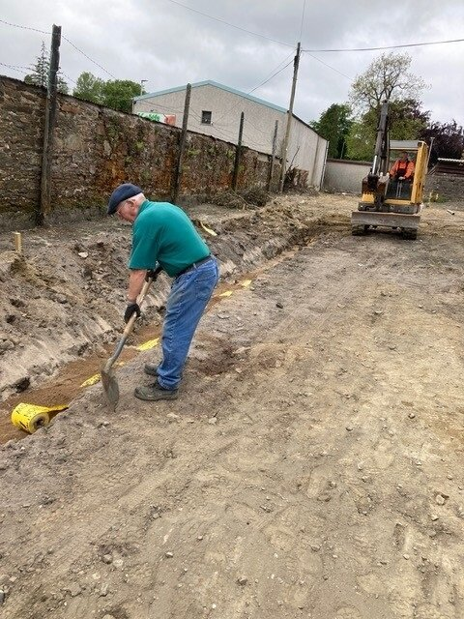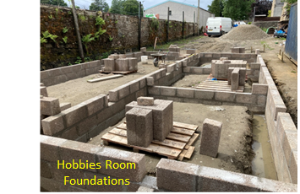

The Keith Men’s Shed applied for funding from the Edintore Wind Farm Community Benefit Fund to fund Phase 2 of the construction of our Men’s Shed buildings. Phase 2 is making the site ready for five portable cabins to be set in position on their foundations. The portable cabins were purchased back in 2017 with assistance of Edintore Wind Farm Community Benefit Fund. We have the funding in place for Phase 3, positioning the portable cabins on their foundations.
The money was awarded and used to clear and prepare the site, set out, dig and pour the foundations and build the foundations.

Grange Community Association – Ongoing Refurbishment of King Memorial Hall £2,200
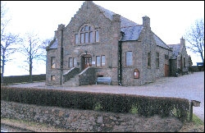

King Memorial Hall is an old stone-built property which requires continual maintenance. They applied for funding to Edintore for the on-going project to modernise and refurbish the hall. The funding of £2,200 enabled them to provide an improved and more pleasant and comfortable environment for all hall users.

Moray Food Plus – Keith Community Pantry £2,074
We launched our own mobile pantry Big Blue at the beginning of April; one of the development workers from this project worked with The Loft Youth Project to develop their own pantry following the same model.
Big Blue launched at the beginning of April 2022 and they were keen for the Keith pantry to launch around the same time to maximise impact. Moray Food Plus were also developing a pantry in Forres in partnership with Forres Area Community Trust funded by Berry Burn Community Fund and felt if all 3 projects launched within the same timeframe, they could maximise publicity across the county.

The pantry was extremely well received and feedback
has been positive. Here is what some of the participants
said about the project: “This is a great help to me on a
weekly basis for a small fee," "Great to see short-dated
food being used," and 'I enjoyed seeing a different variety
of food each week."
Moray Food Plus and The Loft Youth Project would very much like to thank the Edintore Board for their support in enabling this project to be established.

Strathisla Pipe Band was suspended in March 2020 due to COVID. The pipe band was looking to fund the refresh needed before restrictions would be lifted. They were hoping to recommence practices sometime later in 2021. As pipes had not been used for a period of time, and the applied for funding from Edintore for the equipment they needed to replace. They were successful and awarded in full.
Strathisla Pipe Band – Post Covid Refresh £3,855.56

Photo © Braemar Media
Keith Royal British Legion – Fit door & Fire Exit £10,500
The Royal British Legion in Keith applied for funding to replace the external doors of the venue as they were becoming old, unsafe and difficult for older members to use. Security was becoming an issue. As these doors were sagging at the hinges and they were worried about the winter ahead. They were awarded fully to replace the doors for future generations.
Here is what the chairman, Peter Milton had to say, ‘We must thank the Edintore windfarm for their generous grant. It has made a huge difference to the appearance of the building as well as greatly improving warmth inside. Given the cost of living and utility bill increases we are sure to get this will help greatly in reducing these running costs.’

Moray Wellbeing Hub – Keith Connect 21 £998.50
The Moray Wellbeing Hub were successful with an award of £998.50 from the Edintore Wind Farm to improve the wellbeing of children, young people and families.
This project built on the learning of a COVID recovery project ending August 2021 for the Keith and surrounding area. The activity was delivered that increased connection and empowerment of local families through use of wild swimming, nature walks and exploring setting up a parent empowerment group. This project linked with our ‘partnership working’ ongoing with partners around families that support young people with Autism and other neurodiversity challenges.
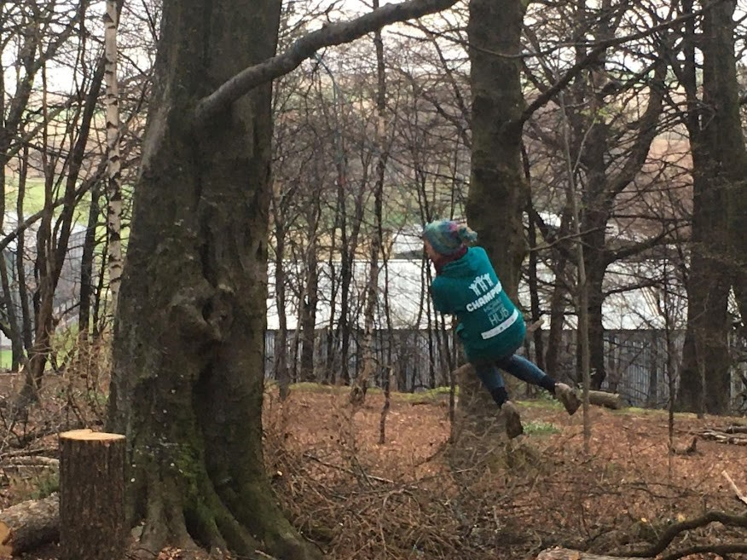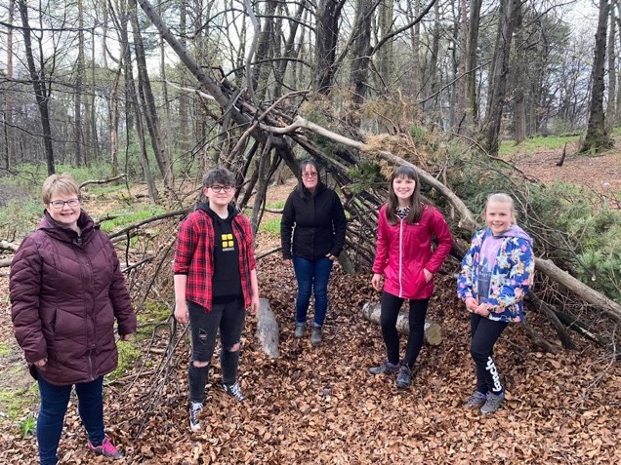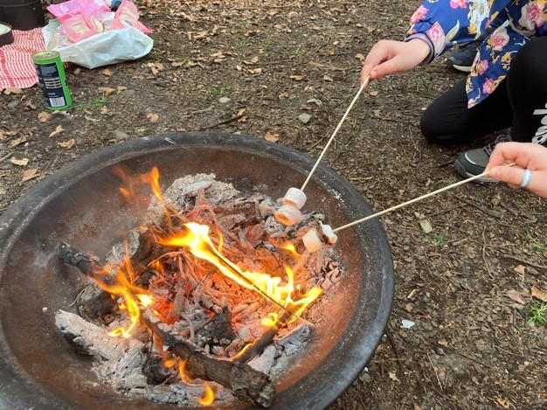
Here is what some of the participants said about the project:
‘I am an anxious person anyway I was very anxious about coming on this walk, and I am still anxious, but walking helps,’
‘Setting aside fears to a new mum ‘I wasn’t sure I would be able to come as my boy is only 5 weeks old’. Reassurance given by everyone that ‘we are all parents here and we can support each other,’
‘It was my first outing with the parent wellbeing walk. I was struck by how friendly everyone was from the get go. It was lovely that there was a group with children of ages and I’m looking forward to the 27th Feb,’
Keith Golf Club – Drainage & Waterways Renovation £10,000

Keith Golf Club applied for to part fund a mini excavator to help them carry out renovation work on they course drainage system and the ditches and waterways in the adjacent cottage woodlands.
Here is what Neil Kidd the chairman of the Golf Club said about their project, ‘This digger will be a great asset to us at Keith Golf Club, it will save us time and money to help us upgrade our various drainage systems both on and around the Golf Course.’


St Andrews Kirk – Creating Rest Room & Kitchen Facility £5,574
St Andrew's Kirk, Glass is a registered Scottish Charity created in December 2020 with the following aims: To promote the preservation of the building known as St Andrew's Church, Glass (closed by Church of Scotland in 2007 and in private ownership until 2020) as a building accessible by the public to promote the advancement of community development to promote the advancement of the arts, heritage and culture.
In addition to preserving this listed building, the charity has created a research centre for visitors and the local community to find information about their ancestors and information about Glass and the local area.
They were successful in required funding for their ongoing project to modernise the Kirk. This project would include obtaining planning permission and listed building consent and would require the services of an architect, civil engineer and quantity surveyor.
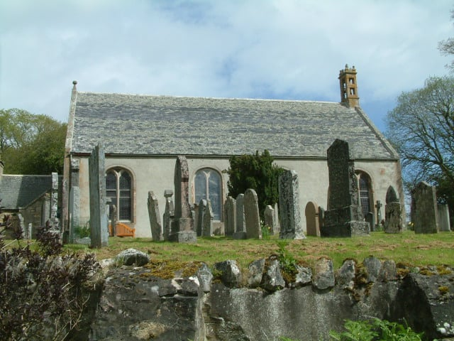

Crossroads School Council – Outdoor Shelter for Outdoor Learning £7,026
Crossroads asked for a grant to purchase a hexagonal classroom/outdoor shelter which would be situated on the tarmac in the playground and used in various ways throughout the school day.
The shelter will be: large enough to be used as an outdoor classroom, a place for the children to sit and relax/chat with friends during their break and lunchtime, an area for a child to have a quiet moment if playground games/noise becomes too much for them and a
dry/sheltered area for the cold and wetter days which they don't have at the moment.
‘A huge thank you to the Edintore Benefit Fund who awarded us a grant for an outdoor shelter for outdoor learning projects. As you can see it is perfect size for us!’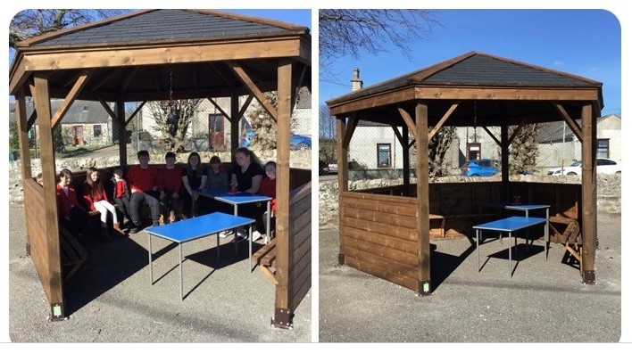

Keith Christmas Lights – Refurbishment of Brackets & Wiring
Due to wear and tear and the great Scottish weather, the brackets that hold the Fife Keith Christmas trees have deteriorated so much that they are no longer fit for purpose. They were looking for funding for materials to replace the holding brackets and re-new the wiring. Due to Covid fundraising had proved hard, as they usually fundraised with a big Christmas Extravaganza.
Amy Inglis said on behalf of Keith Christmas Lights successful application:
‘We would like to extend a big Thank You for the grant that we received from the Hilt of Towie.
This has been a massive help in bringing festive cheer to the town. We have been speaking for a few years now that the lights needed a wee revamp but due to a small volunteer group of only 3 that was a mammoth task.
In January 2022 we put out a plea for volunteers. The response to this was amazing and we manage to recruit 8 new volunteers who have been amazing. Every Wednesday we met at the shed and began the process of stripping the rope from the old lights and replacing it with new bright lights. Over the weeks we saw huge progress to the volume that we could get through with the additional help and we managed to basically re-wire the majority of the lights. They look so much better and brighter.
In December when they were all switched on we received amazing feedback from the people of Keith and also outsiders who complimented our work.

Our volunteers are still very keen to be helping so this year we are looking for other ways to help out the community.’

Application process and support

Application forms and guidance notes are available for download on the REAP website (www.reapscotland.org.uk) and hard copies are available on request. REAP staff are available to provide support or answer questions about the application process or forms.

Successful applicants are required to complete an end of grant report itemising grant fund spend, provide supporting evidence, and confirm the grant has been spent per their application.

Details of grants awarded, award reports and minutes of decision-making meetings are available online on the REAP website.

