


Grant funding made available by Edintore Wind Farm Ltd.

Edintore Wind Farm

Community Benefit Fund 2019

Grant Awards

ROUND 3

Edintore Wind Farm Community Benefit Fund

The Community Fund is made available by the wind farm developers, Edintore Wind Farm Ltd. The funding was awarded in May 2019. Interest in the fund was high and once again, all grant funds for the year were awarded in a single round. A second meeting was held in October 2019 to review the processes and procedures and set the next application deadline.

Round 3

Interest in the fund was high and once again, all grant funds for the year were awarded in a single round. Nine applications totalling £82,867.99 were received, eight from the primary area of benefit and 1 from the secondary area of benefit. The available grant was £69,844.77.

Seven applicants were awarded full grant funding, one with a condition, and two were declined and given advice. Grants totalling £65,480.00 were awarded in this round.

Successful applicants

Keith Rollerbladers & Skaters | £7,780.00
Dufftown Royal British Legion | £20,000.00
Keith Royal British Legion | £7,000.00
Keith Golf Club | £10,000.00
Strathisla Pipe Band | £5,000.00
Trefoil Guild | £700.00
Longmore Hall | £15,000.00
Total | £65,480.00

Keith Rollerbladers & Skaters were awarded £7,780 towards refurbishing the skate park
KeRBS are continuing with the phased improvement of the Skate Park, expanding and building on the ramps installed so far. They continue to consult with park users and ramp suppliers to extend and improve the skate park and make it useful to young people of all abilities.
Some of the young people who use the park sit on the KeRBS committee and continue to have fundraising events, littler picks and do outreach work.

Dufftown Royal British Legion was awarded £20,000 towards the costs of a refurbishment project
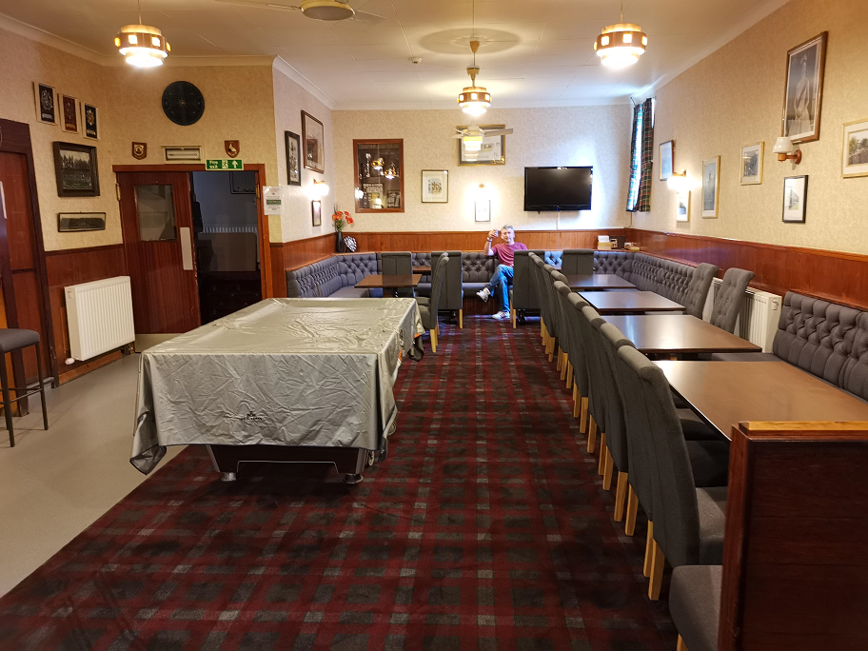
Dufftown Legion is a very well used building hosting many community groups, exercise classes
The building had not had work done for some time and had poor disabled access so it was decided to apply for funding to improve the entrance, hall and toilets.
In just a few months, some of the work was completed, in spite of the discovery that part of the roof was not watertight. The Committee dealt with this unexpected expense and pushed on.
By October a disabled toilet was installed, the hall and lounge refurbished and work was about to start on refurbishing the main toilets. Success with this first application was a confidence boost for the Legion committee. They continue to seek further funding for more refurbishments to the building and the car park, working hard to improve the building and the Legion’s sustainability for the community.
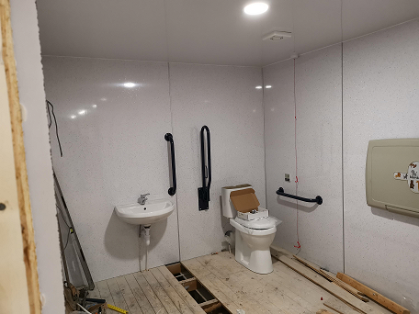
Keith Royal British Legion was awarded £7,000 towards the costs of refurbishing the toilets
Keith’s Royal British Legion also suffered from outdated toilets with poor disabled access. Having successfully upgraded the kitchen, improving the toilets was next on the list. The grant provided major match funding and along with another grant and some of the Legion’s own funds means the toilets have been upgraded to a modern standard and look very attractive. The photos show before and after facilities, including an unusual and creative use for beer kegs.
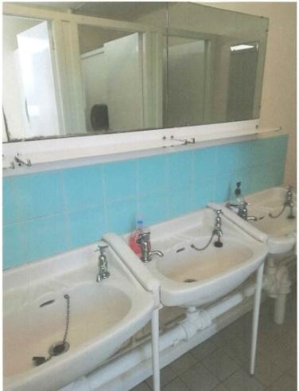
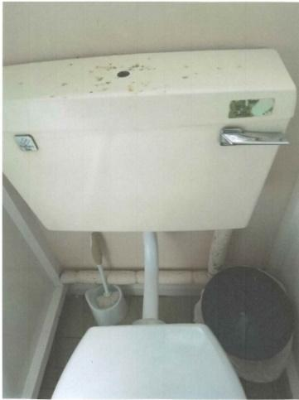
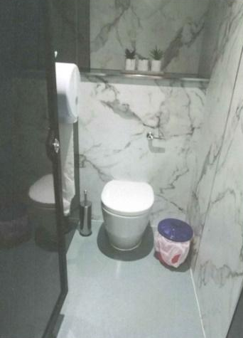
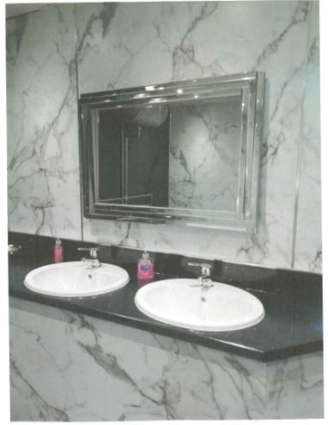
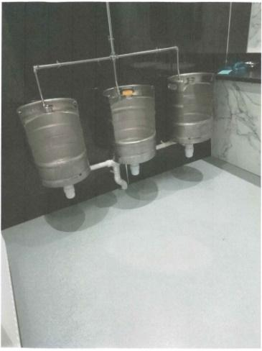
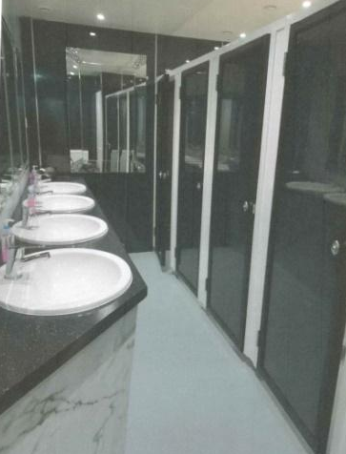
Keith Golf Club was awarded£10,000 for a Ride on Mower Keith Golf Club purchased a ride on mower to contribute to course maintenance. Volunteers contributed to this plan by offering to service and maintain the machinery free of charge. The Course Manager said, “This mower has been a fantastic addition to our machinery fleet, which will help us keep our greens in the best condition possible for years to come. Without this grant, it would not have been possible for Keith Golf Club to purchase this machine.”

Strathisla Pipe Band was awarded £5,000 towards the costs of a Massed Pipe Band Event as part of their Centenary Celebration
Strathisla Pipe Band turned 100 years old in 2019 and planned several events to celebrate. One of these was to invite local pipe bands to a massed band event at the launch of the 2019 Keith Show. Over 100 musicians from 9 local pipe bands marched and played despite some rain and wind.
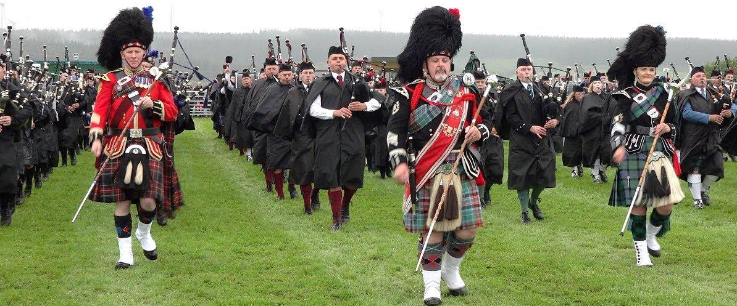
Photo © Braemar Media
Keith Trefoil Guild was awarded £700 for a laptop and projector
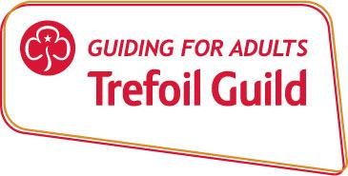
The Trefoil Guild is a branch of Girl Guiding for members aged 18 and upwards. The Keith Guild has several members and requested a grant for a laptop and projector to allow them to have speakers at Guild meetings. They plan to loan the equipment to other local groups where needed.
Longmore Hall was awarded £15,000 towards the costs of sound and lighting equipment) as part of the Longmore Hall Improvement Project
The Hall committee has planned a large programme of refurbishment of the Longmore Hall, while working towards returning it to community ownership. The grant application to Edintore Community Benefit Fund was to order and install new lighting and sound equipment.

Improving the stage and facilities should lead to increased hires and increase the sustainability of the Hall. Local artists and art groups are keen to display work in the hall and will help with siting and fitting of the picture rails.
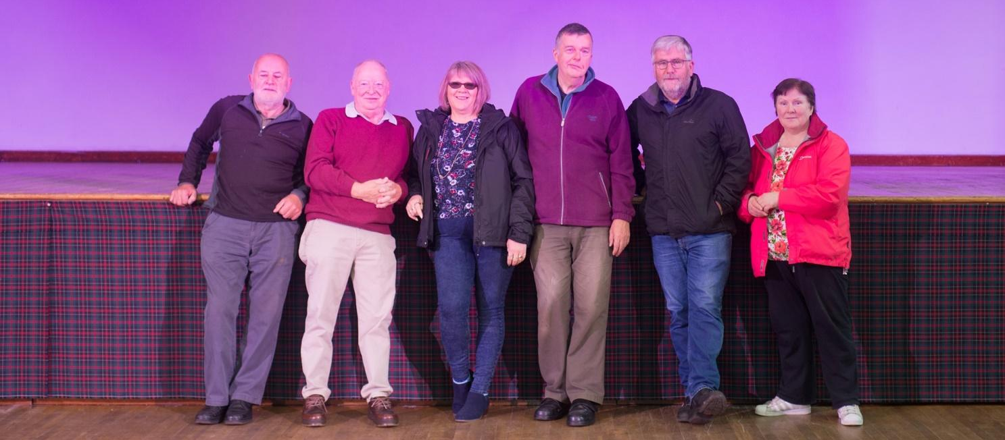

Application process and support

Application forms and guidance notes are available for download on the REAP website (www.reapscotland.org.uk) and hard copies are available on request. REAP staff are available to provide support or answer questions about the application process or forms.

Successful applicants are required to complete an end of grant report itemising grant fund spend, provide supporting evidence, and confirm the grant has been spent per their application.

Details of grants awarded, award reports and minutes of decision making meetings are available online on the REAP website.

Edintore Community Benefit Fund Rounds 1 - 3 Distribution

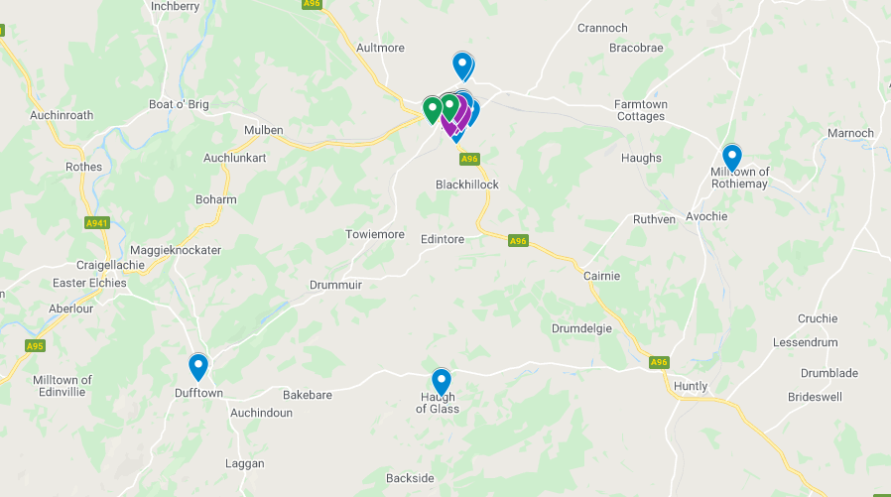

Several applications benefitted a wider area or were potentially of benefit to the whole fund area.

Four applicants were awarded grants from two rounds of funding.

Two applicants were awarded grants from all three rounds of funding.

