


Grant funding made available by Edintore Wind Farm Ltd.

Edintore Wind Farm

Community Benefit Fund 2018

Grant Awards

Round 2

Edintore Wind Farm Community Benefit Fund

The Community Fund is made available by the wind farm developers, Edintore Wind Farm Ltd. The second round of funding was awarded in May 2018. Interest in the fund was high and once again, all grant funds for the year were awarded in a single round. A second meeting was held in October 2018 to review the processes and procedures and set the next application deadline.

Round 2

A total of 13 applications totalling £92,201.03 were received. The available grant was £64,926.70. Eleven applications were awarded their grant funding in full, one was awarded a partial grant, conditional on securing match funding and one was declined. Grants totalling £59,701.03 were awarded.

The applicant that was part funded and the applicant that was declined were signposted to sources of further support and potential match funders.

Successful applicants
Keith & Dufftown Railway Association | £2,495.00
Keith Community Radio Ltd | £597.60
George V Memorial Field Rothiemay Trust | £10,000.00
Edinburgh International Science Festival | £2,000.00
Keith Golf Club | £10,000.00
Keith & Dufftown Railway Association | £3,630.00
Keith Royal British Legion | £6,000.00
Keith & District Men's Shed | £5,228.43
Longmore Hall Steering Group | £500.00
Keith & Strathisla Regeneration Partnership | £5,500.00
Moray School Bank | £3,750.00
Keith Country Show | £10,000.00
Total awarded | £59,701.03

Keith and Dufftown Railway Association was awarded £2,495.00 to print a ‘Tales with Trains’ book and £3,630.00 to replace the windows in Keith Town Train station
The original Keith Town Station was constructed by the Great North Railway of Scotland in 1862 but latterly was removed by British Rail. KDRA volunteers built and exact replica of the original station which, other than the windows, which were of plastic construction. These did not retain heat well and meant the station required a lot of heating. KDRA applied for grant funding to put in double glazing units to improve the environmental impact of the station and help it look more like the original.

KDRA also applied for funding to print a book, called ‘Tales with Trains’, written by one of the volunteers. This is a compilation of stories and memories about railways and journeys from members of our local community and further afield, particularly in the Highlands and North East. This book of archive materials will feature in the Railway’s heritage centre and book sales will also help provide funds for the ongoing needs of the Railway.

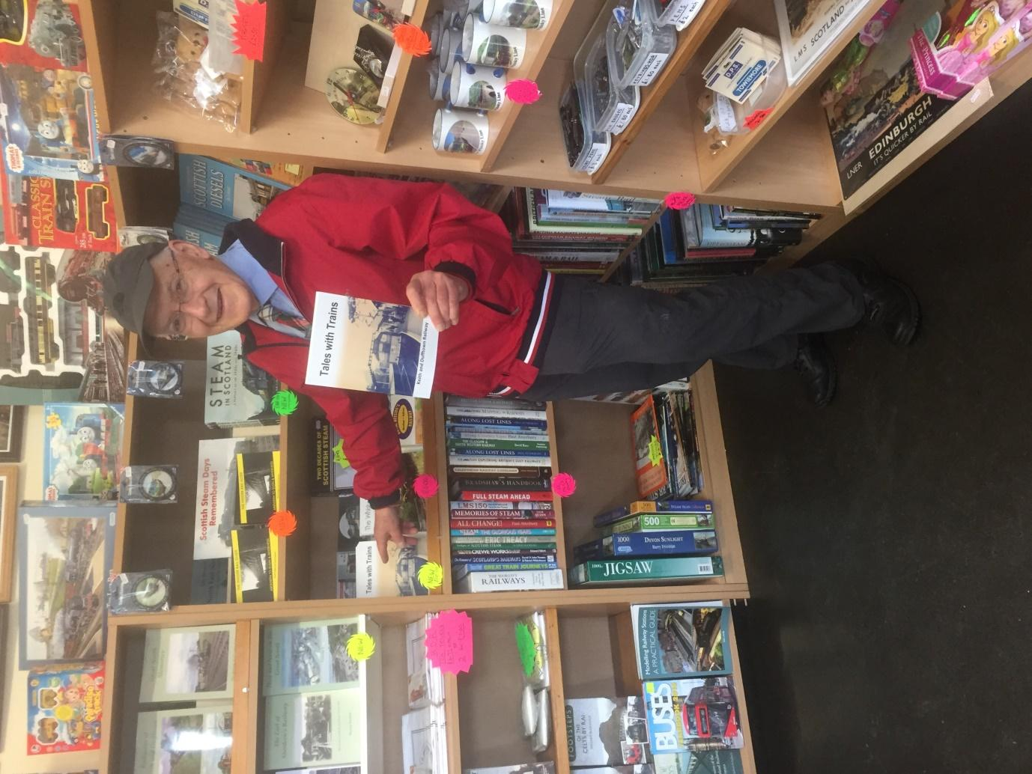
Tales with Trains on display at Keith Town Station

Keith Community Radio was awarded £597.60 for branding including sweatshirts

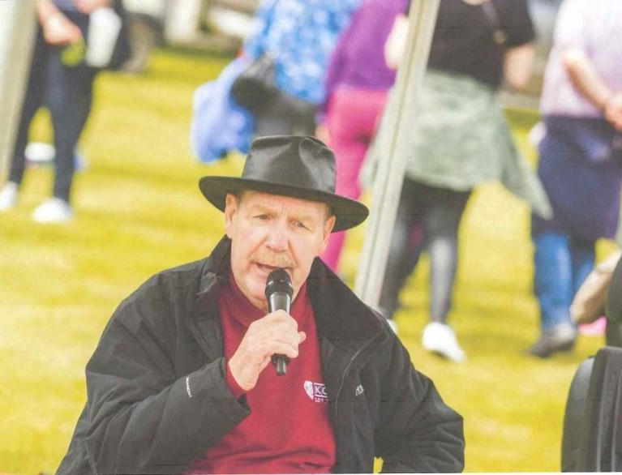
KCR applied for a grant to purchase branded sweatshirts to raise the profile of the radio and to give their volunteers a sense of belonging and pride.

As the radio also lends its expertise and outdoor broadcast equipment to community groups, the branded tops will increase other organisations’ awareness of this service when they see equipment being set up.

KCR Director John Seivwright hard at work at Gordon Castle games

George V Memorial Field Rothiemay Trust was awarded £10,000.00 towards the cost of converting The Lossat Building

The Lossat was originally a farm but was bought for community use in 1949, with the aid of a grant from The King George’s Fields Foundation and £1,000 raised by the community.

The building and sports field are held in trust for the community. Trustees carried out community consultation on how best to develop the building to better fit the current needs of the community. Several ideas were explored and the final proposal was to develop the building into self-catering accommodation and an adjoining community room that could be used as a studio or gallery in conjunction with the house, or separately as a venue for meetings, mobile hairdresser etc.

Due to high demand on the fund, the application was part funded and the Trust has been applying for match funding. They have updated their plans to complete the community room only if funding is not available for the whole project.

Edinburgh Science Festival was awarded £2,000.00 towards the costs of ‘Generation Science’

Generation Science brings unique science lessons directly to classrooms all over Scotland with a programme of interactive shows and hands-on workshops each year. Edinburgh Science Festival applied for funding to deliver sessions in local primary schools. In total, 158 pupils from Botriphnie Primary School, St Thomas Primary School, Newmill Primary School and Keith Primary School attended workshops on a range of technical and scientific topics.

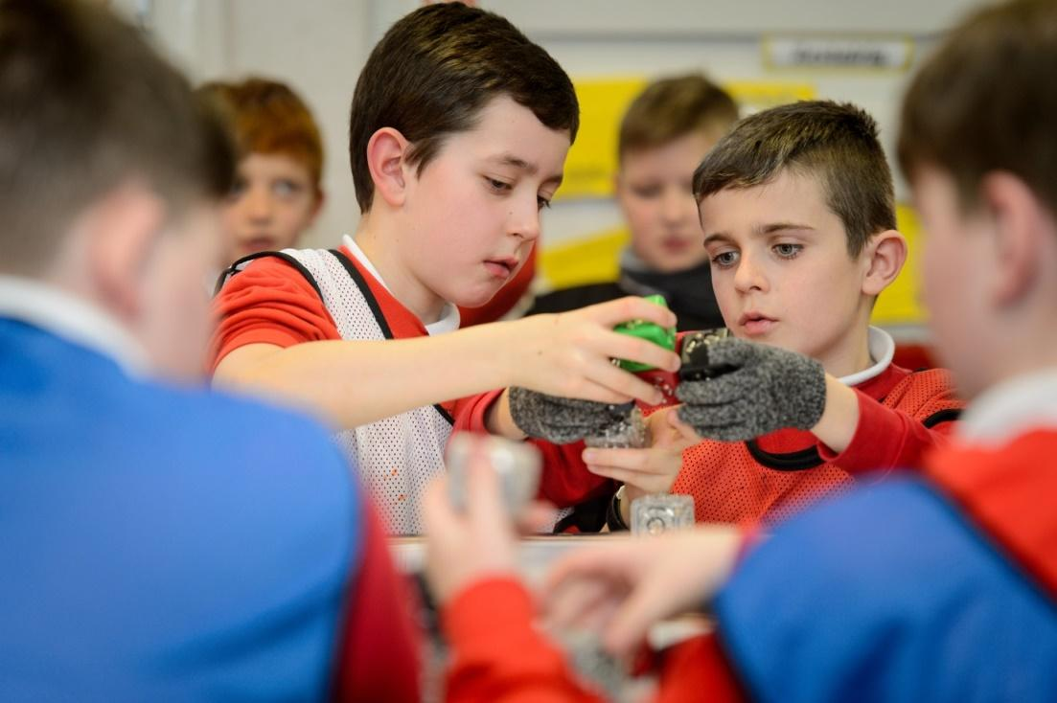

Generation Science said,

“Edintore Wind Farm Community Benefit Fund directly supported 4 workshops in schools surrounding the wind farm, enabling us to reach some of Scotland’s most rural schools that would not otherwise have experienced a Generation Science Workshop.”

Keith Golf Club was awarded £10,000.00 towards the costs of replacing the Clubhouse flat roof

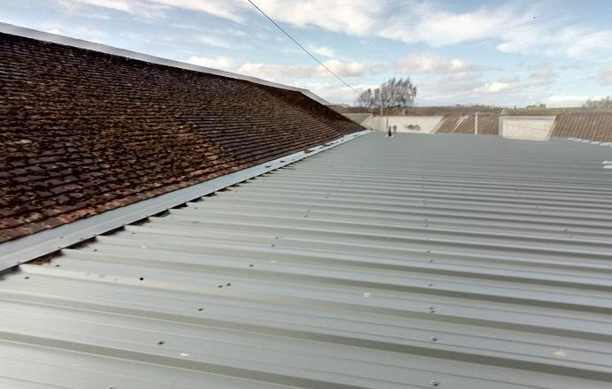
The Golf Club is a not for profit organisation based in Keith. As well as running the Golf Club, the Club house is made available free of charge to other groups who need a fundraising venue e.g. for quiz nights.

A leak alerted committee members to a problem with the flat roof and investigation found that a significant amount of work was needed and insulation would need to be replaced.

The grant funding was supplemented by volunteer labour from Club members, including retired tradesmen. The roof was repaired, insulation upgraded and the ladies’ changing room where the leak had stained the wall was refreshed and repainted.

This work not only helps with the environmental footprint and heating of the club house, but keeping the facilities in good order helps retain and attract members, which is essential for the club.
Keith Royal British Legion was awarded £6,000.00 towards the cost of refurbishing the kitchen
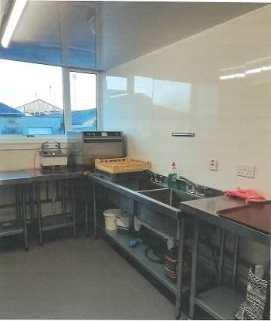
As well as being open to veterans and their families, the Legion in Keith is a well-used community venue for funerals, classes, parties and other events. It also provides outside catering.

The aging kitchen was in need of upgrading, to allow for more efficiency and safety but also to comply with current regulations.

“The funds will go towards the costs of the rewiring and installation costs of our upgrade, which is much needed to keep up with today’s standards.”

The Legion applied for match funding, undertook fundraising activities and used some volunteer labour to cover the estimated total costs of this project of £25,000.

The Legion Secretary said, “Thanks for your support of our project and for your continued support of the Keith and surrounding community. It is very much appreciated.”

Keith & District Men's Shed was awarded £5,228.43 for a shed heating system

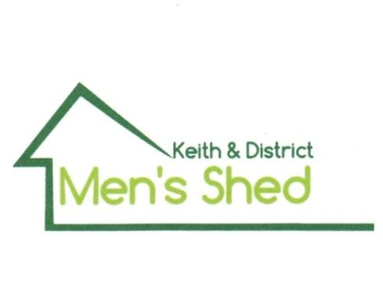
The local Men’s Shed continued with plans for their premises and work shop using portacabins. The Shedders made it clear to the committee they would need to be warm and comfortable whether socialising or working in the Shed premises.

Some of the Keith Shedders visited Inverurie Men’s Shed and witnessed their stove in action. As it had good reports on efficiency and performance, the Keith Men’s Shed plan to fit the same model. Once their premises have passed Planning requirements and are in situ, Shedders will be able to work on their own projects and share their skills. They are also discussing handyperson or repair work they can do in the community. Keeping the Shedders healthy in a warm environment and socially active should be of benefit to the whole community.

Longmore Hall Steering Group was awarded £500.00 for a fighting fund

As a result of local authority budget cuts, several halls in towns and villages could no longer be subsidised. There was strong support from the community that Longmore Hall should remain open and a group of volunteers negotiated with Moray Council to take on the running of the hall.

The Chair said,

“The grant allowed us to fund the printing of flyers and business cards that have been used at a number of events. The usage of the hall has increased… and we are continuing the process of transfer of ownership/title back to Keith. Thank you again for your support.”

Keith & Strathisla Regeneration Partnership was awarded £5,500.00 for the InKeith website and promotion

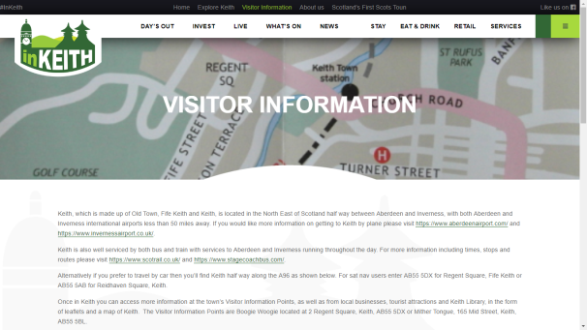
Keith & Strathisla Regeneration Partnership (KSRP) works to support economic development in the area and support other groups in the area.

It was previously funded by the Moray Towns Partnership but this fund was withdrawn as a result of local authority budget cuts.

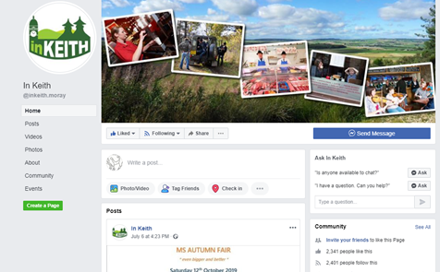
Having just employed a new web and social media editor and with plans to upgrade the website, this cut left useful resources at risk.

The grant awarded has allowed KSRP to complete the upgrade to the website and to continue to share information about businesses and community groups, events and news and to continue the employment of the editor to promote useful information.

Moray School Bank was awarded £3,750.00 for school uniforms and equipment

The School Bank applied for funding for ‘Back to School 2018’ with the aim of providing school uniforms and warm winter clothing to families facing hardship. They accept referrals from a wide range of support organisations and tailor their service to young people to ensure they are happy with their uniform and feel comfortable and confident to return to school in the new term.

Since becoming established in January 2017, more than double the expected referrals have been received due to rising numbers of children living in poverty. As awareness of this local charity continued to increase, referrals also increased. The application was made to supply uniforms and equipment to children in and Keith with an estimated cost of £150 per child. Having a school uniform and equipment helps children’s wellbeing and avoids stigma.

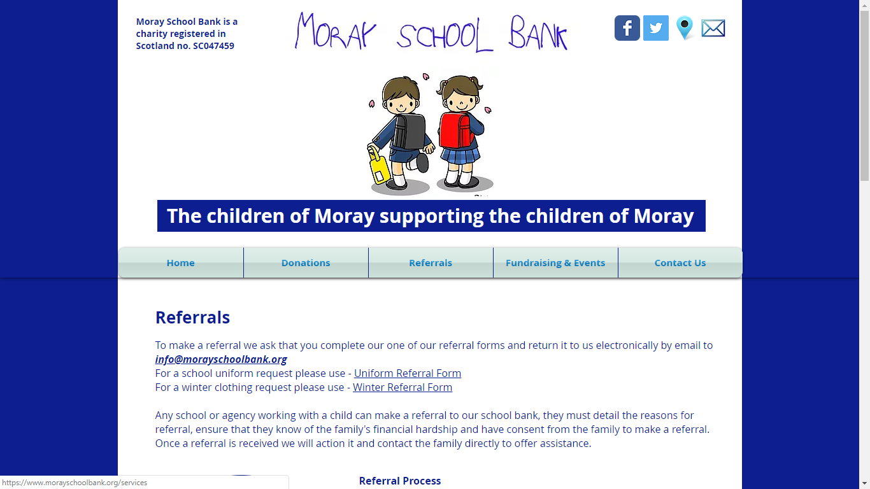

Keith Country Show was awarded £10,000.00 towards the cost of power distribution for the show park

Keith Country Show is a not for profit company that runs the Keith Show each year. The show ground at Seafield Park is also used for other events throughout the year. The show had previously secured funding to provide a mains connection to the Show Park. This second phase is to provide a permanent power supply throughout the park and do away with the need to hire generators and use surface mounted wiring. This not only improves the costs for users of the show park, it should also reduce the environmental footprint.
The funding applied for was supplemented by volunteer labour to backfill trenches etc. and the contractors factored this into their quotes.

Application process and support

Application forms and guidance notes are available for download on the REAP website (www.reapscotland.org.uk) and hardcopies are available on request. REAP staff are available to provide support or answer questions about the application process or forms.

Successful applicants are required to complete an end of grant report itemising grant fund spend and confirming the grant has been spent per their application.

Edintore Wind Farm Community Fund - INCOME & EXPENDITURE
INCOME |  |  | EXPENSES
Date | Amount £ | Income Details | Date | Amount £ | Details
01 January 2018 | 0.50 | interest
02 January 2018 | 70,500.00 | Grant
01 February 2018 | 1.08 | interest
 |  |  | 05 February 2018 | 5,900.00 | REAP Fees
01 March 2018 | 2.97 | interest
 |  |  | 15 March 2018 | 0.10 | charges
01 April 2018 | 3.25 | interest
 |  |  | 16 April 2018 | 0.20 | charges
01 May 2018 | 3.14 | interest
 |  |  | 09 May 2018 | 500.00 | Longmore Hall Steering Group
 |  |  | 09 May 2018 | 6,000.00 | Royal British Legion Keith
 |  |  | 09 May 2018 | 597.60 | Keith Community Radio
 |  |  | 09 May 2018 | 10,000.00 | Keith Golf Club
 |  |  | 09 May 2018 | 3,630.00 | Keith & Dufftown Railway Association
 |  |  | 15 May 2018 | 0.10 | charges
 |  |  | 16 May 2018 | 3,750.00 | Moray School Bank
 |  |  | 23 May 2018 | 2,000.00 | Edinburgh Science Festival
 |  |  | 23 May 2018 | 5,500.00 | Keith & Strathisla Regeneration Partnership
 |  |  | 23 May 2018 | 5,228.43 | Keith & District Men's Shed
01 June 2018 | 2.35 | interest
 |  |  | 05 June 2018 | 10,000.00 | Keith Country Show
 |  |  | 15 June 2018 | 0.90 | charges
01 July 2018 | 1.26 | interest
 |  |  | 16 July 2018 | 0.10 | charges
01 August 2018 | 1.24 | interest
 |  |  | 15 August 2018 | 2,495.00 | Keith & Dufftown Railway Association
01 September 2018 | 1.18 | interest
 |  |  | 17 September 2018
01 October 2018 | 1.10 | interest
01 November 2018 | 1.14 | interest
 |  |  | 01 November 2018 | 11,506.46 | Glass Community Association
01 December 2018 | 0.63 | interest
TOTAL | 70,519.84 |  | TOTAL | 67,108.89

