


Grant funding made available by Edintore Wind Farm Ltd.

Edintore Wind Farm

Community Benefit Fund 2017

Grant Awards

Round 1

Edintore Wind Farm Community Benefit Fund

The Community Fund is made available by the wind farm developers, Edintore Wind Farm Ltd. The aims of the fund are to support sustainable improvements to the physical, social, economic and environmental aspects of the local area, with priority given to the area of benefit.

A working group made of volunteers from key local community groups met regularly through 2016 and 17. They worked on the grant funding scheme agreeing the fund areas of benefit and inviting tenders for admin support to help develop the fund documentation – a constitution, guidance and application forms. Thanks are due for the many hours of voluntary work put in by the working group.

Once this work was complete, some of the members went forward to form the Edintore Decision Making Panel, along with some new members, all of whom are drawn from Keith, Strathisla and Strathbogie Community Councils.

The first round of funding was awarded in May 2017. A combination of publicising the fund and word of mouth led to great interest from local groups and organisations. Demand was such that, in this first round, no applications from the secondary area of were funded and several applicants from the primary area of benefit were awarded partial funding.
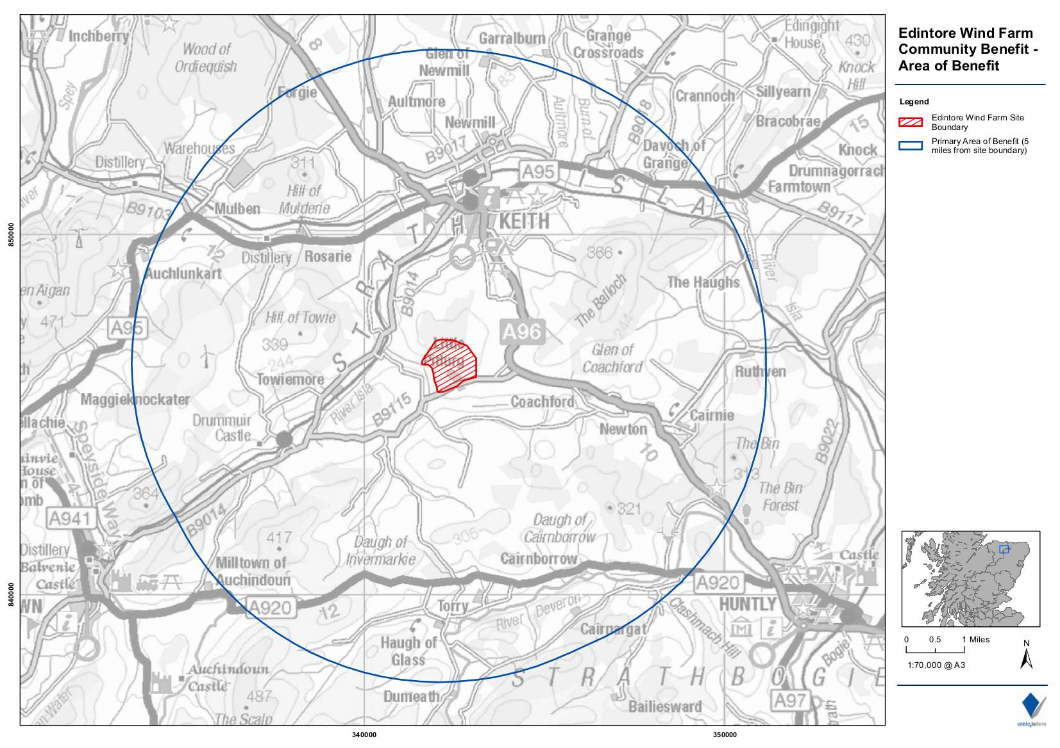

Fund documents including the area of benefit map, application forms, guidance notes, constitution and minutes of meetings are all available on the REAP website www.reapscotland.org.uk or in hard copy on request. REAP staff are happy to provide support completing application forms where needed and screen applications for eligibility and completeness, giving feedback to applicants where needed.
Round 1

A total of 24 applications totalling £246,623.25 were received. The available grant was £64,373.86 leading to a challenging first meeting for the Decision Making Panel, who all rose to the occasion. Decisions were reached by consensus with the focus on the most sustainable applications. Local knowledge was very useful in informing decisions to award partial funds, factoring in the capacity of the organisation to secure match funding.

Applicants that were part funded were also signposted to potential sources of match funding and further support. Applicants that were declined were given advice or encouraged to re-apply as appropriate, and also signposted to potential sources of funding and support. A total of £64,059.58 was awarded.

Successful applicants

Organisation | Project name | Award
Keith Roller Bladers & Skaters | Redevelop much loved skate park | £9,500.00
Friends of Newmill Primary | Outdoor learning area | £3,000.00
St Rufus Park Regeneration Group | Green Gym | £4,300.00
Keith North Church Tuesday Table | Tuesday Table lunch running costs | £80.00
Keith & Dufftown Railway Association | Towiemore Shelter | £2,750.00
Newmill Hall Committee | Extend Biomass heating into main hall | £3,455.82
Isla Archers | Replace & refurbish equipment | £1,883.55
Strathisla Pipe Band | Kitting out the Pipe band | £600.00
Keith & District Men's shed | Premises | £16,155.00
Keith Golf Club | Multi-purpose tractor | £6,750.00
Sunshine Developmental Playgroup | Cosy Book Corner | £580.00
Loft Youth Club | The Lofties | £506.25
Strathspey Fiddles | Kronach 2017 | £742.50
Newmill Community Association | Newmill War Memorial | £2,250.00
Glass Community Association | New Community Hall: Phase 2 | £11,506.46
 | Total awarded | £64,059.58

Keith Roller Bladers & Skaters was awarded £9,500.00 to re-develop much loved skate park

KeRBS has undertaken an ambitious programme of refurbishing the local skate park, which was in poor condition and had some ramps removed on safety grounds. The park benefits a group of local skaters, roller bladers and BMX bikers from the local area, as well as visiting groups. It also benefits the local community by providing a designated place for people to go and learn new skills, rather than having to make do with pavements, playparks and other public spaces.

The committee is a mix of adults and the young people who use the park and decisions are made by the young members. The group has been very active in local fundraising, running bag packs and coffee mornings, as well as litter picking the site and keeping it clean and tidy. This commitment is ongoing and impressive and encourages funders to support the refurbishment project.

The skate park represents a long-lived capital asset for the area, with parts guaranteed for 25 years, but also shows great community involvement and team work.

“We want to thank the decision panel for choosing to support Ke.R.B.S. with their project, it was a great boost. We are hopeful and believe that we can now achieve our aim to redevelop the skate park for the young people in the Keith area due to being close to completion. We would not have been able to do this without your help.”

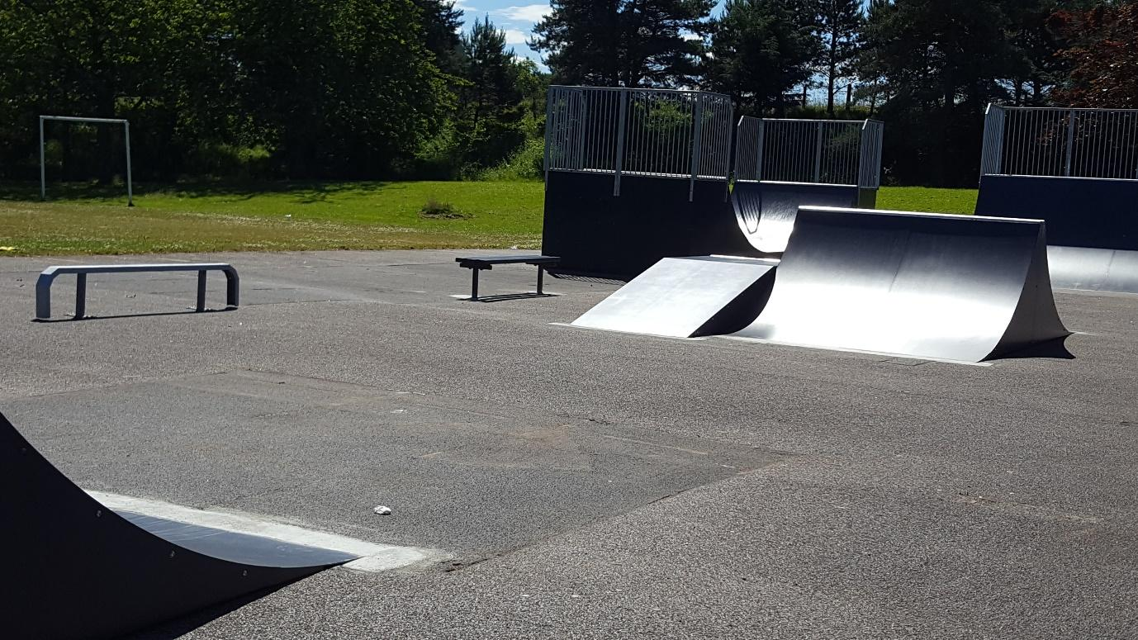

Phase 3 of the skate park redevelopment, which includes 2 quarter pipes, fun box, spine and a skateable bench which the Edintore Wind Farm Community Benefit Fund helped fund

Friends of Newmill Primary was awarded £3,000.00 towards costs of an outdoor learning area

Newmill Primary is at the heart of the village of Newmill and well supported by its parents’ committee. Keen to have the benefits of outdoor learning at the school, the group applied for funding for equipment and a shed to store it in. The group and had never applied for funding before and appreciated the advice they got to complete their application.

Their priorities were a wooden shed and mud kitchen play area and they used a local joiner for the work. Friends of Newmill Primary said,

“The new shed will allow the children to access a vast range of play equipment while outside. This is something that will make a big difference to the children as before all equipment had to be stored with the school PE cupboard.

On behalf of everyone at Newmill Primary School I would like to say thank you again for supporting us with our project.”

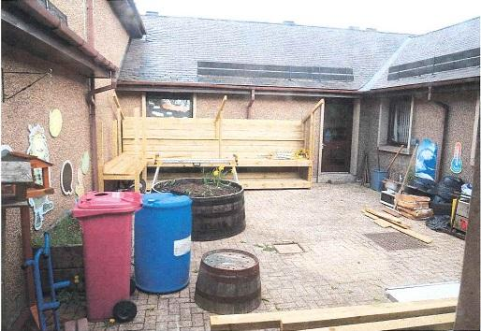
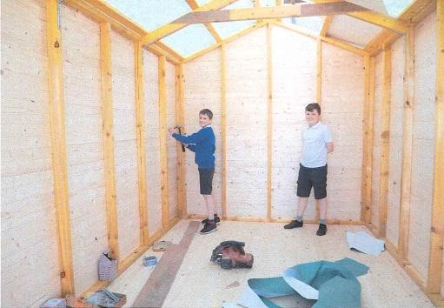
Shed and mud kitchen area under construction

St Rufus Park Regeneration Group was awarded £4,300.00 towards the cost of a Green Gym

This group was formed by local mums who wanted to improve facilities at a local park. With some help from Moray Council Community Support Unit, the group constituted and drew up an ambitious plan for new park facilities. This group also fundraised locally very actively. They submitted detailed development plans in support of their application that outlined the scope of the plan and how it could be achieved in phases.

Phase one has now been completed with the installation of a Green Gym in the park, which is being well used by people of all ages. As owners of the park, Moray Council agreed to install and maintain the equipment.

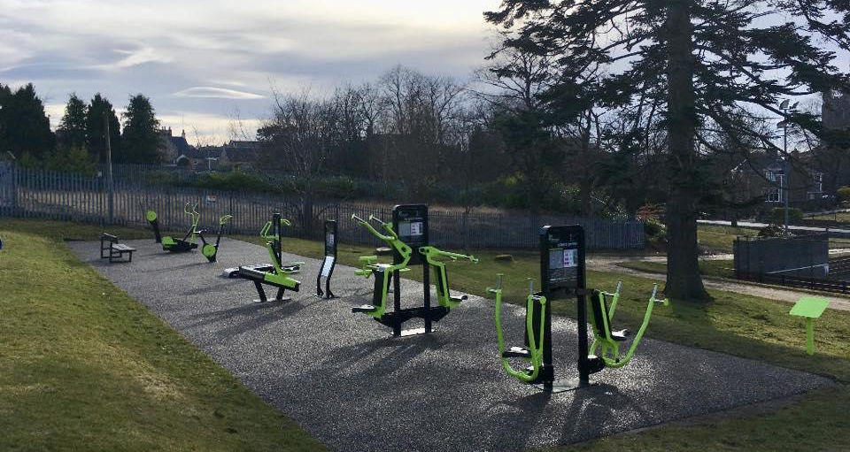
St Rufus Park Green Gym equipment

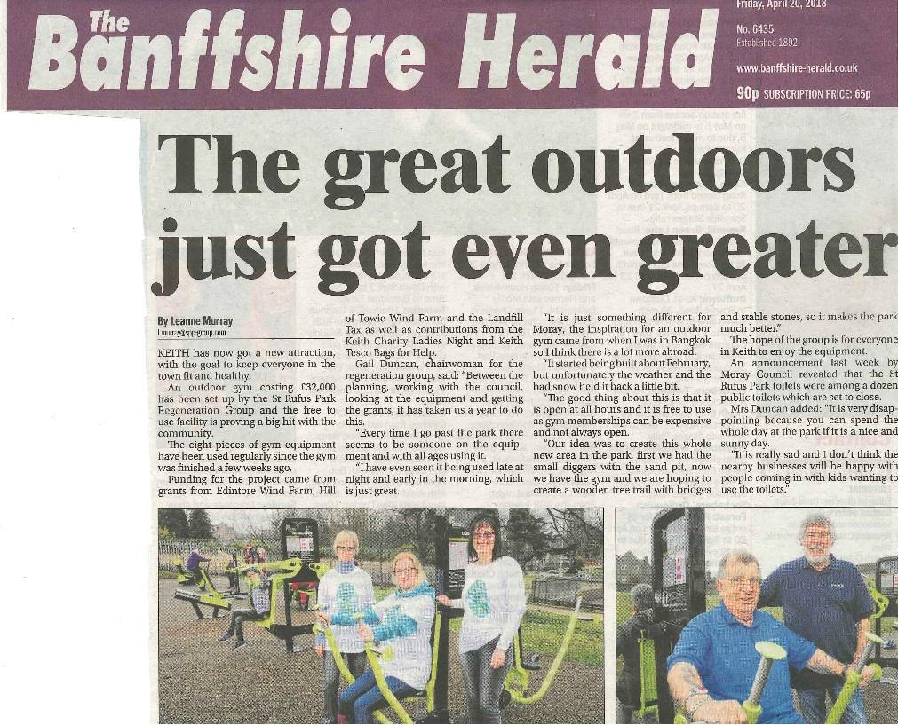

Coverage of St Rufus Green Gym in the local press

© The Banffshire Herald

Keith North Church Tuesday Table awarded £80.00 towards kitchen equipment

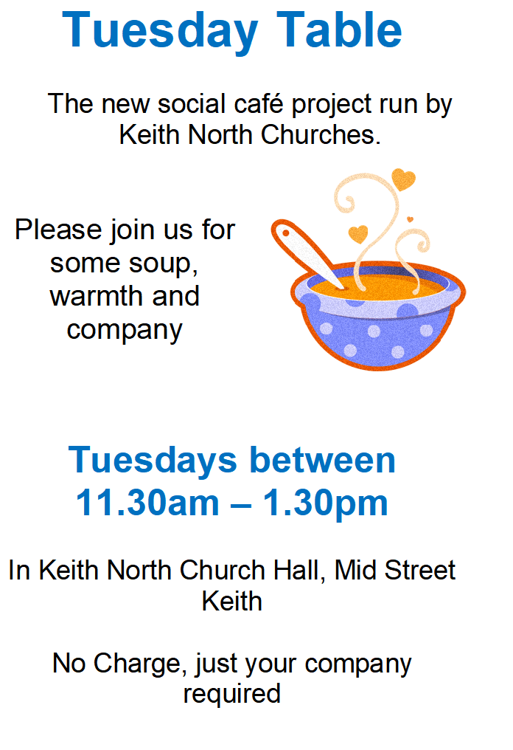
Keith North Church started putting on ‘soup and sweet’ lunches on a Tuesday. Word quickly spread and by the time the application was made to Edintore Community Benefit Fund lunch was regularly being served to 40-50 people. Since then numbers have grown further still.

A mixture of folk attend; some enjoying the social side and a tasty lunch and some who are socially or economically disadvantaged or referred by the local food bank, health visitors or social workers.

The lunches rely on a small army of highly organised volunteers. Tuesday Table has also formed links with Fare Share and the local supermarket to take on surplus food donations and incorporate them into lunches and distribute them to patrons to take home.

Their grant was used to purchase hot food flasks and a food mixer, thanks to generous discounts from local suppliers.

Keith & Dufftown Railway Association was awarded £2,750.00 towards the costs of the Towiemore Shelter

Keith and Dufftown Railway Association planned to get a contractor to refurbish the existing concrete building by repairing the roof and putting in a new window. Just as they heard their grant had been funded, a new volunteer with joinery skills joined the railway. He asked if he could take on the work and put a lot of time and effort in to take the project far beyond what was originally intended.

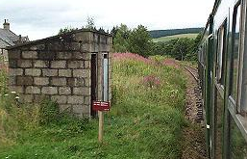
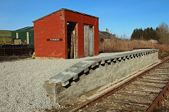
Images © KDRA –Towiemore Halt ‘before’…

The project developed into repairing the platform itself with new slabs, putting on a complete new roof, repairing a crack in one wall, fitting a new window frame and window and painting the building. A new door was made and fitted to the small store to the left of this waiting room and a new timber building was constructed to simulate the old railway carriage that was used as a booking office and waiting room in Great North of Scotland Railway days.

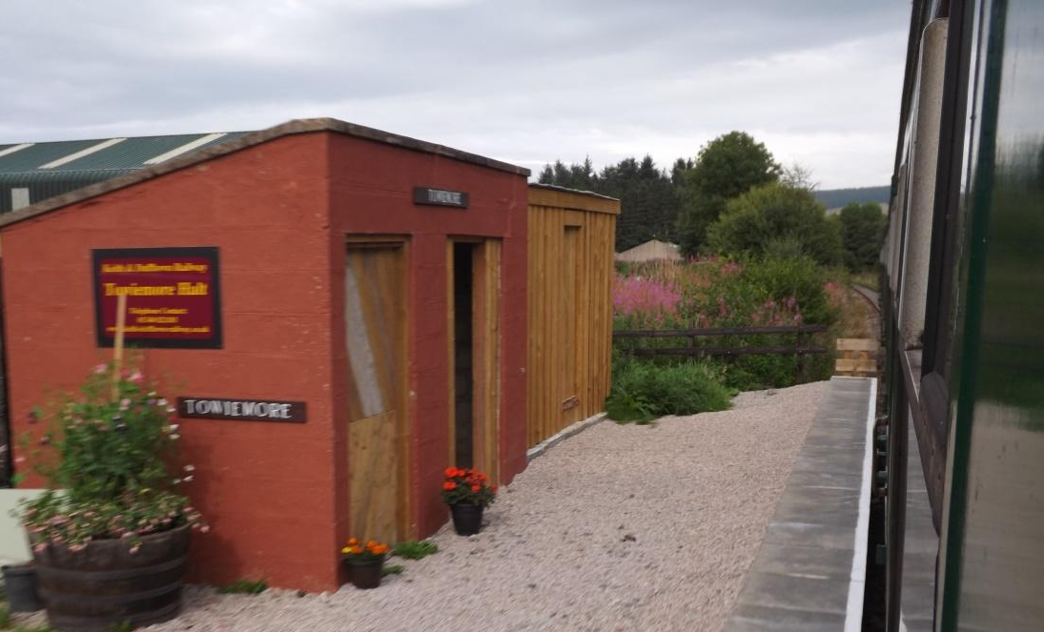

… in progress…

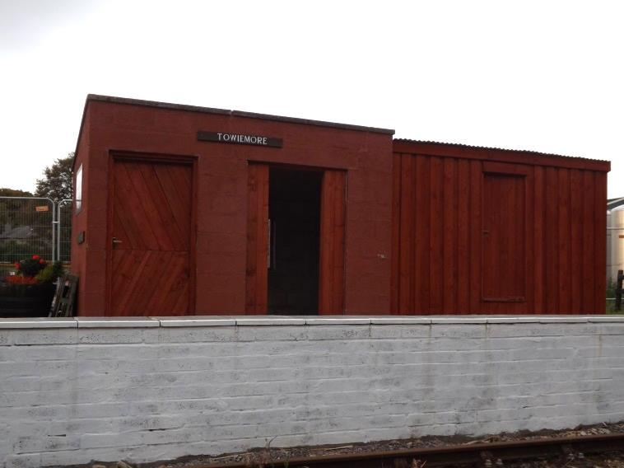
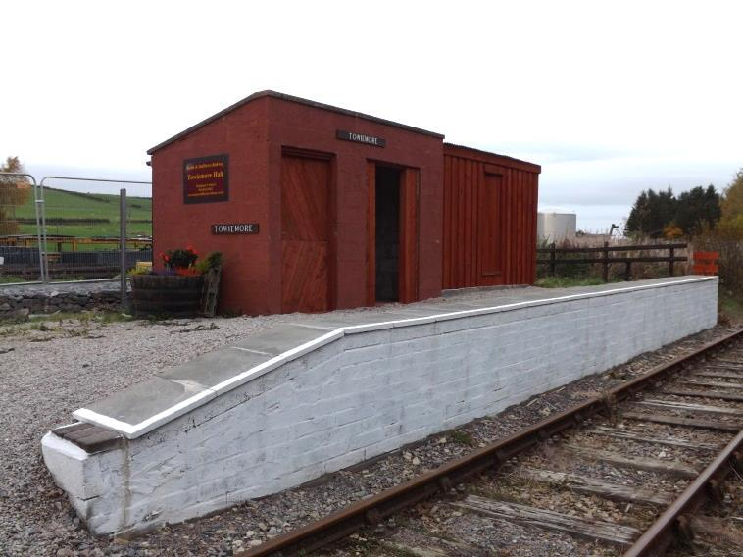
… and complete.

“The project has exceeded our expectations and has made Towiemore Halt look like a proper railway station. Our volunteers have developed more skills and it has motivated us to ‘think big’ about future projects.”

Steve Rhodes, Director, Keith & Dufftown Railway Association

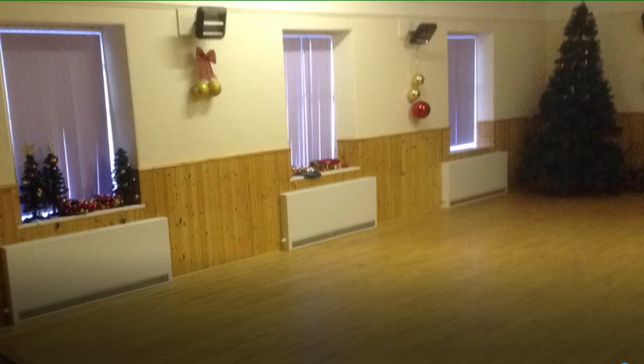
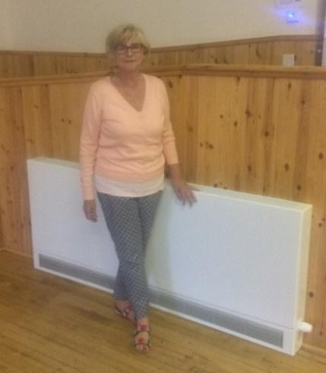
Newmill Hall Committee was awarded £3,455.82 to extend Biomass heating into the main hall

As with any local hall, the Committee is keen to increase use of their facilities. Newmill Hall already hosts a range of activities from children’s parties to kick boxing classes, conferences and discos. A few years ago, the community won a biomass boiler which heats the local primary school and heated the hall kitchen and ‘small hall’. The main hall had wall mounted electric panel heaters but these were costly to run and not always able to provide even and controllable heat.

Satisfied that the biomass boiler had capacity, the Hall Committee was able to secure funding from Edintore Community Benefit Fund to have 5 radiators and connecting pipework fitted. This has proved a great success, leading to increased bookings and glowing feedback. The main hall is now just as comfortable and welcoming as the rest of the hall.

Isla Archers was awarded £1,883.55 towards the costs of replacing and refurbishing equipment

Isla Archers had never applied for funding in their 30 plus year history. They are a very practical and inclusive group, adapting equipment to make the sport accessible to just about everyone. An amazing range of people have passed through their hands from some of the kids from Chernobyl who visit Moray each year to the occasional Royal school pupil.

They have a policy of repairing equipment wherever possible but some pieces of kit needed replaced, and some funds were needed to buy more materials to repair equipment. The repairing of kit was seen as a very positive sign of sustainability. Having made a successful application, they feel more confident about applying for funding in future.

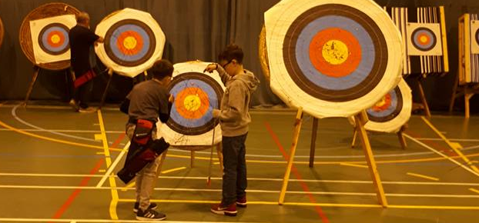

Photos © Isla Archers

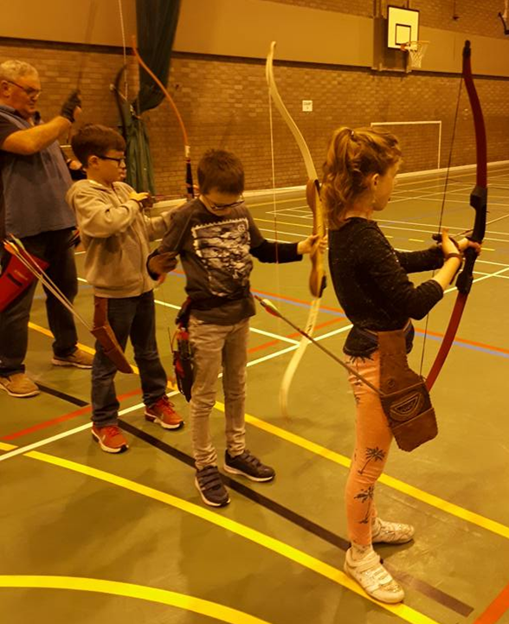
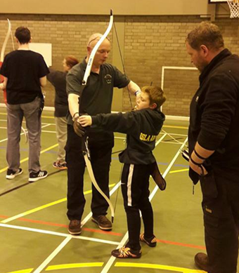

Strathisla Pipe Band was awarded £600.00 for kitting out the Pipe band

Strathisla Pipe Band turns 100 years old in 2018. They have a long and proud tradition of supporting the community, playing for free at local events and supporting the fundraising efforts of other groups. They also actively fundraise to cover their costs and say,

“Kitting out new members and keeping current members’ uniforms up to scratch is an ongoing project.”

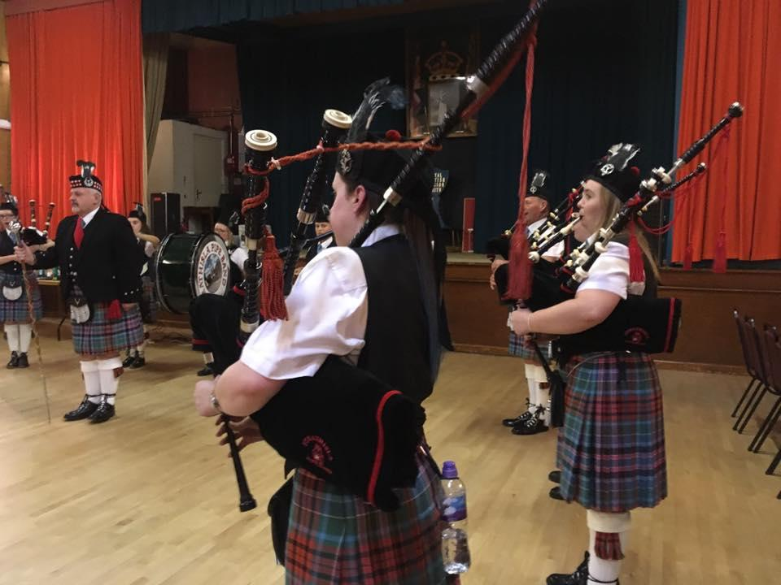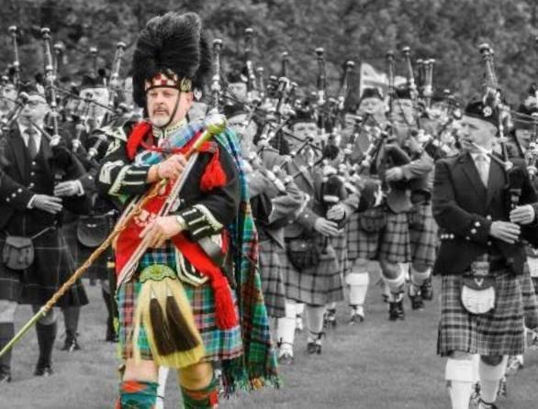
Photos © Strathisla Pipe Band

The Pipe Band applied to Edintore Community Benefit Fund for a grant towards the costs of uniforms. This is particularly important to support young members in joining up and helps guarantee the success of the Pipe Band for many years to come.
Keith & District Men's shed was awarded £16,155.00 towards the cost of premises

Established in 2017, Keith & District Men’s Shed already has around 50 members of all ages. ‘Shedders’ currently meet in The Loft Youth Project for but have plans for premises of their own where they can carry out a wider range of activities for the benefit of members as well as the local community. They applied to Edintore Community Benefit Fund for portacabins to use as workshops for repairs and woodworking to compliment a building they will lease from Moray Council as a meeting space.

Negotiations with the local authority and fulfilling all Planning conditions has taken a little longer than expected but the Decision Making Panel can see the great social and community benefit of these plans so agreed to grant a short extension to the grant funding period.

Keith Golf Club was awarded £6,750.00 towards the cost of a multi-purpose tractor

Keith Golf Club is a not-for-profit organisation, open to golfers of all ages and with an active youth development programme. It also makes its clubhouse available to local groups for fundraising events, free of charge and lends equipment and skilled operators to other local organisations. The Club applied for funding for a multi-purpose tractor which has made a big difference to their ability to use equipment, including a much needed aerator. They traded in their old tractor to help offset the cost and are delighted with their new purchase.

Sunshine Developmental Playgroup was awarded £580.00 for a cosy book corner

The grant was used to buy items to create a defined cosy area for the children who attend this special, independent play group. The playgroup manager said,

“The new sensory pod is great as it is big enough for a small group of children to use together, as well as staff being able to go in with the children. As it is a pop up we are able to store it easily and it will get a lot of use due to the ease of putting it up and taking down.”

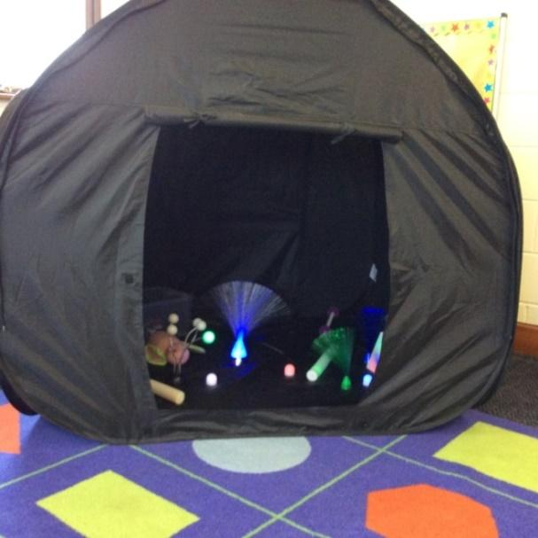
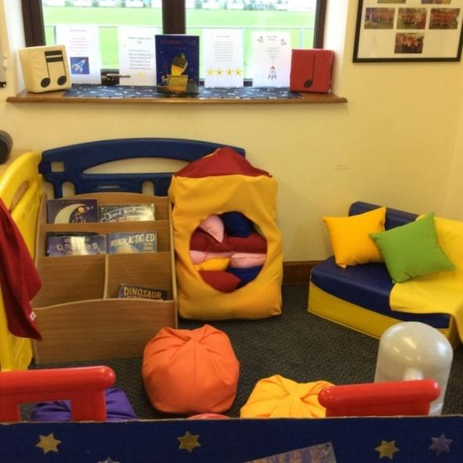

“The bookcase means even the youngest and least mobile children can access books independently. The beanbags have brightened the area and the children enjoy sitting on them looking at their new books or listening to a story. We would like to thank the Edintore Wind Farm Community Benefit Fund for the grant.”

The Loft Youth Project was awarded £506.25 towards the cost of ‘The Lofties’

The Loft Youth Project is a long-established youth café and centre in Keith. The Lofties is a group of young people identified by guidance teachers at Keith Grammar School who would benefit from opportunities to get involved with their peers and the community. About half the group live in rural areas, a risk factor for becoming socially isolated. Funding helped provide support for this group. The Loft manager said,

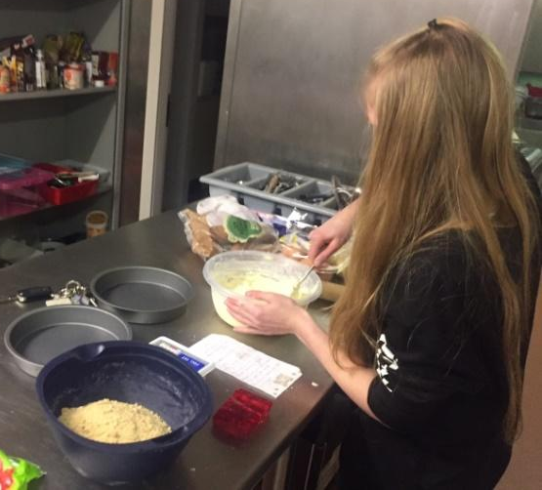
"We appreciate this funding as it has allowed us to continue to support our Lofties to develop their interpersonal and leadership skills.

We have put the grant funding towards costs of skilled youth workers, a nutritious meal and a range of activities that help to build life skills, and provide volunteering and training opportunities. The Lofties have enjoyed their sessions and we have seen a real difference in the wellness, self-confidence and abilities of group members over the last year."

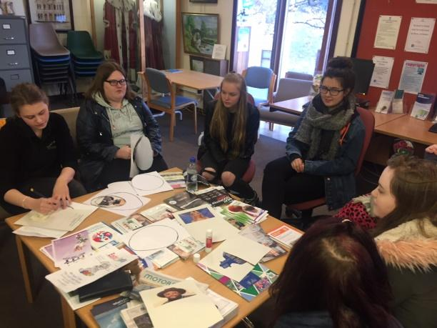
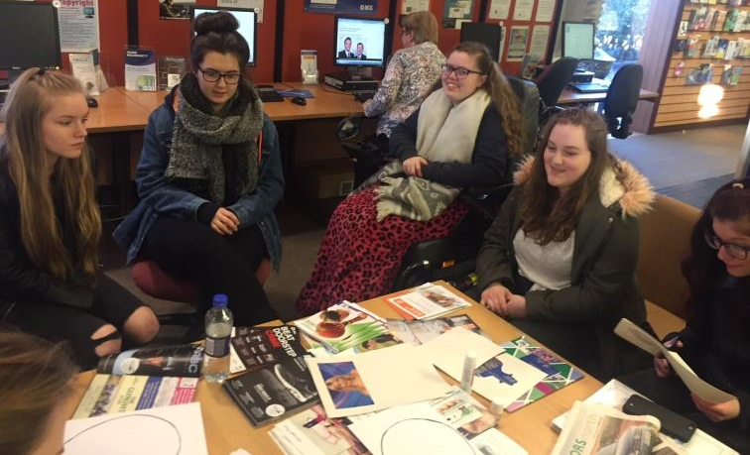
Lofties Group activities

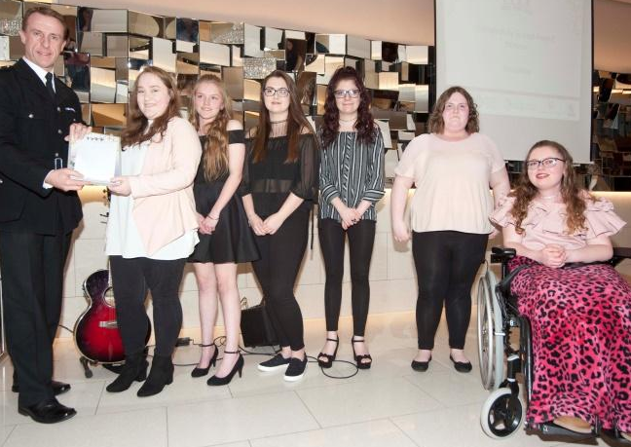
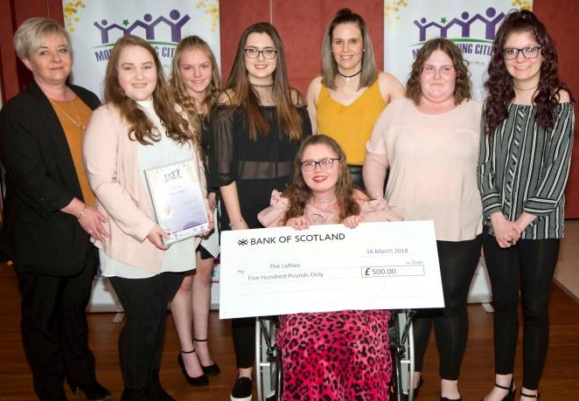
The Lofties receiving the Moray Young Citizen Award for a Community Group

Strathspey Fiddlers was awarded £742.50 towards the cost of Kronach 2017

Strathspey Fiddlers are a well-known musical group locally. In 2017 they travelled to Kronach, an area of Bavaria historically twinned with Banffshire. They applied for funding for new branded polo shirts and hoodies so they could travel and play in style.

Newmill Community Association was awarded £2,250.00 towards the cost of restoring Newmill War Memorial

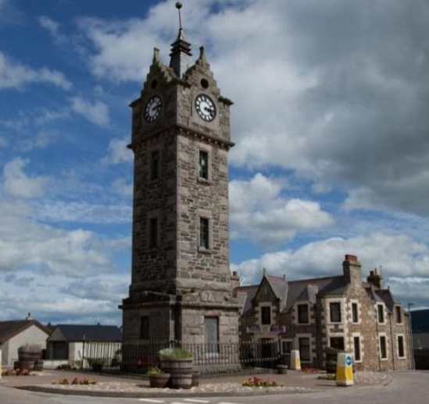
Newmill War Memorial is a central feature of Newmill village and was built by public subscription. A programme of restoration has been undertaken in the last few years including restoration of stonework and mortar by specialist masons, new lighting and repairs to the windows.

The Community Association has worked hard to secure the funding required to finish this work, applying to a number of funders to make up a shortfall in local authority funding of the work. They are determined to preserve this striking clock tower in memory of the men of the parish who lost their lives in two world wars.
By Duncan123 (Own work)
[CC BY-SA 3.0] via Wikimedia Commons

Glass Community Association was awarded £11,506.46 towards the cost of Phase 2 of a new Community Hall
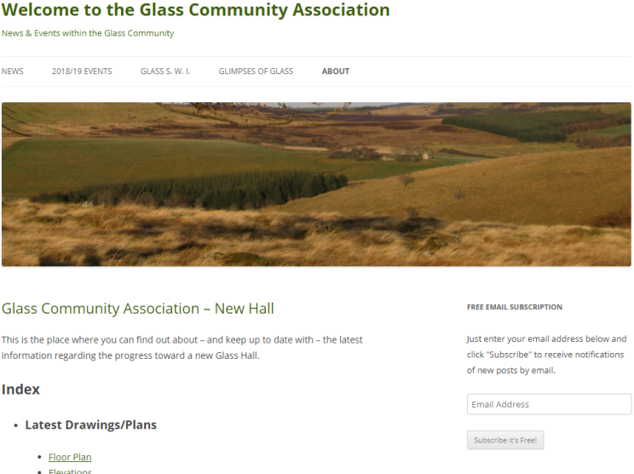

Glass Community Association has a well-used public hall but it was felt that the structure of the hall was limiting to its use and that better facilities would increase use and improve the hall’s sustainability. The Association consulted the community about options for the hall and it was felt that rebuilding the hall would be the most cost-effective solution.

Due to high demand on Round 1 of Edintore funding, most applicants received part funding and this was the case with Glass Community Association. They set off to find match funding to complete phase two of their new hall project. As this took longer than expected, a request for an extension to the grant funding period was requested. The Decision Making Panel agreed to grant an extension and in March 2018, Glass Community Association successfully secured match funding from Clashindarroch Wind Farm Community Benefit Fund and plan to proceed with phase 2 shortly.

Income and Expenses

Annual Grant £70,500.00
Bank Interest £14.13

REAP fee £5,900.00
Insurance £233.75
Bank charges £3.00

Balance £11,825.66 with £11,506.46 to be awarded to Glass Community Association leaving £319.20

Edintore Wind Farm Community Fund - INCOME & EXPENDITURE
INCOME |  |  | EXPENSES
Date | Amount £ | Income Details |  |  |  | End of Month Balance
02 Feb 2017 | 70,500 | Grant |  | 5,900.00 | REAP Fees
 |  |  | 23 February 2017 | 233.75 | Indemnity insurance | Jan | 64,366.25
01 March 2017 | 2.43 | a/c interest |  |  |  | Feb | 64,368.68
 |  |  | 15 March 2017 | 0.20 | charges | March | 64,368.48
01 April 2017 | 2.73 | a/c interest |  |  |  | April | 64,371.21
01 May 2017 | 2.65 | a/c interest |  |  |  | May | 64,373.86
 |  |  | 17 May 2017 | 9,500.00 | KeRBS
 |  |  | 17 May 2017 | 3,000.00 | Friends of Newmilll Primary
 |  |  | 17 May 2017 | 4,300.00 | St Rufus Park Regen
 |  |  | 17 May 2017 | 80.00 | Tuesday Table
 |  |  | 17 May 2017 | 2,750.00 | KDRA
 |  |  | 17 May 2017 | 1,883.55 | Isla Archers
 |  |  | 17 May 2017 | 580.00 | Sunshine Dev Playgroup
 |  |  | 17 May 2017 | 506.25 | Loft Youth Project
 |  |  | 17 May 2017 | 742.50 | Strathspey Fiddlers
 |  |  | 22 May 2017 | 3,455.82 | Newmill Hall Committee
 |  |  | 22 May 2017 | 600.00 | Strathisla Pipe Band
01 June 2017 | 2.20 | a/c interest |  |  |  | June | 36,977.94
 |  |  | 15 June 2017 | 1.10 | charges
 |  |  | 21 June 2017 | 16,155.00 | Keith Men's Sheds
 |  |  | 26 June 2017 | 2,250.00 | Newmill Community Association
01 July 2017 | 1.28 | a/c interest
 |  |  | 27 July 2017 | 0.20 | charges | July | 18572.92
01 August 2017 | 0.79 | a/c interest |  |  |  | Aug | 18573.71
 |  |  | 09 August 2017 | 6,750.00 | Keith Golf Club | Sep | 11,824.18
01 September 2017 | 0.57 | a/c interest
 |  |  | 15 September 2017 | 0.10 | charges
01 October 2017 | 0.49 | a/c interest |  |  |  | Oct | 11,824.67
01 November 2017 | 0.50 | a/c interest |  |  |  | Nov | 11,825.17
01 December 2017 | 0.49 | a/c interest |  |  |  | Dec | 11,825.66
TOTAL | 70,514.13 |  | TOTAL | 58,688.47 |  | Balance | 11,825.66

