

**Hill of Towie Wind Farm**

**Community Benefit Fund**

**Annual Report**

**Round 21**

**2022**

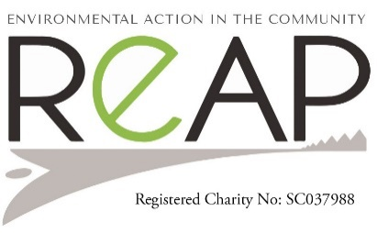

COMMUNITY BENEFIT FUND

The round twenty-one decision-making panel meeting was held, 28th November 2022 at Drummuir Hall. Seven applications were considered, and six were successful and awarded on the night.

SUCCESSFUL APPLICANTS

Round 21 - November 2022

Keith Football Club - Upgrade of Floodlights in Effort to Achieve Net Zero £38,906.16

Mulben Picnic Committee - Grass Cutting at Playing Fields, Mulben £200.00

Keith in Flower - Improving Watering and Maintenance Facilities £12,746.01

The Loft Youth Project - Youth Work £21,265.00

Keith Bowling Club - Seating Refurbishment & Fire Doors £23,074.80

Keith Royal British Legion - Function Hall Seating £8,000.00

Total for Round 21 £104,191.97

Round 21

Keith Football Club – Upgrade of Floodlights to achieve NET ZERO

The Highland League club successfully applied to the Scottish FA Grassroots Pitch and Facilities Fund and the Hill of Towie Community Benefit Fund for grant cash to help complete essential stadium work.

The money secured will now be used to upgrade the club's current floodlights to a new LED system, including new foundations and columns.

This is a step forward for the club moving towards net zero.

Club director Grant McWilliam said the Maroons were delighted to receive the funding from the various bodies.

"This upgrade to our floodlights will not only improve the quality of our match-day experience, but it will also reduce our carbon footprint," he said. Keith Football club are extremely thankful to the Hill of Towie benefit fund for funding towards their project.

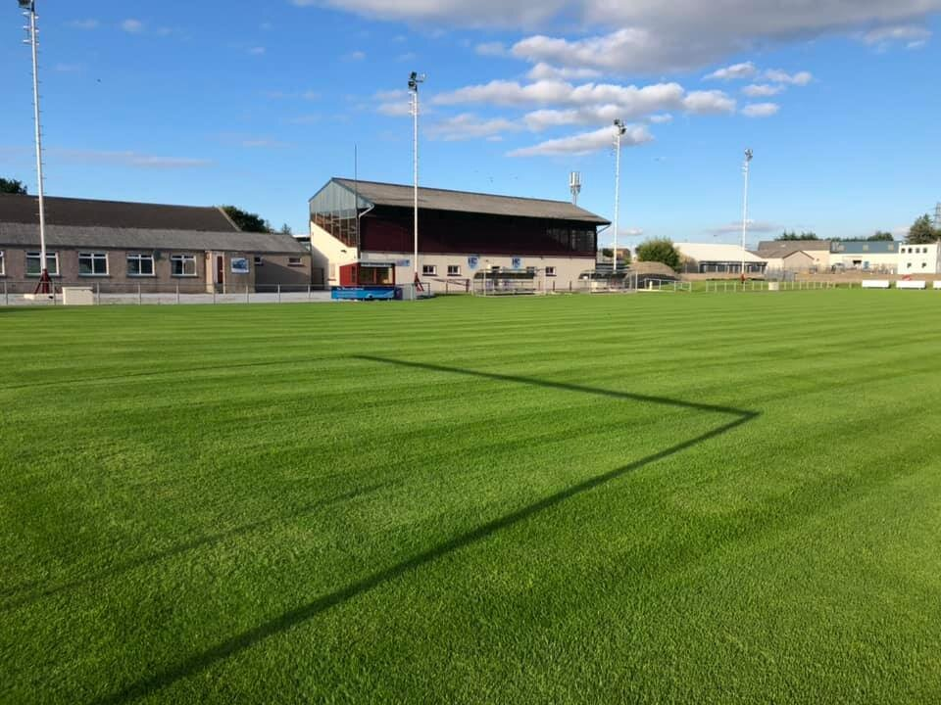

Mulben Picnic Committee – Playing field upkeep

Mulben picnic committee applied for the running costs for the upkeep of the playing field around Mulben. As costs of transporting cutting equipment and fuel to use this equipment was becoming more expensive, they applied to Hill of Towie for a grant towards the running costs for their charity. 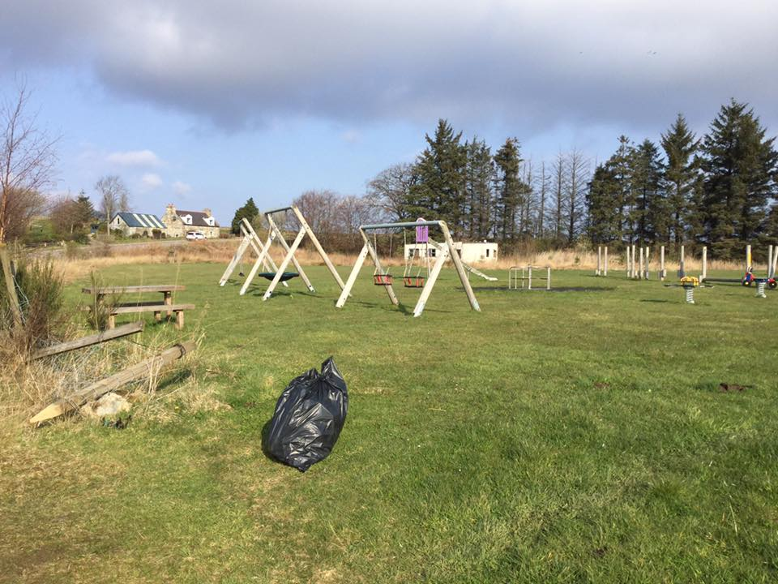

Keith in Flower

In 2022, it was noted that the Keith in Flower watering equipment wasn’t entirely practical and fit for purpose. We were delighted that the application was successful, and the funds granted. We quickly set about sourcing equipment to allow us plenty of time to prepare it for the 2023 season. We took advice from various suppliers and decided in the end to purchase the buggy – which has a roll cage, seatbelts and proper seats. The hanging baskets were put up just before the Keith TMSA Festival in early June and the tubs filled around that time too. This is the earliest we’ve had the plants out for a long time, since our committee were well organised, and the weather had allowed the plants to be ready earlier than usual. The watering quickly begun, with us using over 1000l of water in the first night, filling reservoirs in the planters and baskets. This is when the new watering system begun to show its worth. The task was completed in just 3 hours in the first night – half the time the ‘first fill’ took in 2022. The watering has now become much more enjoyable – due to the fact the task is no longer completed alone. We have one person to water, one person to watch traffic and manage the hose and a third to drive. We’ve had the equipment sign written, showing the main groups who use it. Some of the equipment has already started to be used for the setup of Keith Show, and this will increase in coming weeks. The response from the town has been very positive – the flowers are looking beautiful and since we’re spending less time watering, we can allow more time for the deadheading, weeding etc of our plants. We now feel comfortable to expand Keith in Flower, so will be looking into planters for next season.

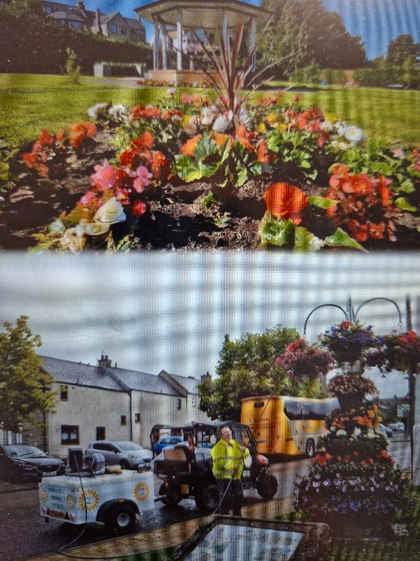

The Loft – Youth Project

The Loft Project was awarded the amount of £21,265. This funding allowed 1,646 youth work hours for Keith & Strathisla areas. The funding allowed the Loft to run a full programme from Jan - Oct 2023. The Loft ran 10 youth clubs/activities with a total of 364 sessions. These sessions provided engagement with over 125 young people on a weekly basis, covering taboo subjects like mental health and well-being, confidence building, social skills, etc. The Loft are thankful to Hill of Towie for funding this project for the small youth charity.

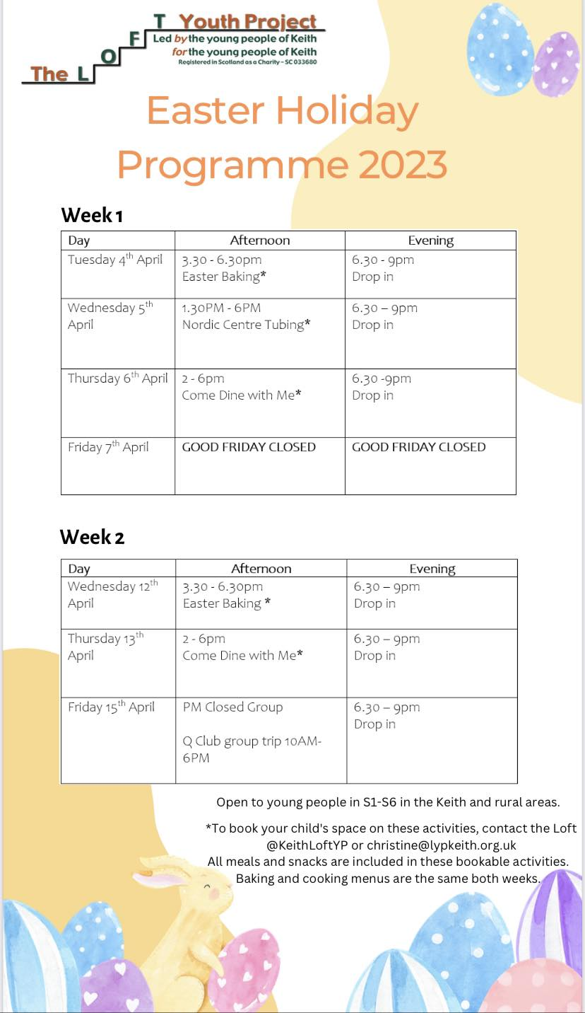

Keith Bowling Club

Keith Bowling Club was awarded £23,074.80 in this funding round.

The Club has been established since 1879 and is a sports facility for all ages. The current membership is from ages 11 to 78 and is a great asset to all and allows for younger people to learn how to re-engage appropriately with adults and people from all walks of life.

To ensure that they kept the facility secure and in good state of repair, the club needed to replace two external emergency exit doors. They also applied to replace the chairs in the Lounge and Hall area, which are causing Health and Safety issues, with several breakages when sat in due to their age.

Everyone has commented on the seats that have visited the club. The Keith bowling Club are extremely grateful to the Hill of Towie Windfarm community benefit fund for making this happen.

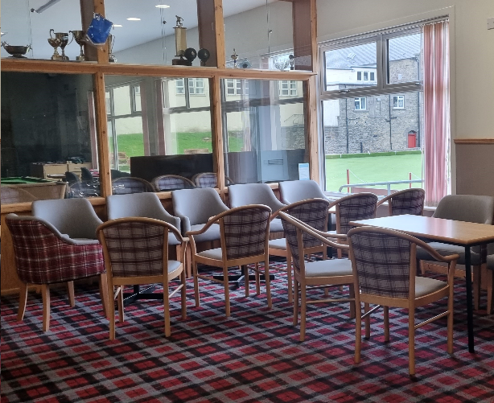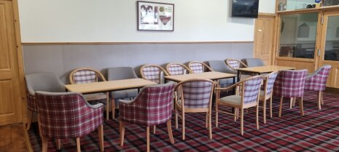

Keith Royal British Legion

The Royal British Legion Keith Committee would like to thank the Hill of Towie windfarm for the grant we received to help purchase new seating for the hall. The money was used to purchase the chairs. The Keith Royal British Legion are delighted with the chairs. The spokesperson said, ‘It is a pleasure to look around the hall and see all the matching chairs as opposed to the 3 or 4 different types and colours, as there was before. Not only is it pleasing to the eye, but the risk of someone also getting hurt has now gone. We can only but thank you once again.’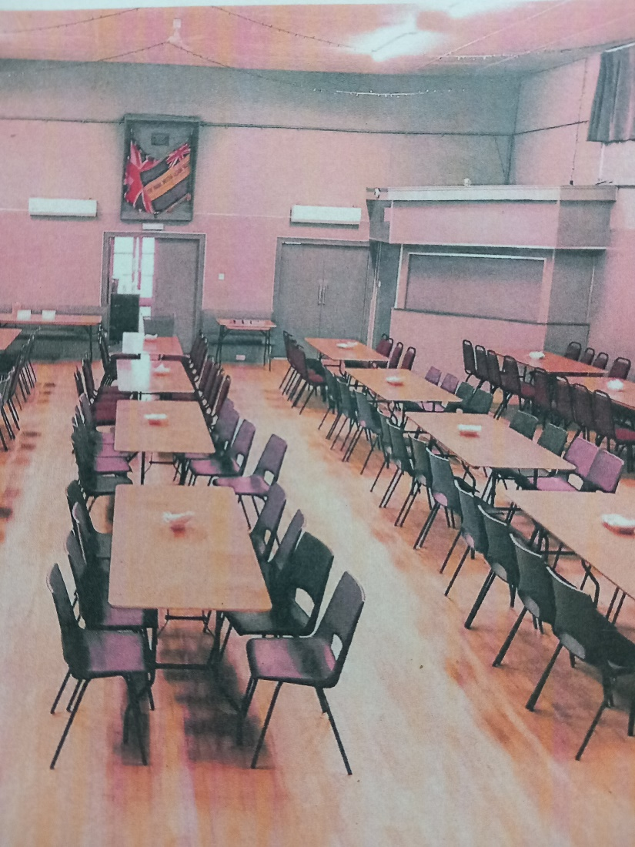

Fund Governance and Administration

Governance of the fund is overseen by a local volunteer Decision Making according to the fund aims and objective. All complete and eligible applications are assessed by Panel members and discussed at Decision Making meetings.

The fund is administered by REAP, a local environmental charity. REAP staff can assist with the application process and clarify any questions on the application form. All applications are screened for completeness, and advice is given to applicants where necessary. Application forms and guidance notes are always available on the website and hard copies are available on request.

Grants awarded are published on the REAP website, along with reports from successful applicants.

The fund is advertised in local venues, local radio station (Keith Community Radio),TSI Moray and online and on social media.