
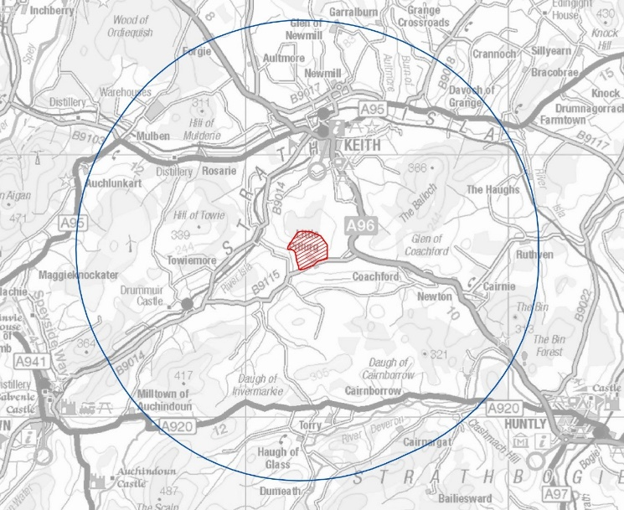





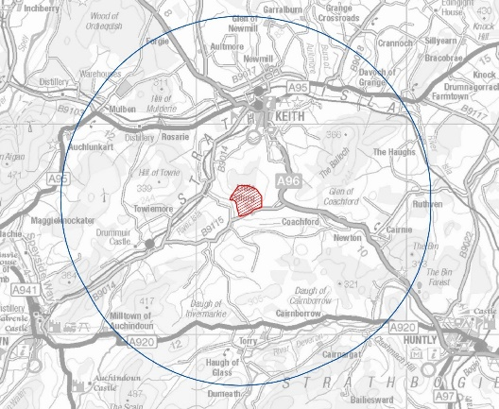
Applications must meet the aims of the fund:

Improving the environment, social and community life within the area of benefit

Providing benefit to the community beyond the 25-year lifespan of the windfarm
For more information see www.reapscotland.org.uk
info@reapscotland.org.uk or phone 01542 888070
Edintore Wind Farm Community Fund is funded by Edintore Windfarm ltd
and administered by REAP

Priority is given to groups operating in the primary area of benefit. This is a 5 miles radius from the Edintore Wind Farm. Priority will be given to applications based on their merit and proximity to the primary area of benefit.
Closing date for applications:
5pm on Tuesday
the 27th of August 2024

EDINTORE WIND FARM
COMMUNITY BENEFIT FUND

QR-Code

