Hill of Towie Wind Farm
Community Benefit Fund

Annual Report
Rounds 19 & 20

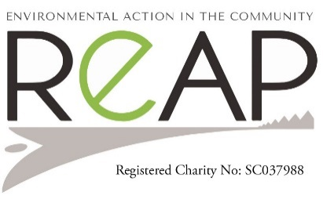
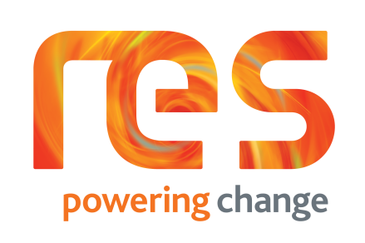
COMMUNITY BENEFIT FUND
Fifteen applications were received for rounds 19 and 20 of the Hill of Towie community benefit fund.
The round nineteen’s Decision-making panel meeting was held in November 2021. Seven applications were considered and five were successful and awarded on the night.
In round twenty the Decision-making panel meeting was held in May 2022. Eight applications were considered, and all were awarded on the night.

SUCCESSFUL APPLICANTS

Round 19 - November 2021

Earthtime for all £990
Keiths Men shed £42,722.31
Keith and District Sports Trust £7,302
Boharm SWI £200
The Loft £14,720
Total £65,934.31

Round 20 – May 2022

Boharm Public Hall £10,620
Botriphnie Primary Parent Council £1,680
Drummuir 21 £1,450
Drummuir and Botriphnie Community Trust £1,000
Keith Country Show £5,268
Keith Golf Club £10,250
The Loft Youth Project £3,432
TMSA £8,739.37
Total £42,439.37

Round 19

Earthtime for all was granted £999 for their waddle toddle Keith.
Earthtime provided weekly Waddle Toddle activities throughout 2021 (March to December).
Over a hundred participants took part in the sessions and enjoyed the nature play activities, providing support to those families with pre-school children to get out and about in the local environment. The money provided was used towards travel, staffing and material costs which allowed Earthtime to provide the activities free of charge. We provided 36 out of the 44 planned sessions, due to family issues for the staff member providing the activities we weren’t able to carry out all the sessions, but hope to be able offer these later in 2023.
Parents/carers and children all enjoyed the activities provided and being able to mix with each other as a community together in a local place.
Photos from one of the last sessions during December 2022 when the snow added an extra dimension to the day!
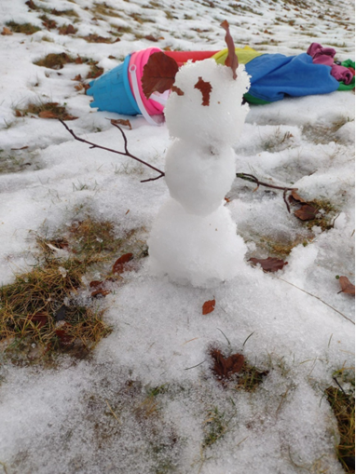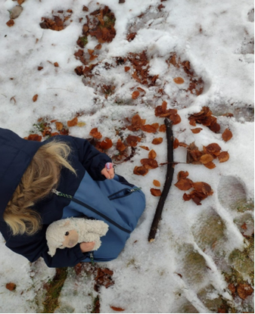

Keith Mens Shed – Workshop & hobbies room

The social and community bonding that has been prevalent in our relationship with the local community since the Shed opened in 2017. The skills and experience that our Men’s Shed members have between them are a great resource for other community groups and vulnerable community members. Having our own premises and being able to open longer hours will encourage more men to come along. More men mean more skills and increase the pool of resources available to the community and increases the amount of interaction with the local community. The benefits provided by a Men’s Shed are not derived from providing financial assistance to individuals or groups, but by providing the space and opportunity for men to come together, to combat loneliness and isolation, to gain a sense of purpose and self respect, to share skills they may have with other Shedders or others in the community and share information on things like health and wellbeing. We have been receiving excellent feedback from members of the community. Some have commented on how they wished that there had been something like the Men’s Shed for their relatives to attend. Others have thanked us for including and supporting their relatives when they most needed it. In the Shed we treat everyone the same, we don’t see a wheelchair user or a dementia sufferer as a disabled person, but just as a person who may need a little more help. But don’t we all need a little bit extra help at times?
This project was held up through planning permission with the council. In 2023 the project finally started and progressed well. The men of the mens shed pushed forward to create a wonderful place for them to work and socialise.
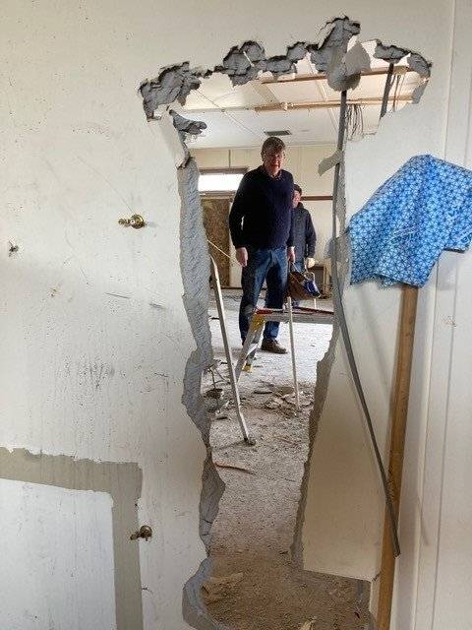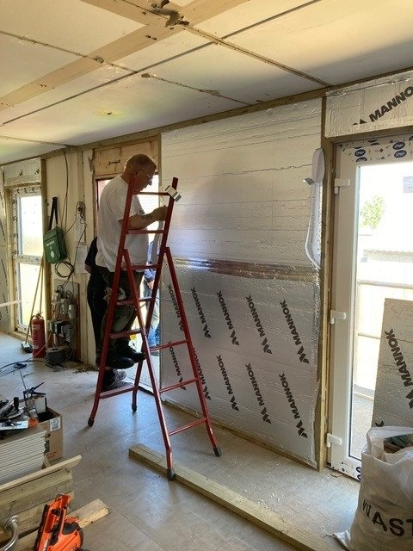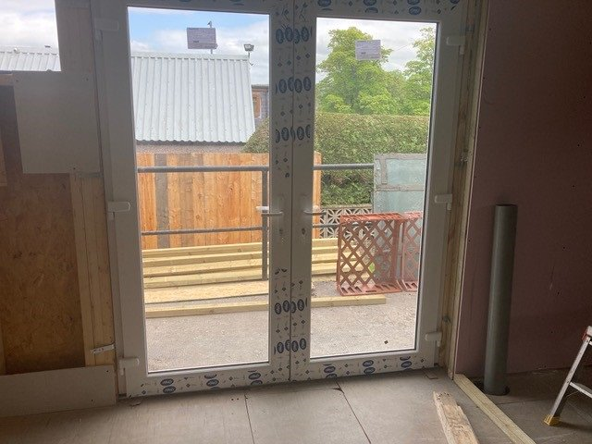
Keith and District Sports Trust was awarded £7,302 for their Refurbishment of their urinals.
The aim of the project was to replace current stainless-steel urinals (troughs) in the gent’s toilets with 5 ceramic urinal bowls. It was felt the replacement of the troughs would greatly enhance the facility and youngers users would be able to use them without disruption.
‘There is no doubt that the urinal replacements have enhanced the facility.’

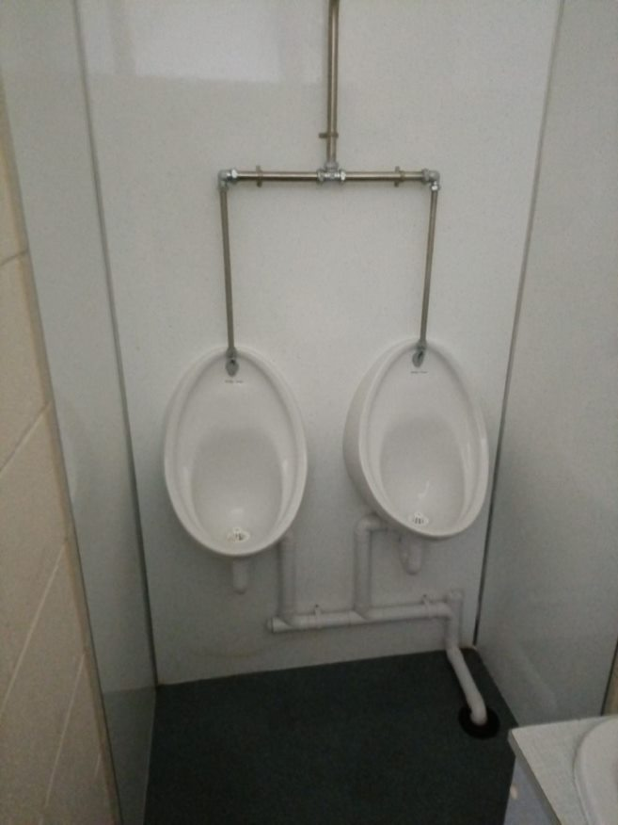

Boharm SWI was awarded £ 200 for their running costs.
Thank you so much for awarding us a grant of £200 to allow us with running costs for the last 12 months.
Our subscription of £22 per year is completely taken up with £21 required by our Headquarters in Edinburgh and the remaining £1 is a levy required by our local Federation. Charges for rental of the Village Hall and speakers are all met by ourselves by organising a small raffle (self funded) at each meeting. Teas etc. are also supplied by members free of charge.
We have gained some 2 new members during the last few months and hopefully numbers will continue to increase . We are organising an open meeting in April to encourage people to attend to see what we do and hopefully encourage them to join.
Once again, many thanks from all of us for allowing us to continue and to expand our syllabus with new and interesting speakers. A copy of our latest syllabus is attached for your information.

The Loft youth work staff
The loft youth work helped fund a bank of sessional youth work staff to work alongside the project manager. The Loft are the only youth provision in Keith area that provide a safe nurturing environment for all the young people to help support their needs. By supporting young people in a variety of ways by developing personal and physical skills, changing their behaviour and attitude.

ROUND 20 – MAY 2022

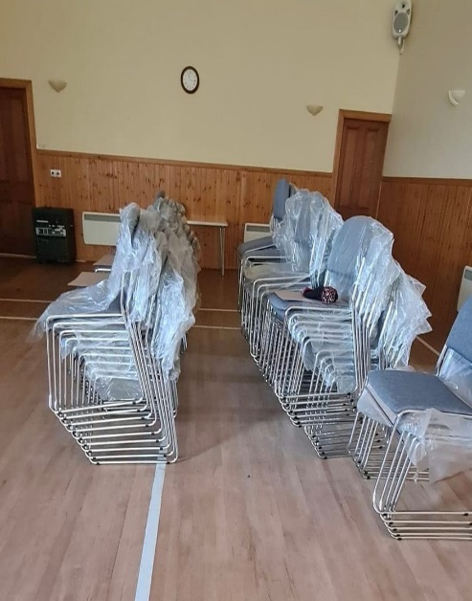
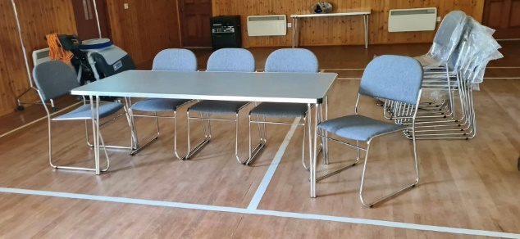

Boharm Public Hall was funded £10,620 for a refurbishment of the halls chairs and tables to keep them easily clean and wipeable with the present covid cleaning guidelines ‘Thank you and the Committee for the grant to purchase new tables and chairs for our village hall. We are delighted to confirm that after a long wait 20 new tables and 100 new chairs have finally been delivered together with special cleaning fluid to protect the upholstery from the dangers of Covid.‘

Botriphnie Primary Parent Council was funded £1680 for their ‘Outdoor Activity Week project.’The weather was on Botriphnie’s Primary School’s side as P1-4 ventured outdoors for Earthtime sessions 10-12 daily. The P4-7 went on a different kind of outdoor adventure with Outfit Moray. Earthtime sessions were well received by all and a fantastic way to promote health and wellbeing, providing a motivating context for their new P1s to get know everyone. It was fantastic for both staff and pupils. They were inspired to dig out their fire pit from the shed as part of their end of term celebrations. Celebrated those who go ‘over and above’ demonstrating their commitment to the school values, around the fire pit, on Wednesday. Here are some of our pupil highlights.
“I learned how to make a fire using a flint and steel”. (Torin, P2)
“I was a bug hunter and found lots of different creatures.”(Sinan, P2)
“I learned how to make tree houses.” (Charles, P1)
“I enjoyed climbing and pond dipping and all of the snacks!” (Luna, P1)
“I enjoyed swinging in the hammock.” (Kaila, P1)
“I made a rope swing and enjoyed jumping from up high.” (Amelie, P3)
“I liked pond dipping and I liked making special recipes at the mud kitchen.”(Lexi, P3)“I enjoyed making a rock family out of clay.” (Hannah)
The School was immensely proud of what the children have achieved and thanked Hill of Towie benefit fund to helping them achieve a successful week for all pupils.
“We learned new skills like making knots in the figure of 8 and how to use a flint and steel to light a fire. I enjoyed tyrolean it was really fun. It was like a zip line but we had to pull ourselves across.” Taylah, P5.
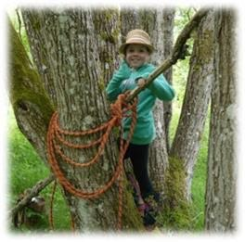
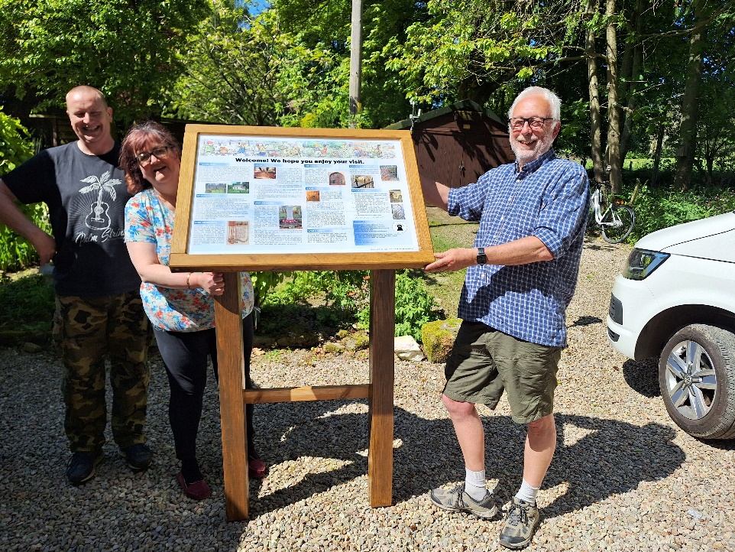
Drummuir 21’s ‘Botriphnie Kirk & St Fumac’s Well Storyboard’ project was awarded £1,450.
A high quality story board was funded by this round highlighting the local sites of historical interest. The story board includes photos of Botriphnie Kirk, Graveyard, St Fumac’s Well and the Botriphnie War Memorial. You can find the story board at the gates to the Kirk next to the Isla Way.

Drummuir and Botriphnie Community Trust was awarded £1,000 for their Drummuir in Bloom project.
In June 2022 Drummuir in Bloom received a grant of £1000.00, to employ the services of Lochpark Rural Skills, which is a local Day Centre for Adults with learning difficulties. They supplied compost and plants for planting out and the hanging baskets and floral displays, in and around the Village of Drummuir. They also maintained and watered the plants throughout the summer months. The beautiful display of flowers were very much appreciated by the local and wider communities and visitors to the area. The total cost of the project exceeded the grant but DBCT were more than happy to make up the difference and help to support Lochpark Rural Skills.
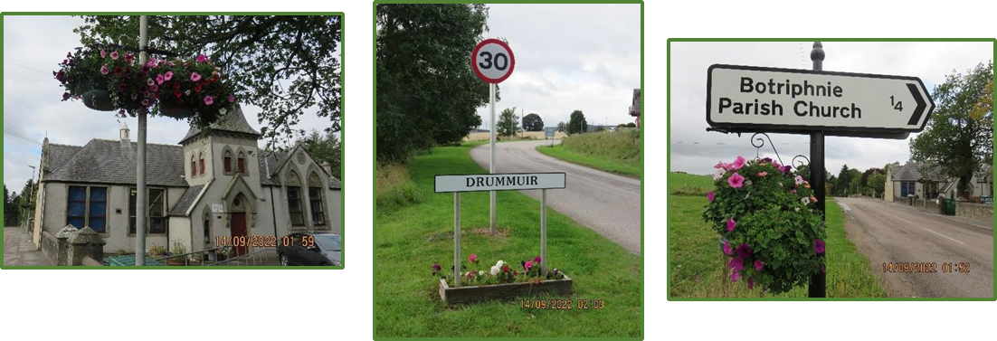
Keith Country Show’s project was secure the show field at their yearly event were awarded £5,268.
After several attacks of vandalism at the event which ended up costing thousands to repair. They were awarded the funds to try and prevent it happening again. Ground works, installing underground cables, installing a CCTV column, making the ground good again and connecting the electrics was a huge undertaking. The Tech and cameras were connected through another company Forsyth and Freeman Ltd.

‘We were delighted to receive the £5268 to purchase CCTV equipment. This is enough to purchase 8 high definition cameras covering the areas of our ground most susceptible to damage.
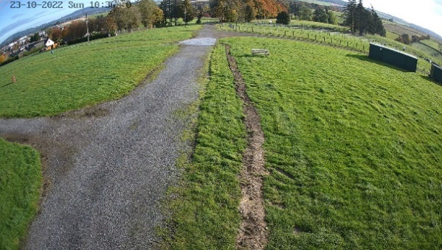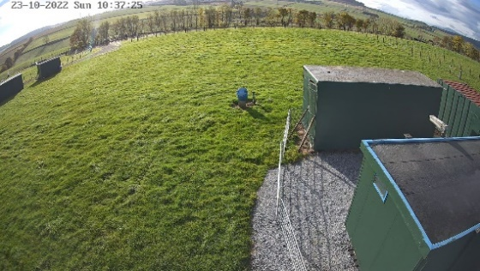

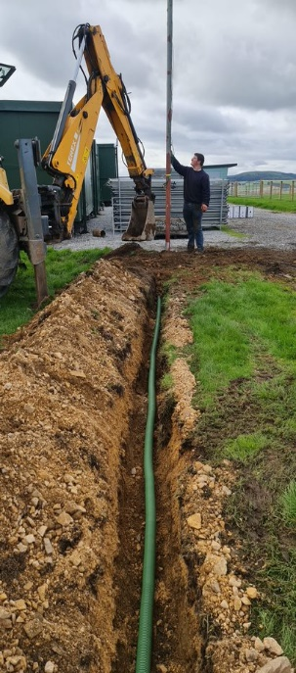
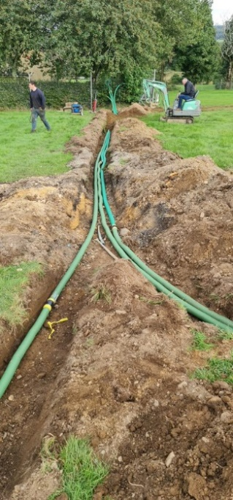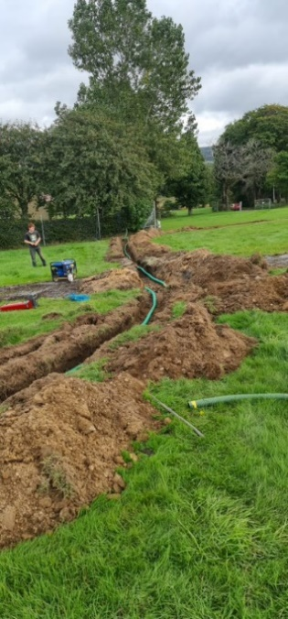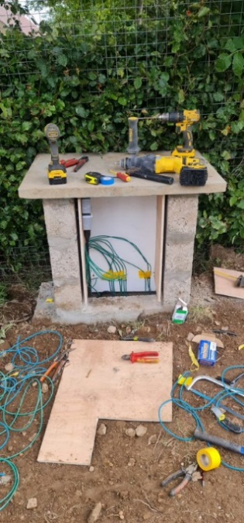

Keith Golf Club was granted the ‘Utility Vehicle’ projects sum of £10,250.
This vehicle is a great asset to us here at Keith Golf Club. With its versatility, robustness, and all-round quality we are able to use it in all weathers and ground conditions. It does not mark the grass, even when fully loaded, and it saves us using our heavier tractor especially when it’s soft and wet. Thanks very much to the Hill of Towie Community Fund for awarding us the grant of £10,250 to enable us to buy it.
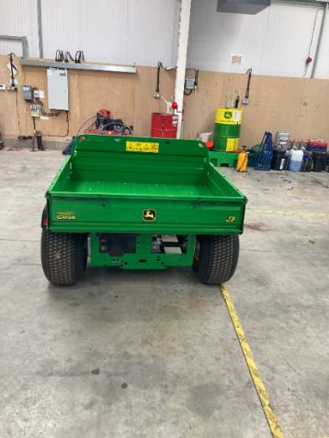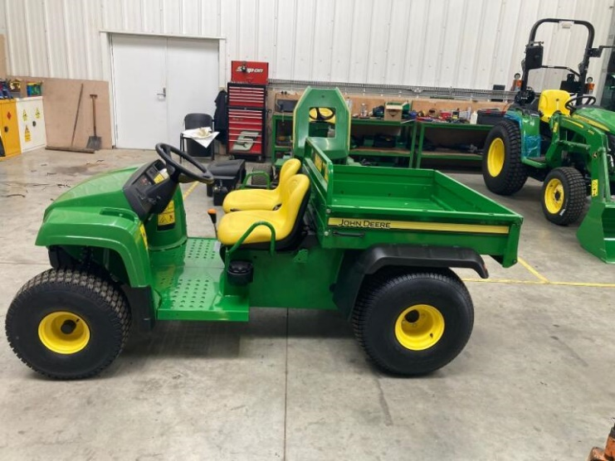

The Loft Youth Project was awarded £3,432 for CCTV.

The Loft’s CCTV was over 10 years old and images were blurry and not working to its full potential. The new system monitors the community garden, up and down the lane outside the Loft, hall door, office area and inside the hall. Keeping all users of this facility safe and the Loft’s equipment secure. what a huge difference this makes to the safety of our building and contents.

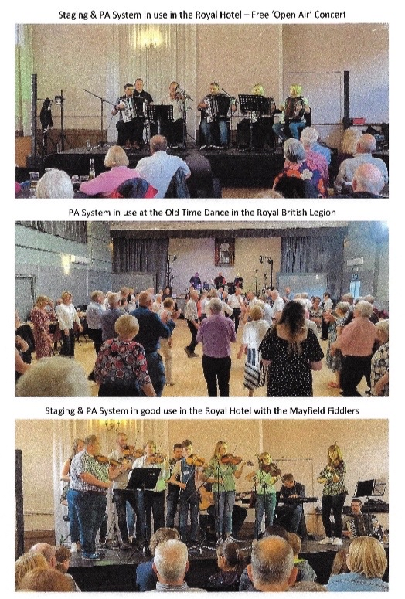

Keith Traditional Music and Song Association Festival received a grant for £8739.37 for new concert stage equipment.
The Keith brand of the Traditional Music and Song Association were absolutely delighted to be awarded the grant to the value of £8,739.37 to purchase stage equipment in June 2022.

‘The equipment has already benefited well over a thousand people over the festive weekend alone. This number is slightly lower than normal due to us not holding competitions at the 2022 festival as an after effect of the pandemic. This year (2023) we will be back to full capacity with competitions as well as concerts so the equipment will come into even more use’.

Fund Governance and Administration
Governance of the fund is overseen by a local volunteer Decision Making according to the fund aims and objective. All complete and eligible applications are assessed by Panel members and discussed at Decision Making meetings.

The fund is administered by REAP, a local environmental charity. REAP staff can assist with the application process and clarify any questions on the application form. All applications are screened for completeness, and advice is given to applicants where necessary. Application forms and guidance notes are always available on the website and hard copies are available on request.
Grants awarded are published on the REAP website, along with reports from successful applicants.

The fund is advertised in local venues, local radio station (Keith Community Radio) ,TSI Moray and online and on social media.

Accounts
The annual grant fund of £99,873.13 for 2022 was received from RES in May.

A total of thirteen grants totalling £108,373.68 were awarded in rounds 19 and 20.

