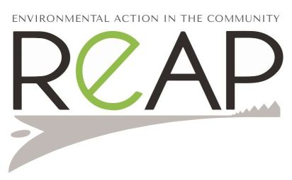REAP Community Gardener, Maryhill Therapeutic Gardens
Job Description
The REAP Community Gardener will be responsible for supporting the development of the Maryhill Therapeutic Gardens, funded by The National Lottery Community Fund until August 2024.
The Maryhill Therapeutic Gardens project is an exciting project that implements nature-based interventions to improve mental, social and physical wellbeing of its users.
The REAP Community Gardener position is a fantastic position for an individual with a good understanding of sustainable methods of growing, interested in creating a beautiful, therapeutic space with our clients - mental health service users and a team of volunteers

The REAP Community Gardener will co-ordinate activities in the Garden, including planning gardening tasks in consultation with the REAP Therapeutic Garden Worker and volunteers while helping to run weekly gardening sessions. They will be responsible for working with, training and supporting the team of volunteers in partnership with the REAP Manager and REAP Therapeutic Garden Worker. They will lead on providing learning opportunities for the clients such as food growing and composting workshops. They will be responsible for managing the site and ensuring that the materials and tools are supplied timeously. They will be a confident user of MS Office software and Internet and social media tools.
Post Terms & Conditions
Location: Based in Elgin
Hours: 10.5 hours per week
Salary: £20,000 pro rata
Holidays: 34 days per annum pro rata which includes public holidays
The post will be a 3 years fixed term contract.
Accountability
The Community Gardener will be line managed by the REAP Manager
Main tasks:
Develop and deliver growing sessions at Maryhill Gardens for those with mild to moderate mental health needs alongside a team of volunteers.
Plan and have overall responsibility for maintaining the growing spaces at the Maryhill Gardens
Deliver training in growing skills/ composting etc for clients and volunteers attending Maryhill Gardens project
Assist the REAP Project Manager and other REAP team members to train, work with and support the projects team of volunteers
Work as part of the whole project team to deliver successful outcomes, in line with good practice, code of conduct, Health and Safety and other REAP policies and procedures
Work with the GP Practice to maintain a visually pleasant and cared for growing space
Contribute to web page and social media content.

Person Specification
Attributes | Required
Experience | Experience and evidence of community work and engagement skills  Experience of community gardening and sustainable methods of growing  Experience of working with volunteers and vulnerable adults is desirable
Education & Qualifications | A good general standard of education (e.g. Standard grade or above)
Skills/Abilities General | Excellent communication skills and good at engaging with a wide range of people  Polite, personable and non-judgemental  Adaptable and motivated  Able to manage own time and workload
Skills/abilities specific to post | Driving licence and access to vehicle  Competent Information and Communication Technology (ICT) skills
Interpersonal & Social Skills | Able to work well as part of a team  Understanding of community work and the need for confidentiality

Applications
Please note that a PVG check will be carried out for all applicants for this post
Application forms available at http://reapscotland.org.uk/our-people/vacancies/
Completed applications forms should e-mailed to info@reapscotland.org.uk
Closing Date: Thursday, 24th June 2021 10am.
Candidates will be informed if they are unsuccessful

REAP is committed to Equal Opportunities.
Scottish Charity (SCO37988). Company Limited by Guarantee (316989)
For further information see www.reapscotland.org.uk
This post is funded by The National Lottery Community Fund.

